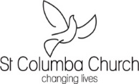
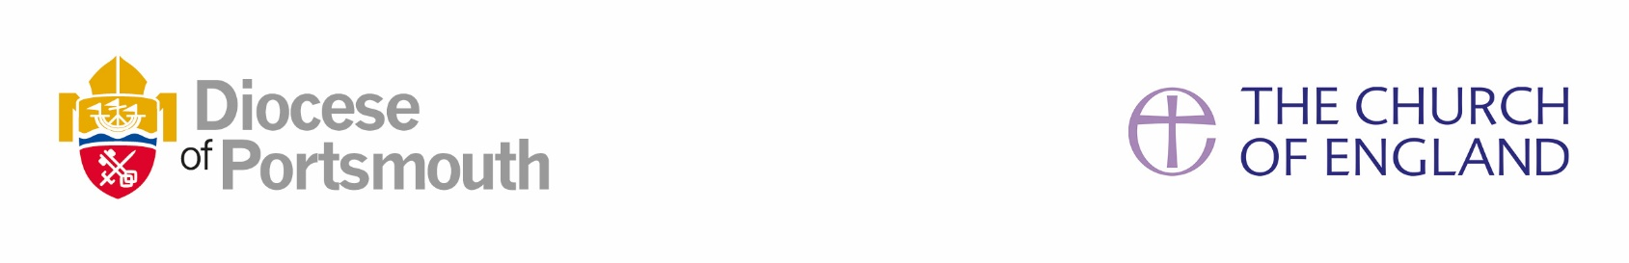


HOLY TRINITY WITH ST COLUMBA, FAREHAM

Job profile
Job title | Secretary to the Vicar
Reports to | The Vicar
Principle Location | Parish Centre, Holy Trinity Church Fareham PO16 0EL
Travel required | Home to Parish Centre and some travel to St Columba Church as required.
Work pattern / hours | 15 hours per week Mon-Fri
Date written/updated | May 2025
Closing Date | June 20th 2025
Interview Date | July 1st 2025
BACKGROUND and ROLE
We are a large Parish, blessed with two churches, one in the town centre of Fareham, the other in the heart of a residential area off Highlands Road.
Located in the Diocese of Portsmouth, seeking to be “a rejuvenating community of Jesus-centred, Kingdom-seeking disciples”, our Mission is to practise our faith together, by reaching out, sharing what we have and partnering with others for the common good. Our Values include engaging with the wider world and generously serving those in need.
We seek to grow together as a welcoming and inclusive community of faith. We are an active member of Christians Together in Fareham and the Inclusive Church Network, as well Host to Deaf Church and to the Open Table Network. Further information can be found on our website. https://htscf.org.uk/
Responsible to the Vicar, the Secretary has a pivotal role in providing administrative support and overseeing the running of the Parish Office, which serves as a focus of information and communication at the heart of church life.

KEY RESPONSIBILITIES
Responsible to the Vicar:
- Handle routine letters and e-mails, replying or drafting replies where required.
- Act as a point of contact for enquiries, by post, e-mail, phone or in person.
- Be responsible for the administration and all necessary arrangements for funerals, baptisms and weddings from first contact to follow up after the services, print the marriage documentation, certificates, liaise with verger/organist/choir, print Orders of Service, prepare baptism gift bags etc.
- Assist with production of parish publications.
- Preparing Orders of Service, special service sheets, photocopying, etc.
- Assisting the Vicar and Churchwardens in ensuring policies (Safeguarding, Health and Safety, Data Protection, etc) are regularly updated and alerting Vicar/ Churchwardens to possible non-compliance.
- Any other administrative duties as required by the Vicar.

Administrative support to the wider Parish
- Take responsibility for office organisation so that information is accessible to those requiring it.
- Assist the Parish Administrator in compiling updates for CCLI hymn and music data reports.
- Manage bookings & keys of Holy Trinity Parish Centre and St Columba Church administration of contracts, invoices, accurate recording and banking of cash receipts. Develop on-going constructive dialogue with users and be pro-active in suggesting helpful changes to Standing Committee.
- Shared with office team, to handle routine office mail and appropriate correspondence for the Churchwardens and other clergy.
- Assist the Administrator in keeping office files updated, maintaining parish database and various parish lists and electronic diaries.
- Assist with keeping the Parish website up to date.
- Deputise for Administrator's routine tasks during periods of absence/holiday.
- Manage stationery & book orders
- Manage the parish cleaner’s working hours and scheduling the leaning for the week.
- Update the website with posters, notices of events, Orders of Service (including redaction of copyright material), the Newsheet and bookings via the website calendar.
- Manage and update the ‘A Church Near You’ entry for the parish, including update and posting of regular and one-off events, service details and notices.
- Undertake Safeguarding training as required.
- Produce monthly service posters for both churches. Update the external and internal notice boards at Holy Trinity.
- Collate the data for the Parish Annual Statistics.

PERSON SPECIFICATION

Qualifications
• Educated to a good general level, particularly in English and Maths.
• RSA or equivalent Typing- or proven secretarial experience.
• IT skills - proficient in Microsoft Word, Excel, Publisher, Outlook.
• Working knowledge of database desirable but training will be given.

Experience, Skills and Knowledge
Essential
• General office and administration procedures, filing and reception work.
• Good communication skills, both written and oral.
• Ability to prioritise use of time and resources.
• Able to work alone but also with others.
• Able to work to deadlines.
Desirable
• Knowledge of Church of England and insight into parish life.

Personal Qualities
• Helpful and approachable.
• Able to handle pressure.
• Assertive.
• Diplomatic, confidential and discreet.
• Able to relate to individuals at all levels.
• Attention to detail.
• Ability to use initiative and common sense.
• Quick to grasp essentials and willing to attend relevant training courses.
• Flexible - including a willingness to be flexible about working hours.
• Sympathetic to views and beliefs of the Church of England.

Remuneration
Salary: £14.50 per hour
Holidays: 20 days + bank holidays

