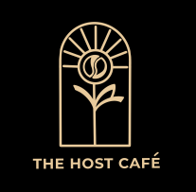
We are hiring!

Cafe Manager
The Host Café
Are you a coffee lover with a passion for providing exceptional customer service at the heart of the city? Look no further! Your local cafe needs your help. Why not make a positive difference to your community as we offer training opportunities to young adults in the local area.
We are looking for a café manager to lead a talented team in our brand-new coffee shop situated next to St Luke’s Church in Greetham Street.
Who are we looking for to lead the team?
As Host Cafe Manager, you will be responsible for managing the daily operations training volunteers and employees, ordering supplies, monitoring finances, and maintaining a clean and inviting environment. You will also nurture customer relationships and explore imaginative marketing approaches to create a thriving community café with a friendly and upbeat attitude.

This could be a job share (2x15 hrs)
or a full-time position (min of 30 hrs)

For more information please contact
Liz Jones, The Host Cafe, St Lukes Church, Southsea PO5 4LH
cafe@stlukessouthsea.church
Or call Annie for a chat on 07802644525
Deadline for applications: Monday 23 December 2024

