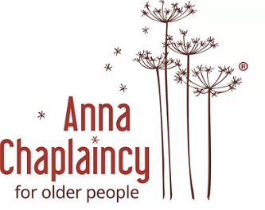
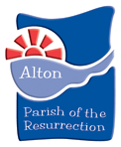

Anna Chaplain to Older People Job advertisement

The Greater Alton Project - Anglicans and Methodists journeying together (GAP) - invites applications for the part-time post (20 hours per week) of Anna Chaplain to Older People.

Salary: In the range £12 - £15 per hour (@ 20 hours per week = £12,480 - £15,600 annual)

Holiday: 20 days per annum pro rata plus bank holidays (80 hours plus bank holidays)

The Anna Chaplaincy is an ecumenical post promoting the spiritual and emotional welfare of older people, including those living in residential care homes and sheltered housing complexes, and offering support to their relatives and carers.

The Anna Chaplain reaches out to all, whether of Christian faith, other faith or none and a feature of the work has been in developing links with many of the clubs in Alton where older people gather. However, an important part of the work has also been the development of services of worship adapted to meet the range of needs of those who would wish to participate.

The increasing development of housing for older people in the Alton area, and the success
of previous postholders in developing strong links within the community, has led to a realization of the need to train and enable volunteers to support this work. The successful applicant will therefore be able to build, lead and develop a team of volunteers to support them in this ministry.

The successful applicant would become part of a growing national network of such Anna chaplains within Bible Reading Fellowship, who can provide training.

To gain a fuller picture of the variety of work Anna Chaplains are undertaking please see www.annachaplaincy,org.uk, the Alton Methodist Church website www.altonmethodist.org.uk and the Parish of the Resurrection website www.potr-alton.co.uk

It is an occupational requirement for the person appointed to be a professing and practising Christian, lay or ordained, in a church affiliated to the Council of Churches in England and Wales.
(Equality Act 2010.)

Enhanced DBS and references will be required. Full COVID 19 vaccination status will be required (Recent legislation requires it in all CQC Care Homes)

For an application pack please contact:

Mrs Liz George: altonmethodist@hotmail.com or Tel: 01420 561543

