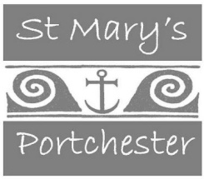

“At St Mary's we are a people of prayer, learning and growing in faith together.
Our vision is to be a caring and welcoming church family who reach out
with the love of God into our local community and the world.”

We have an exciting new job opportunity as a Tea-Room/Catering Manager. We are looking to employ a dynamic, enthusiastic person to run an already well-established volunteer-led tea room.
If you have a passion for food, are innovative, can lead a team of willing volunteers, have good commercial awareness and organisational skills then this is the job for you.
You should be sympathetic to the Christian ethos of the tea room which is more than just a business, but offers hospitality, Christian fellowship and is an outreach ministry for the Church.
Your duties will include mainly the catering needs of the tea-room on a daily basis but will also include management and administration duties to ensure the smooth day-to-day running of the tea-room. You will be expected to bring new ideas to enhance the menus and recognise seasonal change and be adaptable with the food on offer. You may be required, on occasion, to cater for special events put on by the church.
You will need to have knowledge of statutory food and hygiene and health and safety regulations.
You will need to be flexible in your working hours as there may be a need to cover for sickness and absence at short notice.
This is a full-time post of 40 hours worked over 5 days a week.
Salary Circa: £20,800.
Closing date for applications: 3rd April 2020.
Please send a CV and covering letter to the Vicarage 164 Castle Street Portchester PO16 9QH.
Interviews to be held on the 9th April 2020

