Parish Profile
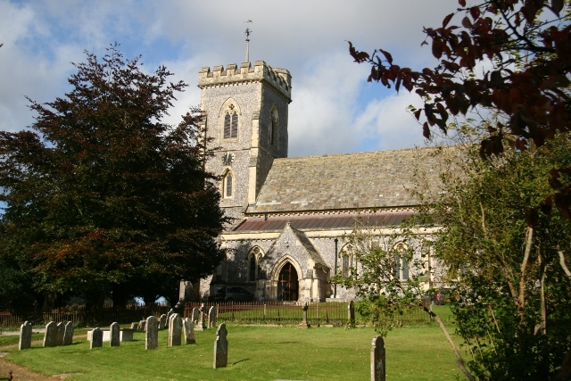

Benefice of West Meon
and Warnford

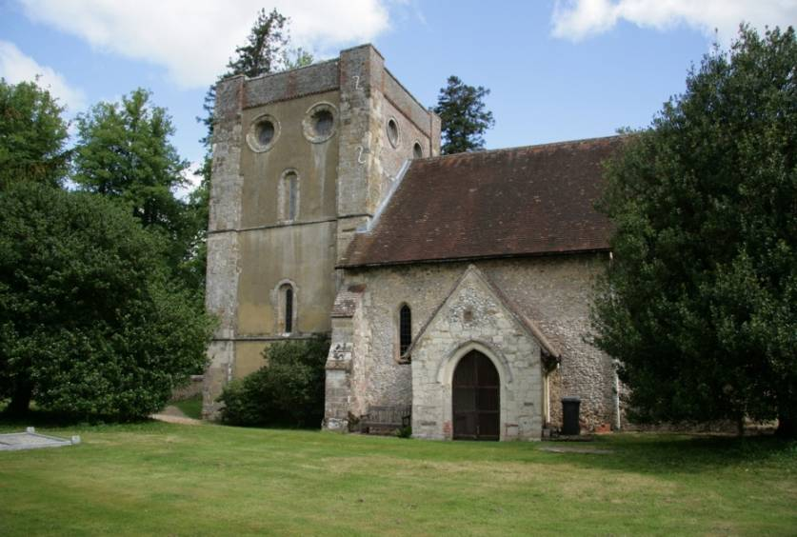

Deanery of Petersfield
Archdeaconry of the Meon
Diocese of Portsmouth

The Parishes
The two villages of West Meon and Warnford are situated two miles apart in the much sought-after beautiful rural setting of the Meon Valley; within the Winchester City Council district of Hampshire. 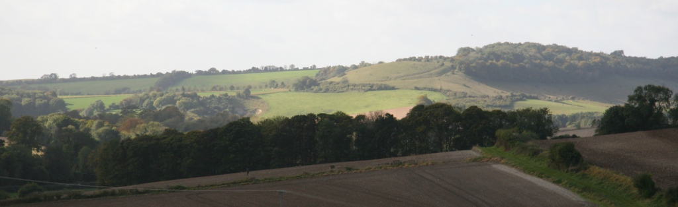
There is a longstanding close relationship between the villages of West Meon and Warnford, which have shared a priest for nearly 50 years and also have close links in sharing amenities in the community. There is also increasingly a crossover of church attendance. It has been agreed by both PCCs that the two parishes will work towards becoming one parish at a future date, though we are still exploring what the arrangements for this might be.
The River Meon runs through both villages alongside the A32. This road runs from Alton south to Fareham and Gosport. Just to the north of West Meon, the A272 runs east from Winchester to Petersfield and West Sussex. Much of West Meon is in a Conservation Area (church but not rectory) and both villages are within the South Downs National Park, so there are many visitors who enjoy passing through.
Several small towns within easy reach include Petersfield, Alresford, Bishop's Waltham, Fareham, Alton and Winchester. There are bus services to Petersfield, Winchester and Bishops Waltham and there is also a community minibus that takes shoppers to Fareham, Hedge End and Waterlooville.
The area is rural and there are some large farms but only a comparatively few people are now engaged in agriculture. Many people work from home or locally and a proportion commute further afield to work. There are some flourishing small businesses in both parishes providing local employment.
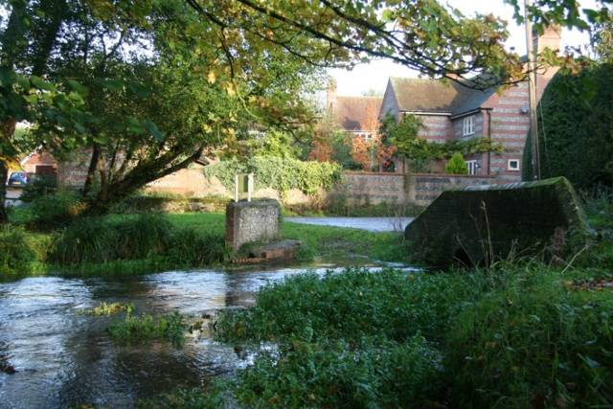
There is a mix of traditional and modern housing, with most being owner-occupied. Housing costs are high. West Meon has five social housing schemes, including one for older residents. The most recent scheme completed in 2012 offers affordable housing to people with strong local ties. West Meon has a small educational charity which still retains one property which it lets. Warnford has a group of five social housing units and a terrace of six houses primarily reserved for local pensioners.
While both communities have many retired people, there is a well-balanced mix of ages, including many young families. This is not surprising as the excellent local schools and amenities make it a wonderful location in which to bring up children.
Amenities
West Meon Church stands near the centre of the village in a site shared with the village primary school (Controlled Church of England).
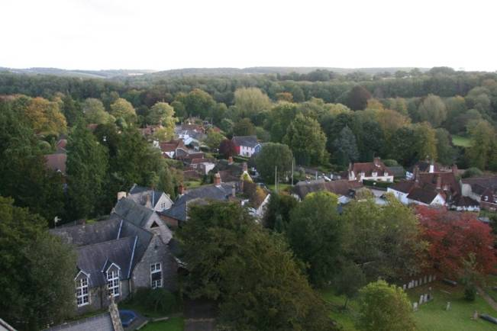
There is a popular public house, a successful butcher and a prize-winning community shop that hosts a post office counter twice a week. The shop still provides deliveries over a wide rural area and is a tribute to the vigorous community spirit in the village.

By the crossroads, about a mile to the north of the village, there is another public house, a café and a petrol station with a Budgens shop.

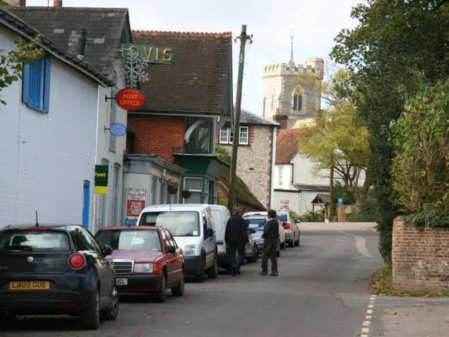
West Meon High Street is often busy with shoppers, children going to school, patients attending the doctors' surgery and those catching buses. This is where the rector, on the way from rectory to church, has the opportunity to meet people casually.
West Meon also has a sizeable and well-used village hall with an adjacent children's playground, together with sports fields and a sports pavilion. It is appropriate that cricket is well-supported as Thomas Lord, the founder of Lord's Cricket Ground, is buried in the churchyard and commemorated in the pub. The village also has a day nursery and there are Montessori nursery schools in adjacent villages. Residents of Warnford and the surrounding area regularly use the facilities of West Meon.
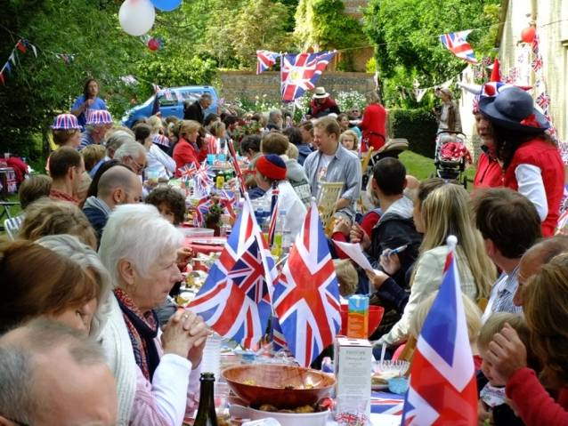
However, Warnford has its own charming village hall, converted from a farm building, and a friendly public house. It no longer has a shop, but there is a delightful and well-used children's playground by the river and a cricket ground that is home to the Hampshire Hogs cricket club. Warnford has a very strong community spirit of its own.

Recreation
West Meon has wonderful community entertainment, with West Meon Theatre putting on plays and pantomimes of a very high standard in various venues and encouraging young people to take part in a separate youth theatre. Public events, such as the Diamond Jubilee celebrations, are well-supported in both villages. There is a parish website with local information which is hosted by West Meon Parish Council.
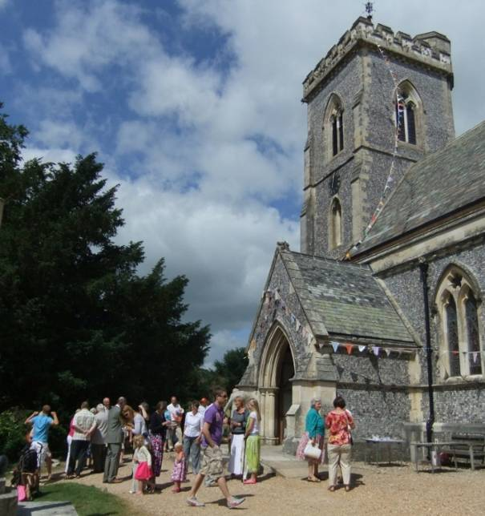
The two villages form a social unit together. There are many shared clubs and facilities, such as the sports of cricket, football, hockey, tennis and table tennis; beavers and cubs; dance and fitness. There is an active garden club and a separate allotment association. The flourishing WI holds monthly meetings and puts on a well-supported harvest supper. There is a very effective care group that provides transport for hospital and surgery appointments, and church members host a monthly coffee and chat for the elderly of both parishes. The two villages complement each other and enjoy good co-operation and there is much friendship between them.

The Church Buildings
The church of St John the Evangelist in West Meon is the second church to be built on this central site. Consecrated in 1846, it was an early design of George Gilbert Scott, with particularly unusual knapped flintwork.
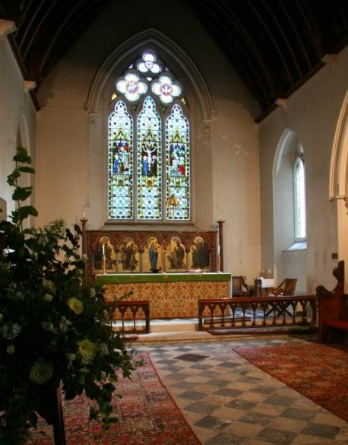
A re-ordering in the 1920s included the addition of an attractive reredos. The organ (Brindley and Foster, 1877) is a fine instrument, now listed, which attracts visiting choirs and organists.
In recent years major works have included restoration of decayed exterior stonework, reroofing and provision of improved drainage. This has depleted reserves but put the church in a better position to raise funds from grant-giving bodies and local appeals in the future. With much of the work on the exterior now complete, we are turning our attention to improving the decoration of the interior.
The Church of Our Lady Warnford stands in a beautiful setting in Warnford Park, half a mile from the village.
The existing building has stood on this site, alongside the River Meon, for nearly 1,000 years. It is built in the simplest Early English style, with a distinctive Norman tower and Jacobean screen separating the chancel.
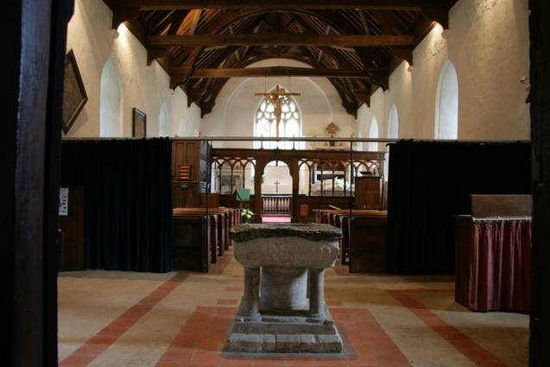
There are remains of an earlier Saxon building incorporated within it and there is a strong tradition that St Wilfrid founded a church here in 682 AD. The church can be visited on foot at any time but vehicular access is limited to advertised times. A toilet has been installed in the grounds, after considerable negotiation over planning constraints. Recent repainting has made the interior bright and attractive.
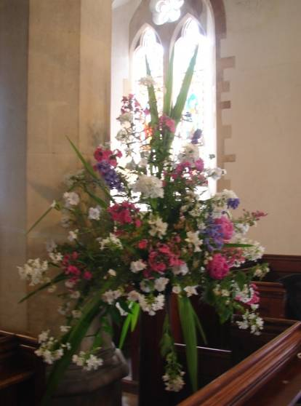
Church Activities
Each church has a ring of bells (8 in West Meon and 6 in Warnford) with a keen combined band of ringers and a network of visiting ringers.
In West Meon, worship and ministry is supported by an active liturgy rota, a dedicated organist, teams providing refreshments, flower arrangers and regular working parties in the churchyard.

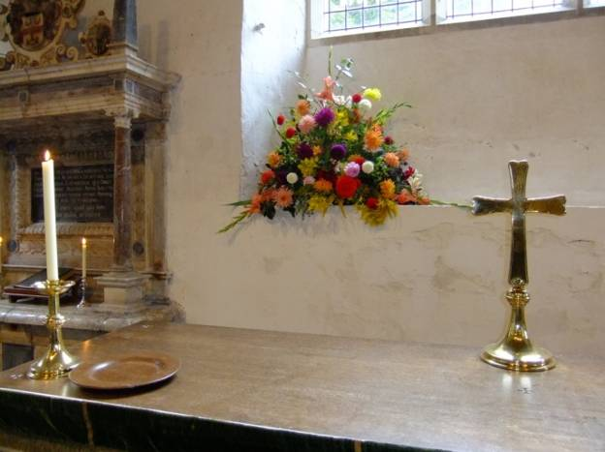
Warnford also has a dedicated team who decorate the church, some of whom come from West Meon. Refreshments are provided with a welcome after some services and the churchyard is beautifully maintained.

Special events
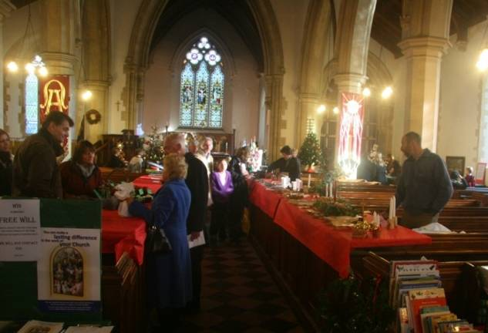
West Meon church is a sizeable building which provides a good rectangular space for a large gathering, with excellent acoustics for performance (and recording) from the crossing, as well as kitchen and toilet facilities. Following a parish plan in May 2007 (recorded on Winchester City Council website) and a public meeting about the use of the church building in May 2009, efforts were made in response to a strong message from the community that more use should be made of the church building for performances. This has led to occasional festivals of books and, since 2011, an annual three-day festival of chamber music, organised by the Primrose Piano Quartet and attracting world-class singers and soloists. These events bring in many from outside the village. A Christmas tree festival has become a regular biennial feature, alternating with a ‘Living Advent Calendar’. The Christmas tree festival encourages participation by many groups within the village as well as local businesses, and it has succeeded in bringing increased numbers into church at Christmas time. The Living Advent Calendar sees a team of volunteers each hosting a free event on a different day in December, with homes being opened for everything from winter barbecues to sushi classes and even a boules evening.
Finances
The two parishes have separate church finances; both have a good record for paying all their parish share in full and on time. In West Meon the running expenses and parish share are paid for from income from donors, supplemented by special events such as the village fête, which has raised £5-6,000 per year lately, and the Christmas tree festival. As reserves have been reduced and investment income has not been productive recently, it was decided that we would provide Sunday teas in August in order to enable us to continue our charitable giving. The teas have proved very successful and we are currently discussing whether to extend them to Sundays in July. Local people, passing walkers and cyclists and motorists who see our signs on the A32 join together to enjoy the beautiful views from our churchyard whilst enjoying a pot of tea and delicious cakes.

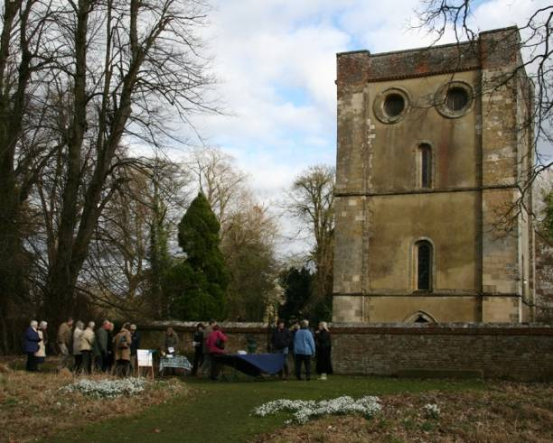
Warnford church is in a sound condition and its finances are assisted by the annual fête and highly popular ‘Snowdrop Sundays’ every February. On these occasions, the park is open to the public for walks through woodland carpeted with ancient drifts of snowdrops. This attracts as many as 3,000 visitors over the month and makes a major contribution to church funds. It involves about 70 people from both villages working together.
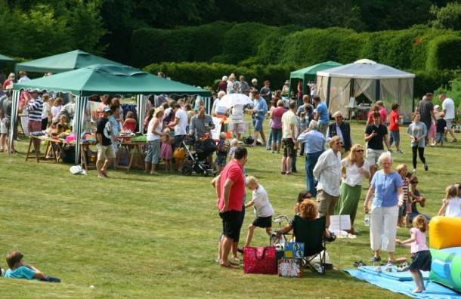
The fêtes also involve many in the community: in West Meon, 100 people can be involved in the organisation and in Warnford, about 60.

The Rectory

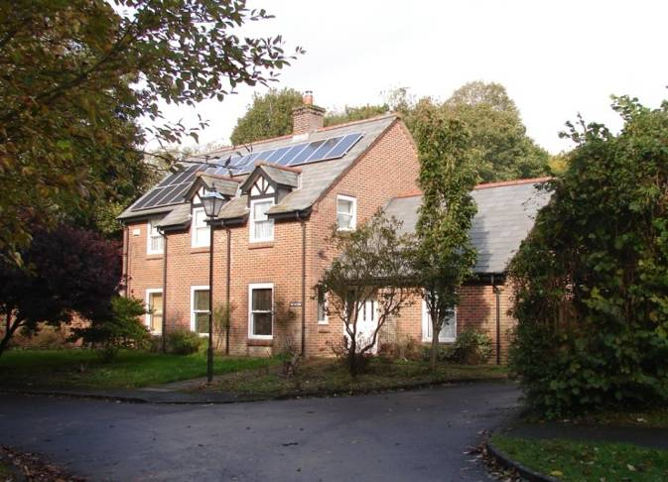
West Meon Rectory is an attractive modern purpose-built rectory. It is economical to run and has the benefit of new windows and solar PV heating system provided under the Diocese’s initiative in 2011, and new bathrooms installed in 2013. It is in excellent condition throughout, with a manageable garden. It has four bedrooms, bathroom and shower room and a very large secure double garage. There is plenty of parking space in the drive. The Rector’s study is an excellent spacious triple-aspect room with generous fitted shelving, but it is not overlooked and provides room for both meetings and office space.
The rectory is not adjacent to the church, but it is central to the village, lying between the doctors’ surgery and a close of social housing for the elderly.
The PCCs
West Meon and Warnford currently have separate PCCs. The two PCCs hold several joint meetings each year, but each church retains its own identity and the finances are kept separate.
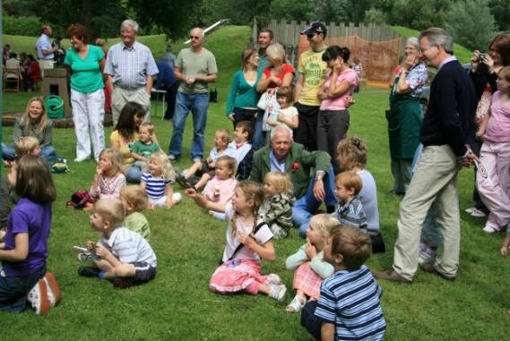
Both parishes currently have two churchwardens and there is excellent co-operation between the two parishes at many levels.
There are 69 people on the West Meon electoral roll and 40 on that of Warnford.
The ‘Parish News’ is a church initiative, delivered free eleven times a year to all the households in the two villages. It covers local social and sporting activities, the Rector writes the front-page article and the magazine contains the times of church services. The cost is met by advertising and appeals for donations.
Cluster group with East Meon and Langrish
Over several years there has been increasingly closer working with the adjacent benefice of East Meon and Langrish, the other two parishes in the Deanery Cluster. The agreed Deanery Plan has clearly indicated that these four parishes are likely to combine in one benefice within the foreseeable future. This has been recognised by appointments in the parishes over the last five years. When Revd Lionel Stock was appointed Rector of West Meon and Warnford in 2013, he was also licensed as Assistant Curate in East Meon and Langrish and likewise Revd Jane Ball, who was appointed the following year to East Meon and Langrish, was also licensed as Assistant Curate in West Meon and Warnford. This commitment to work together has been borne out with the development of closer links, weekly meetings, joint cluster services and clergy taking services in each other’s parishes. We are fortunate to have a Training Curate attached to the four parishes, Revd Katy Garner, who is now in her third year.
A pattern has been established of joint cluster services on an alternating basis for the main service on every fifth Sunday, monthly evensong and special services in the evening, as well as shared Lent discussion groups.
The congregations in West Meon and Warnford enjoy sharing worship and ministry with a larger group.
Church Services
The current pattern of worship in the two churches is:
1st Sunday: 9 am Warnford : Holy Communion (Order Two, Traditional)
10.30 am West Meon: All age worship (Service of the Word)

2nd Sunday 9 am Warnford: Holy Communion (Order One, Traditional, with hymns)
10.30 am West Meon: Holy Communion (Order One, Contemporary)

3rd Sunday 9 am Warnford: Holy Communion (Order Two. Traditional)
10.30 am West Meon Service of the Word
4th Sunday 9 am Warnford: Matins with hymns (Morning Prayer from the BCP)
10.30 am West Meon: Holy Communion (Order One, Contemporary)

5th Sunday 10.30am Cluster Communion Service in one of the four parishes
Occasional Evening service, usually monthly in one of the cluster churches
Readings for all communion services are from NRSV.
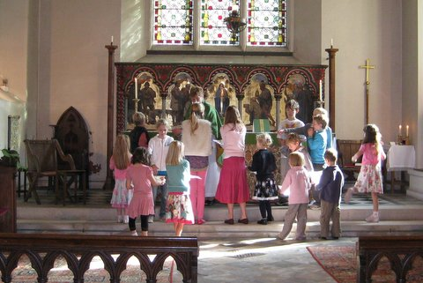
Our two churches are the only places of worship in West Meon and Warnford, so we try to provide accessible worship for the range of people’s spiritual preferences and needs – from special healing services to a pet service. Likewise the occasional offices are aimed to be inclusive and to accommodate the wishes of those involved.
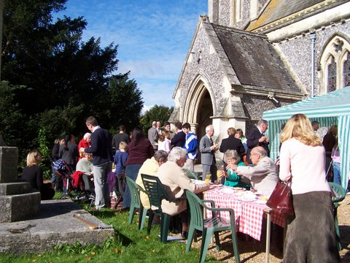
Some of the distinctive special services and events that have become traditional include a Palm Sunday walk from Warnford to West Meon, a well-attended Good Friday walk from Langrish to Warnford, a celebration of St Wilfrid in the parishes of the Meon Valley, harvest festivals, a devotional Advent evening service, carol services in both churches and a crib service on Christmas Eve as well as Midnight Mass.
The combined population is just under 1,000. Sometimes the congregations may seem small but expressed as a proportion of the residents, the number of attendees is more encouraging.
Ministry
An important part of the ministry in West Meon is the link with the primary school. It is a very highly regarded and sought-after school, with currently around 60 children on the roll. The church has an excellent relationship with the head teacher, Mrs Julie Kelly, who attends West Meon church regularly and sits on its PCC.
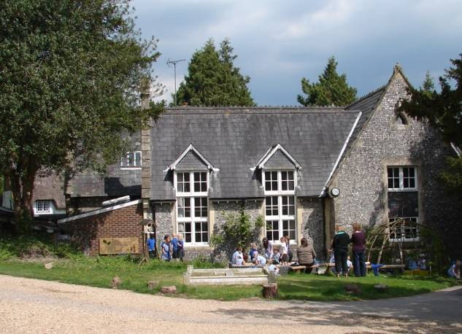
The school uses the church for some assemblies, plays, and services such as harvest festival and the leavers’ service. Members of the church congregation are foundation governors and many others help with school activities. The Rector and Curate are welcomed in to the school on a regular basis to take assemblies and lessons.
A flourishing women’s fellowship group was set up by the previous Rector’s wife, Elizabeth Stock, and continues, led by members of the laity. This group is now named Pilgrims.
The two parishes undertook the LYCiG (lead your church into growth) course together in Lent 2018, following training for the Rector, Curate and two lay people in the previous year. This was well received and supported and led to increasing discipleship training, a thorough consideration of the welcome provided in the churches, including the priorities for the fabric. It also led to the creation of a small group of lay leaders who are beginning to take some of the non-Eucharistic services at West Meon.
There is already a tradition of lay pastoral assistants assisting the clergy in the parishes. There is currently one diocesan-accredited lay pastoral assistant in the benefice and other members of the laity with long experience of, and skills in, parish visiting.
Relations with the Deanery of Petersfield are good and the parishes have supported their activities and the increasing co-operation between the clergy.
Portsmouth Diocese has longstanding links with West Africa and over the last 20 years this has primarily focused on the church in Ghana. Our current Bishop has demonstrated that this relationship is important to his ministry. West Meon and Warnford have active links with the priests and schools in the parish of Winneba (and its daughter churches) near Cape Coast. Some parishioners have visited the link parish and also welcomed visitors from Ghana to West Meon. Barbara Shaw of West Meon represents Petersfield Deanery on the diocesan IDWAL (Inter-Diocesan West Africa Link) committee.
The parishes of West Meon and Warnford are ready to move forward to a new stage of their life together and are open to be led, with others, into a changing pattern of ministry and initiative for mission. They have agreed to work towards uniting as a single parish at some future date, once the exact nature of the arrangements have been fully explored, and they welcome the prospect of joining an enlarged benefice in due course and preparing for that with the development of ways of working together.
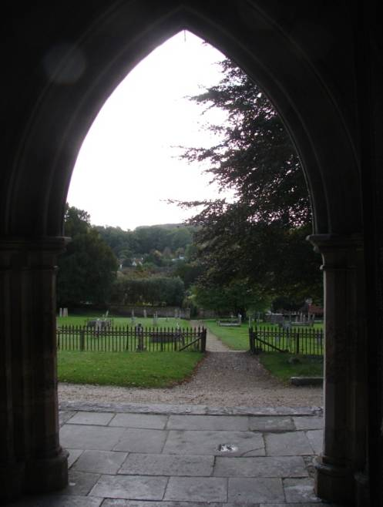
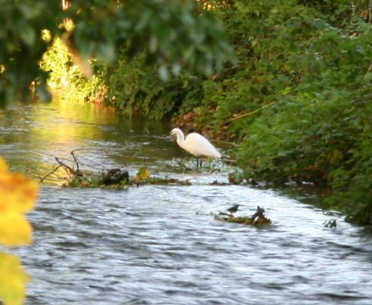

The Person We Are Looking For
Your role will be to balance your ministry in the two parishes of West Meon and Warnford with working with the incumbent of East Meon and Langrish towards a combined benefice.
This list is not meant to be daunting, but a guide to the sort of person we seek. We do not expect you to achieve it all at once and want to support you in setting boundaries on your availability beyond your contracted days plus Sundays.
We are hoping and praying we will find someone who will enable us all to feel our church is part of the body of Christ and to:
- Be a good communicator and listener; friendly, approachable and discreet, willing to get involved in local events and to be visible in the community.
- Be realistic about the challenges of ministry in a rural community with an age profile like ours, but at the same time to have a positive and aspirational vision about what can be achieved.
- Work as a team, collaborating openly with lay volunteers, building on the work done so far with the LYCiG initiative to bring energy to our congregations and lead us into further growth.
- Help discern, value and exercise the gifts and ministry of all, and encourage the church community to look outwards.
- Be willing to engage energetically with:
  - the pastoral needs of the parishes, both the established congregation and others in the community.
  - our church school, taking assemblies, acting as a governor and actively promoting the attendance of families and children at some services, with the aim of building up the number of young people attending church.
- In leading worship
- challenge us with sermons of spiritual depth and biblical study.
- both support traditional services and explore more contemporary and informal worship.
- lead by example in a life of prayer.
- Carry on the close partnership that has been developed with the rest of the Deanery and the parishes of East Meon and Langrish.
- Continue to promote the relationship with our link parish in Ghana.
About the Diocese
The Diocese of Portsmouth is the smallest in mainland England and, rather than this being a handicap, it is a friendly area and the clergy and the laity get to know each other well. Many clergy feel very much part of diocesan life. The Diocese has one Bishop and three Archdeacons.
The Deanery of Petersfield consists of the parishes of:
Blackmoor and Whitehill, Bramshott and Liphook, Buriton, East Meon, Empshott, Froxfield with Privett, Greatham, Hawkley with Priors Dean, Langrish, Liss, Petersfield, Sheet, Steep, West Meon and Warnford.
The Deanery of Petersfield has a rural character and its 15 parishes range from the larger 'commuter' settlements on the eastern side of the Deanery to the more scattered parishes of the hills and valleys of the Meon Valley and the Hangers to the north. Across the Deanery there is a desire to support and celebrate the uniqueness of individual parishes as well as to consider what initiatives might best done across the Deanery. For example, a lay pastoral assistant training course was run for the Deanery with sessions led by different members of the clergy team. In a similar manner we have also run a six-module Christian basics course. The Deanery is committed to the Diocesan strategy Live, Pray, Serve (https://www.portsmouth.anglican.org/our-strategy/): as well as responses to this as individual parishes the Deanery has committed to a focus on prayer, creating a Deanery prayer diary and planning a Deanery Day of Prayer designed to explore different ways of praying. Discussions around relationships with schools are also high on the agenda.
The clergy Chapter generally meets together once a month over lunch. The current Chapter (made up of stipendiary and active non-stipendiary members) is made up of a wonderfully diverse group of people who might differ in their churchmanship and theology but share a strong commitment to personal support and encouragement. Since 1997 the Chapter has gone on retreat to a convent in Brittany every two years. In 2017 the retreat was held at Sheldon with the Society of Martha and Mary with a date booked for the autumn of 2019. These times away prove beneficial not just in the opportunity to spend time together outside of the Deanery but also as an opportunity for some extended time to consider ministry within the Deanery.

