Toolkit for Chaplaincy in Education in The Diocese of Winchester & in The Diocese of Portsmouth

A toolkit designed to help clergy, lay people and schools who are considering developing a chaplaincy role.

Introduction
The role of Chaplain within an organisation is one that is relational, context specific and an important visible presence. The Chaplain ‘comes alongside’ people where they are, and the regular and routine relationship-building and trust is manifestly blessed and useful when serious incidents, personal or community issues come to the fore, or when someone just needs a listening ear and a confidential conversation.

We have a very small number of commissioned and licensed chaplains in our schools, but are keen to encourage schools to explore the benefits for the children and young people, staff and wider community in appointing one to your staff.

Traditionally the parish minister fulfils the ex-officio governor role, but is also a leader of worship, and provides pastoral care weekly, and in specific times of need or request. This arrangement was built on the very establishment of church schools, and assumed one school in one parish, with the majority of the community being regular worshippers. Clearly the context has changed drastically, and many of our vicars now oversee multiple parishes, have many CofE and community schools in their parishes or benefices.

We are therefore trying to support clergy and schools, by looking at alternative models for offering the range of commitments and duties that have typically been expected of one person. We are affirming the benefits of the key roles – but suggesting they can be offered by more than one person. Individuals will have clearly designated roles, but will liaise closely so that the overall benefit to the school will be greater, and the support for individuals will be intentionally shared and resourced.

We have invested time in discussing the options and practical aspects of this with the Bishop’s Staff, the Diocesan Board of Education, clergy, governors, headteachers and others; we have the agreement and enthusiasm of both dioceses in supporting this development.

Please get in touch if you’d like a conversation or presentation to your governors, PCC or Leadership Team.

Thank you for all you are doing already in terms of pastoral and spiritual care for your pupils, students, staff and communities.

Best wishes

Jeff

Director of Education

Chaplaincy in Education can be transformative. It:

- offers spiritual and pastoral care to everyone and shares the life of the community
- is distinctively Christian, inclusive and works with people of all faiths and cultures
- is sometimes seen as ‘the public face of God’ for the school community
- provides a chance to listen and care, to pray for and bless the school and its community

This toolkit is designed to help answer some of the questions that you may have regarding a chaplaincy role in one of our schools academies in the Winchester and Portsmouth dioceses.

Questions may include:
- How does chaplaincy work in a school?
- How can we develop a new chaplaincy?’
- How do I become a chaplain?
- Can a lay person be a chaplain?
- How much of my time will it take up?
- What are the costs?
- How are chaplains supported / supervised

Chaplains can be lay or ordained. With the support of local churches and the diocese, discernment with people who have an appropriate skillset, experience (or potential) may be called and trained to be a chaplain. To establish a new chaplaincy, the following will need to be agreed:
- the vision and role description
- the funding
- the training, support & supervision

A vision for chaplaincy

This is not a ‘one size fits all’ process. There are many ways of articulating a vision for chaplaincy in education. Some examples are:
- Distinctively Christian and utterly inclusive, working with people of all faiths and cultures.
- Bringing ‘life in all its fullness’ to schools and colleges.
- Spiritual and pastoral care for all.
- The chaplain is there to listen and care, to pray for and bless the school.
- The public face of God.
- Existentially literate, at ease with spirituality and with matters of life and death.
- Sharing the life of the community; a member of the team, rather than a visitor.

All church schools are required to have a vision statement that is distinctively Christian and a set of core Christian values (usually three) that the school focusses on. Both the vision and chosen values will reflect the needs of the children growing up in the local community.

The vision for the any school chaplaincy role will need to fit within the wider vision for the school or Trust of which the school is a member. Out of this vision will come the role description and the recruitment of the chaplain.

The role of the chaplain and how
it will contribute to the school’s Christian vision will need to be discussed by all parties.
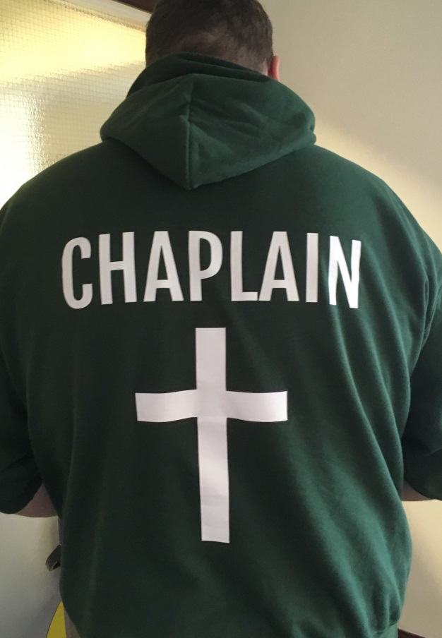
The role of the chaplain

A chaplain is ‘the public face of God’ within an educational community. The role is key in supporting and helping to develop the ethos and values of
the school and offering pastoral and spiritual care to all. The number of hours a chaplain serves will inform the range of roles and responsibilities possible. Some of these roles and responsibilities are outlined below. It should also be remembered that the role is about being as much as it is about doing. Perhaps the most important part of a chaplain’s ministry is to be seen, to meet people and to listen to them.

Christian chaplains are clear and distinctive about what they believe. A chaplain should meet and welcomes people where they are, accepting them unconditionally. A chaplain can prompt and respond to questions of faith, and there are many opportunities for teaching and discussion. The chaplain is there to be distinctive and inclusive, to share God’s presence by words and actions. Chaplains in church schools can help to develop the Christian ethos of the school and prepare for a SIAMS inspection.

▪ Listening: A chaplain goes into schools to listen. Worship, Bible clubs and prayer meetings are important parts of chaplaincy ministry, but the chaplain is there, first and foremost, to meet people where they are, to listen and to develop trusting relationships.

▪ Spiritual and Pastoral Care: Chaplains offer spiritual and pastoral care to all. This is offered though listening, restorative justice and informal mentoring for children, staff and families. In their spiritual and pastoral care, chaplains work with the school staff to support children and their families.

▪ Prayer and Worship: The chaplain is there to pray for and with a school. Chaplains may lead collective worship, collectively and enable prayer, worship and reflection though projects such as prayer spaces or other creative and reflective activities.

▪ Celebrations, Charities and Challenges: In liaison with school leaders, a chaplain can help with school celebrations, faith festivals, anniversaries and parties. A chaplain can be a charity coordinator, working with groups of children and enabling an outward focus. A chaplain can play a supportive role amidst challenges whether caused by bereavement, redundancy, illness, major emergency or Ofsted. In such contexts the chaplain can signpost to specialist support, listen to and support everyone and lead or enable any appropriate services.

▪ Working with local churches: The chaplain will work with local churches, reporting regularly and seeking partnerships for prayer and other forms of Christian ministry and especially enabling links between existing youth and children’s ministry projects and the schools.

▪ Clubs: Alongside Christian clubs, the chaplain can also be involved in a wide diversity of activities, sport, performing arts, home-work clubs, breakfast club, chess club… The list is endless and will depend on the skills and interests of the chaplain and the time available.

The possibilities for chaplaincy are endless but time is limited, both for the chaplain and the school. Each school setting will be distinct, as is each chaplain, and there is a continual cycle of educational change. It is important for the chaplain to meet regularly with the school’s senior leaders, governors and church leaders to discuss, discern and agree the priorities regularly.

A role description will need to be agreed to ensure that the school, chaplain and the wider school community understand the chaplain’s role and responsibility. The Diocesan Education team would be keen to engage with schools in drafting role descriptions and involved in interviews. Below is an example of a role description for a school chaplaincy role.

Purpose
To co-lead the formal and informal expression of Christian ethos & worship at the school, to support and develop the spiritual life of the school community and contribute to the pastoral care of the school.

Duties of the Chaplain
- To build up mutual relationships with staff, pupils and parents of the school
- The Chaplain will work with the Headteacher and Staff to develop the spiritual life of the school
- Work with the Collective Worship Coordinator to organise the planning and delivery of collective worship
- Contribute to the collective worship Rota and look for opportunities to invite local clergy/faith leaders into the school to share in collective worship
- Liaise with the church and school staff to plan suitable acts of worship to mark special occasions in the life of the school e.g. the Christmas, Easter and harvest services
- Provide pastoral support, under the direction of the Headteacher/Deputy Headteacher
- Develop the spiritual garden space as a place of prayer and reflection for staff and pupils (particularly at lunchtimes)
- Take responsibility for the organisation of School Prayer Spaces in collaboration with the Incumbent/church members and school staff
- Create displays which reflect the Christian theology and values of the school
- Support the work of the Religious Education Coordinator.
- Promote links with the church and the local community
- Introducing Godly Play for all Key Stages and offer training for this in class and whole school collective worship

Policies and Procedures
The chaplain will adhere to all guidelines and policies in respect of safeguarding and gender equality and will be subject to an enhanced DBS disclosure

Interfaith and Inclusion
XXX School is a Voluntary Controlled / Voluntary Aided school, / CofE academy with an open and inclusive stance, and although firmly Christian in its foundation and mission, has a legal responsibility to respect and honour the faith and experience of those who are not Christian but seek to worship and serve God through another tradition or those who profess no faith.

Schools have a hugely important part to play in providing the open space in which young people of different faith traditions can learn through inter-personal dialogue to respect and value one another's faith inheritance or personal beliefs. As Chaplain this will involve respecting individual faith traditions, employing prayers, readings and reflections which different faiths can share with integrity and taking care not to be a cause of religious offence to any particular faith groups.

Models of Chaplaincy and Funding

Sometimes funding for school chaplaincy is provided from legacies, endowments, church/school trusts and from larger school budgets (mainly in the Secondary school sector). Many school chaplains work on a purely voluntary basis. Some are co-employed part-time as teachers or support staff as well part-time chaplain to secure a full-time role.

Funding for Chaplaincy can come from a variety of sources
- Schools and Multi Academy Trusts (MATs): Educational budgets are very tight, however, schools that do fund chaplaincy often find that it is a remarkably cost-efficient leadership resource.
- Funding from churches and individuals: Churches and church members can be generous.
- Funding from Trusts and Charities: Charities and trust funds can fund chaplaincy.
- Ex-gratia payments from churches where specific fund-raising or gifting is undertaken annually

Employment
The chaplain will need to be recruited under the Safer Recruitment / DBS scheme, employed and line-managed within the school, and with Spiritual Direction / Supervision outside the school setting.

Partnership
Whichever means a chaplain is funded, the creation of the role will certainly involve a partnership.

This partnership can be nurtured by meeting three times a year to receive reports from the chaplain, see the whole project, support the chaplain and discern the next steps. The partners who may be involved are:

- schools and MATs
- churches
- other funding bodies
- the Director of Education in the Diocese

Line Management & Supervision
Chaplains will have a direct management oversight in schools, typically by the Headteacher or in larger schools, a Deputy Headteacher. Equally, as for all ordained staff, they will have confidential ministerial / spiritual direction.

There are several funding models for school chaplaincy:
- Full-time, paid. This could be a combination of paid employment (eg. if a Qualified Teacher or Teaching Assistant) as well as identified hours as a chaplain.
- Part-time, paid. This can be anything from an extended
lunchtime per week to four days a week. A contract of 12 hours per week can sometimes be spread over three days. It all depends on the chaplain and school
- Secondment of youth or children’s worker from a local church for a set number of hours. This can work very well and can have more impact than a visiting youth worker
- Honorary Chaplains who can either be the lead chaplain or a member of a chaplaincy team. In both scenarios they will still need to be safely recruited with role descriptions and will need to be properly line-managed and resourced [expenses, but not a salary, are paid)

Safeguarding

It is paramount and compulsory that all clergy and those people carrying out pastoral activities in schools on behalf of the parish and diocese have thorough safeguarding checks and are conversant with individual schools’ policies and procedures with regards to safeguarding and child protection.

The standard DBS certificate for clergy is not sufficient for school purposes. Ensuring all necessary enhanced safeguarding checks have been carried out is the responsibility of schools, not the diocese and it is also the school’s responsibility to retain and administer these records. This ensures that the school’s own safeguarding arrangements are in place and watertight. The cost to school for the enhanced, automatically updated service is minimal.
Setting up a school chaplaincy in 10 steps

- Understand the context: meet with the parish and school leadership (including governors) to audit what links and relationships may already exist between church and school.

- Establish the capacity: who are the people in the parish, other churches locally or in the school who have a calling and capacity to offer time, money, energy or all three

- Put it on the agenda: agenda item at PCC, Deanery Synod or Chapter meeting, whichever of the above are most appropriate.

- Form a working party who will make an effective group for carrying the vision of chaplaincy forward

- Discuss the school vision and how a chaplain could contribute to this to best serve the children and the wider school community

- Identify or advertise for a chaplain: assuming the school community is positive about your offer and interested in chaplaincy, consider whether someone already exists in the community who could adopt the role of chaplain. This might be an already licensed minister, a youth worker, a retired teacher etc. If no such person is found, then this becomes a larger question about possible funding

- Draw up a role description: work with the school, church and individual to create a realistic role

- Ensure that the school governors have agreed the role

- Train the chaplain: working with the Diocese, embark on a course of continuing training to raise awareness of issues and build up appropriate skills for a successful and impactful chaplaincy

- Commission the chaplain: The Chaplain should be commissioned, if possible, in the context of the parish church with the Diocesan Team attending

Useful reading

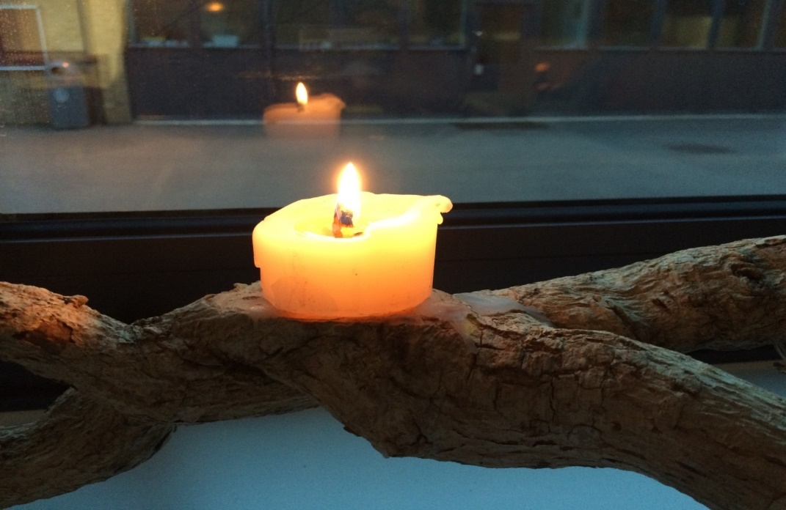
A Theology of Chaplaincy – Rowan Williams
Chaplaincy and Mission – Sarah Watson
A Vital Ministry – Jon Caperon
School Chaplaincy – David Polham
Chaplaincy with Children and Young People – Paul Nash/Nigel Roberts
Fresh Expressions of School Chaplaincy – Diane Tregale
Christian Theology of Chaplaincy Martin Seeley
School-shaped Ministers Lallie Godfrey/Andy Griffiths
Grove Booklets – several on School Chaplaincy
Jesus said, ‘I have come to give you life
in all its fullness.’ John 10.10

