Bishop’s Lent Appeal 2021
An Action a Day

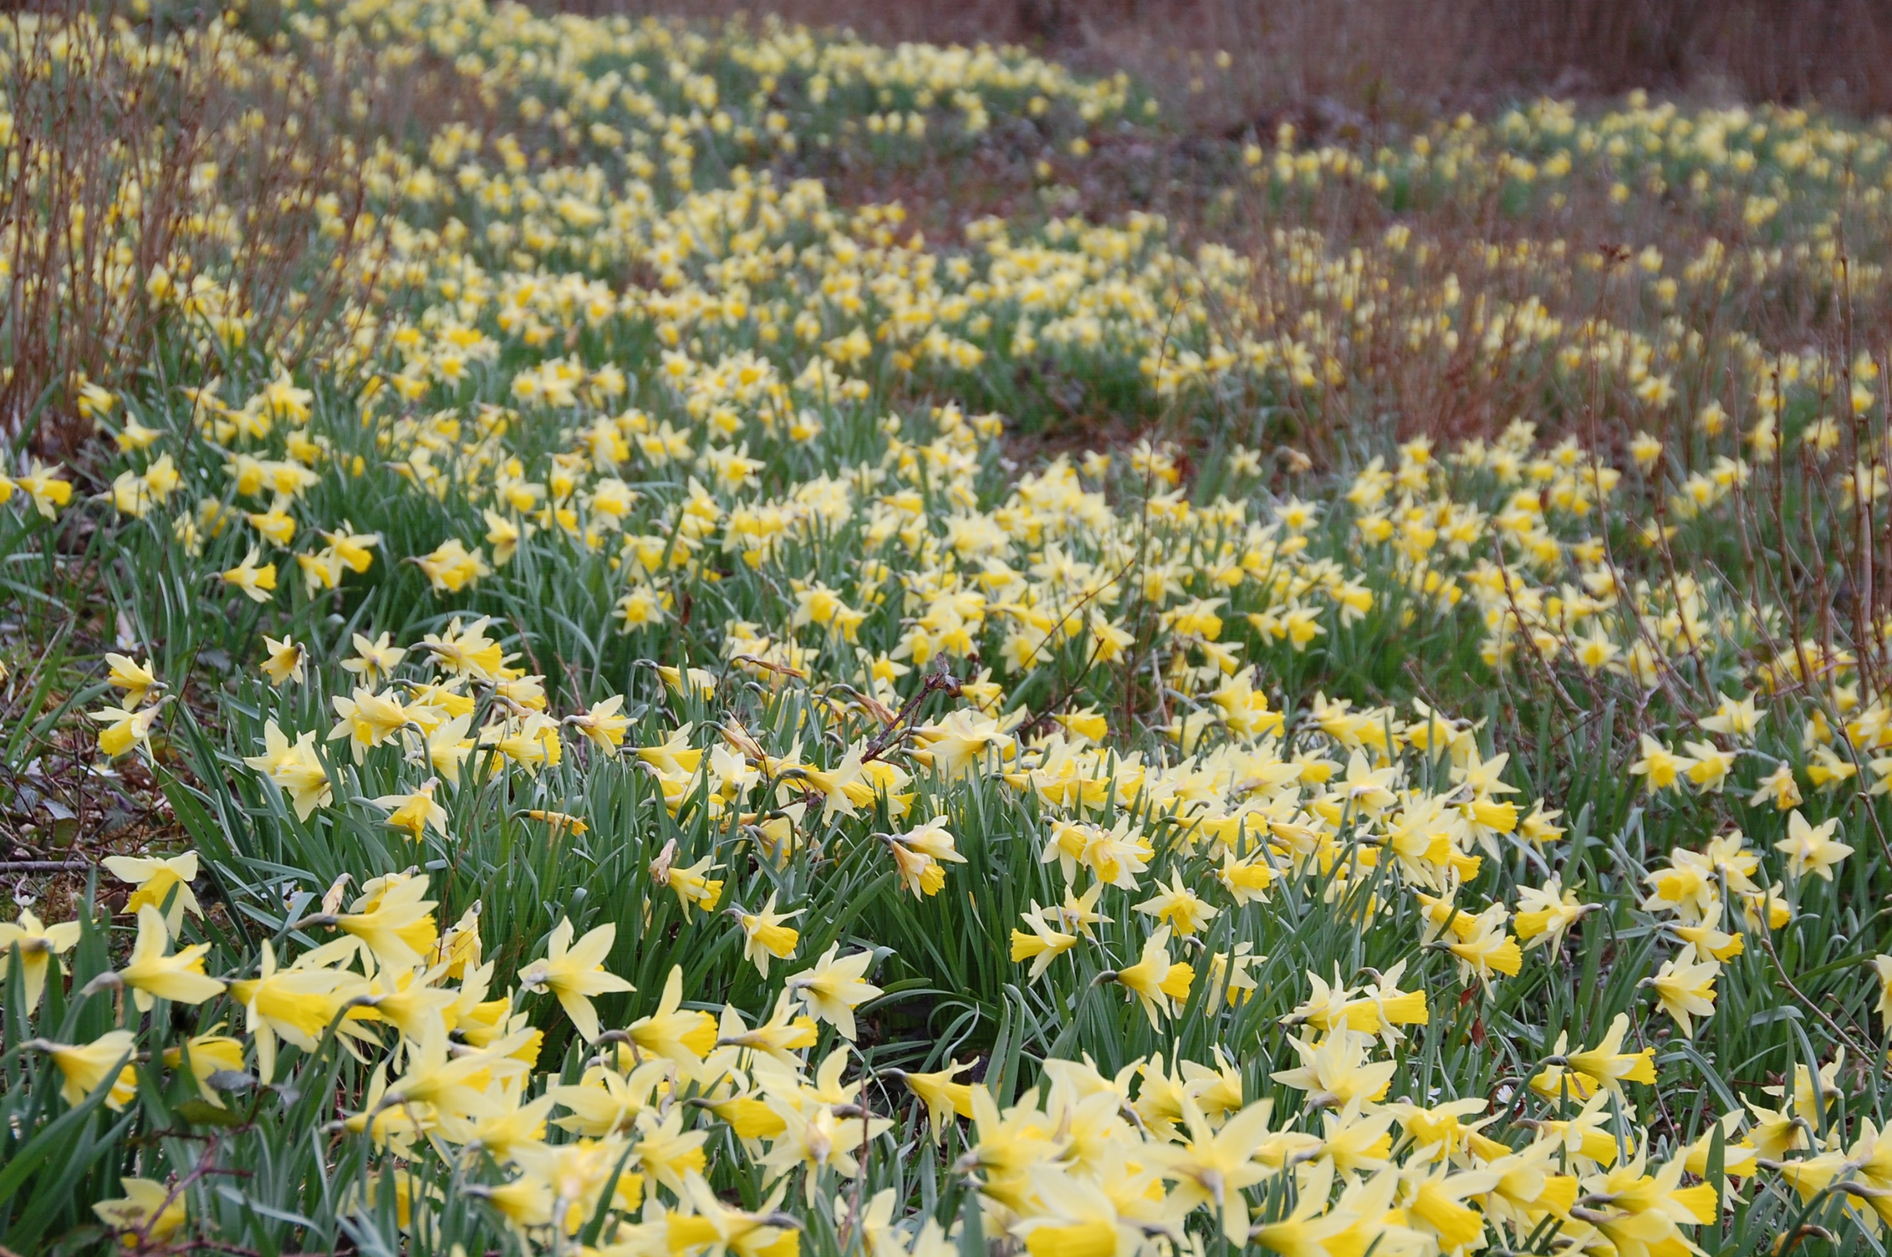
The ‘Lent Action A Day’ activities have been designed so that you can immediately start to live more sustainably and help reduce your impact on the Climate. The activities are family friendly and often ask you to make small changes to your lifestyle or even to reflect on why you do some things. They will not take up a huge amount of time but will hopefully inspire you to examine how your life choices have an impact on the environment. Where possible we have arranged the activities to complement

Date | Action | Why?
Ash Wednesday 17th February | Choose something to give up eating, buying or using. | Human beings and The Earth are closely linked. As consumerism spreads the Earth suffers. To understand our buying behaviour better, take a look at the Diderot Effect.
Thursday  18th February | As part of Fairtrade Fortnight, decide on one item you could replace with a fairly traded substitute. (Coffee and Tea are good examples of Fairtrade products that will make a difference). | Purchasing products that are Fair Trade certified can reduce poverty, encourage environmentally friendly production methods and safeguard humane working conditions.
Friday  19th February | Cutting food miles:  Are you buying food produced as locally as possible? Check the fresh foods packaging in your fridge today to see where the food you have purchased has come from. Can you make a habit of looking for where fresh produce has been grown and try to buy local produce? | Food miles are an important part of the environmental footprint of food production and consumption.
Saturday  20th February | Why not invite a friend to a Zoom Fairtrade Coffee? | This would be a great opportunity to talk about the Bishop’s Lent Appeal; An Action a Day with your friends.

Date | Action |  | Why?
Sunday  21st February | Energy Consumption Action:  Ask everyone in your house to make sure they turn off lights and ‘standby’ on electrical items when they are not in use. |  | Reducing your energy consumption saves money and reduces carbon emissions and air pollution.
Monday  22nd February | We are promoting Meat Free Mondays in Lent. It’s not about going Vegan, but can you limit the amount of meat you eat? This is a chance to reflect on why eating less meat is good for the planet. |  | Eat less meat: UN Climate Change report calls for change to human diet.
Tuesday  23rd February | Switching to low-energy LED bulbs is a small adjustment that could make a big difference. |  | Lighting accounts for 15% of an average household’s electricity bill. It is possible to save money and energy by changing to LED bulbs.
Wednesday  24th February | Consider the impact of your transport choices on climate change. Can you replace a trip with cycling or walking? |  | Cycling or walking particularly reduces your energy consumption, improves your health and lets you take time to wonder at the world.
Thursday  25th February | Transport choices in rural parishes are very limited. Can you think how you might support individuals who want to reduce their Carbon footprint? |  | When the COVID-19 rules allow there are a range of car share options available (LiftShare / GoCarShare) or just offer a parishioner a lift.
Friday  26th February | When you and your family start to think about your holidays can you discuss how you can avoid flying in the future when the COVID-19 restriction ease? This would help reduce your Carbon Footprint. |  | An economy-class return flight from London to New York is equivalent to 11% of the average annual emissions for someone in the UK or about 100% by someone living in Ghana over one year.
Saturday  27th February | Think about how you could reduce your carbon footprint (how much energy you use) during Lent and beyond. Can you change your behaviour to lower your use of energy every-day? |  | You can calculate your own carbon footprint to help you decide.
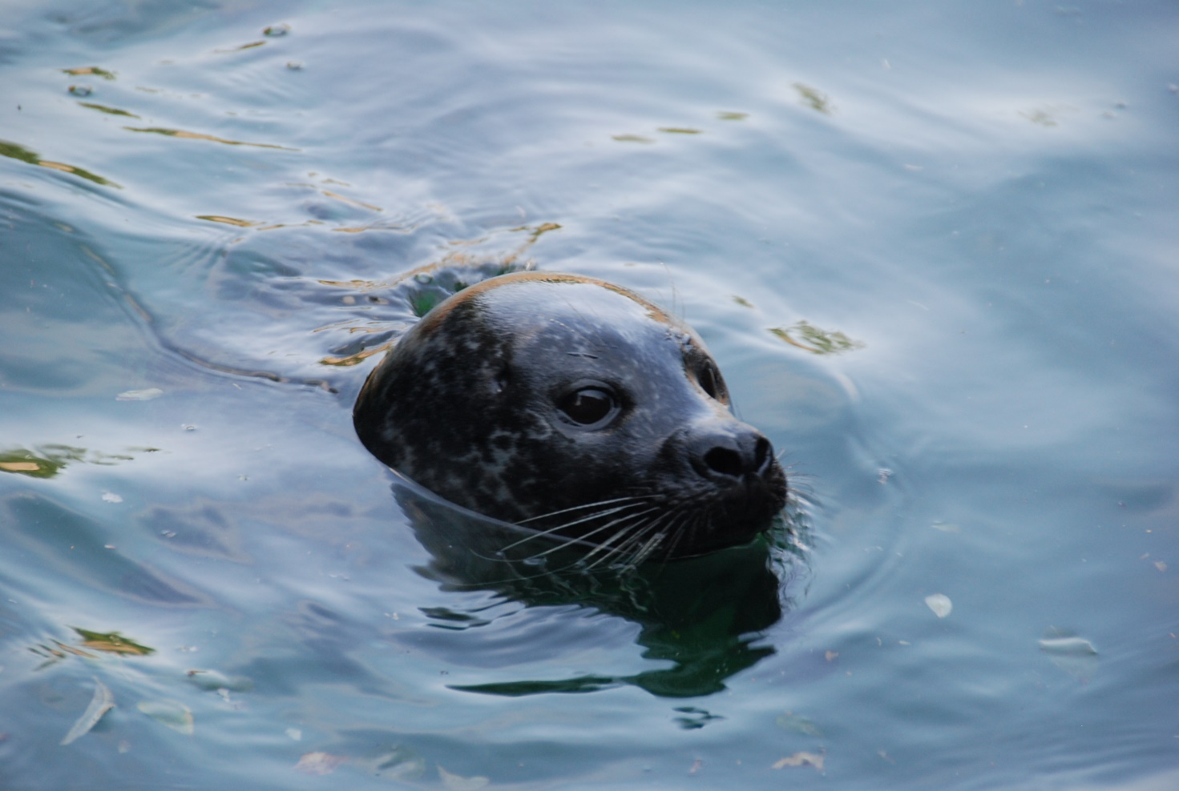  Date | Action | Why?
Sunday  28th February | In preparation for World Water Day (22nd March), count how many tv and newspaper adverts you see asking for help for people suffering dirty water or drought. Pray for those that struggle to access clean water. | Reflect on whether we usually respond with aid, with guilt, with sorrow? Or do we just switch off because we have seen it all before?
Monday  1st March | Try another Meat free Monday, with prayers for the animals in the food industry. | Compassion in World Farming campaign against intensive farming and cruelty against farm animals.
Tuesday  2nd March | It’s surprising how much water is used in the fashion industry. Think about mending or altering items or buy second-hand clothes | It takes 2700 litres of water just to make a cotton shirt.  Why not save your own unwanted clothes to take to a charity shop when COVID-19 rules allow.
Wednesday  3rd March | Fashion, factories and welfare - Can you make more ethical choices even when buying new? Research the ethics behind your favourite brands. | Around 17% of industrial water pollution comes from textile dyeing and treatment.
Thursday  4th March | Prepare for World Water Day (22nd March) by considering how important water is to your home and family life, your livelihood, your cultural practices, your wellbeing, your local environment? | You can join in the conversation about how we value water at the World Water Day discussion.
Friday  5th March | Consider how we waste fresh clean drinking water. Do you often take baths not showers? Today try committing to taking a 4 min only shower. | For free water saving devises and shower timers from “savewatersavemoney.co.uk”
Saturday  6th March | Try drinking just water for a day and calculate how much water you’ve saved. | It takes 140 litres of water to produce a cup of coffee and 30 litres of water to produce a cup of tea.
Date | Action | Why?
Sunday  7th March | Find somewhere today to notice wildlife. If you cannot get out to a wood, park or into a garden look at the birds in the sky, the clouds or the rain and sun. | God’s creation cries out for us to appreciate it. Just being outside in nature and giving time to use all your senses is an act of joy and worship.
Monday  8th March | Our third Meat Free Monday. Try a vegetarian, palm oil free meal with prayers for the dwindling wildlife of the rainforests. | Rainforests are destroyed for many reasons. Only one of those is clearance for farming beef. Experiment with less meat but reflect on the complexity of the issue. What about palm oil too?
Tuesday  9th March | Connect with the source of our food: This is a growing activity. Plant a seed indoors and nurture it over Lent (broad beans are good at this time of year or mustard and cress on a windowsill). Care for a food plant. | The Seed Freedom Campaign brings attention to the crucial role of seed in the battle to defend food sovereignty and food safety. They work against the growing corporate hijacking of our seeds and our food.
Wednesday  10th March | 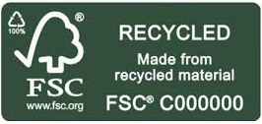  Plan how you will reduce your paper use. Find out which papers are best to use. | Recycling paper and wood products not only makes the best use of the tree (extending the life span of its fibres), it also reduces waste going to landfill sites.
Thursday  11th March | Find a nearby tree. Visit it and commit to protecting it, observing it and seeing it change throughout the seasons. | Remember that just to appreciate Gods World is of value.
Friday  12th March | Ask about Eco Church and what you can do to help. Is your church registered? | This programme is designed to equip your church to express your care for God’s world in your worship.
Saturday  13th March | Eat Seasonal where possible today, especially with fruit and vegetables and salad. Have a look into past diets in Britain. What did the Saxons eat at this time of year? | If you just chose NOT to buy imported Tangerines today that would be an action towards reducing industrial polytunnels and food miles.

Date | Action | Why?
Sunday  14th March | Reflect, pray, recharge. | Reflecting on our actions helps us understand our own behaviour.
Monday  15th March | Our fourth Meat Free Monday in Lent. Try a vegetarian alternative with prayers for the people who legislate about animals in the food industry. | Explore the UN Climate Change Conference COP 26 website and see what actions are planned around the food industry.
Tuesday  16th March | Plan to join the Great British Spring Tidy (28 May – 13 June) if COVID-19 rules allow. But remember it’s not just about tidying it could be sewing a seed- bomb, planting a flowering tree in the church yard or other growing activities. | When people see that an area is cared for it inspires them to respect their environment too.
Wednesday  17th March | Research into why healthy soil is important. Can you help improve soil life in your garden or ask your council about which wildlife friendly horticultural practises they follow. | Consider composting, garden waste, wormeries, removing insecticides, slug pellets or poisons.
Thursday  18th March | Research ‘Permaculture’, ‘Agro-forestry’ and other land restoration movements with positive solutions to environmental challenges. | We must not forget there are solutions to climate change.
Friday  19th March | Can you send prayers to all those who are desperately fighting the Forest Fires World-wide? | There are practical things you can do to help stop the Amazon burning.
Saturday  20th March | Do some research into plastic free alternatives for commonly used items in the home. | This will help prepare for Tuesday’s go plastic free challenge.

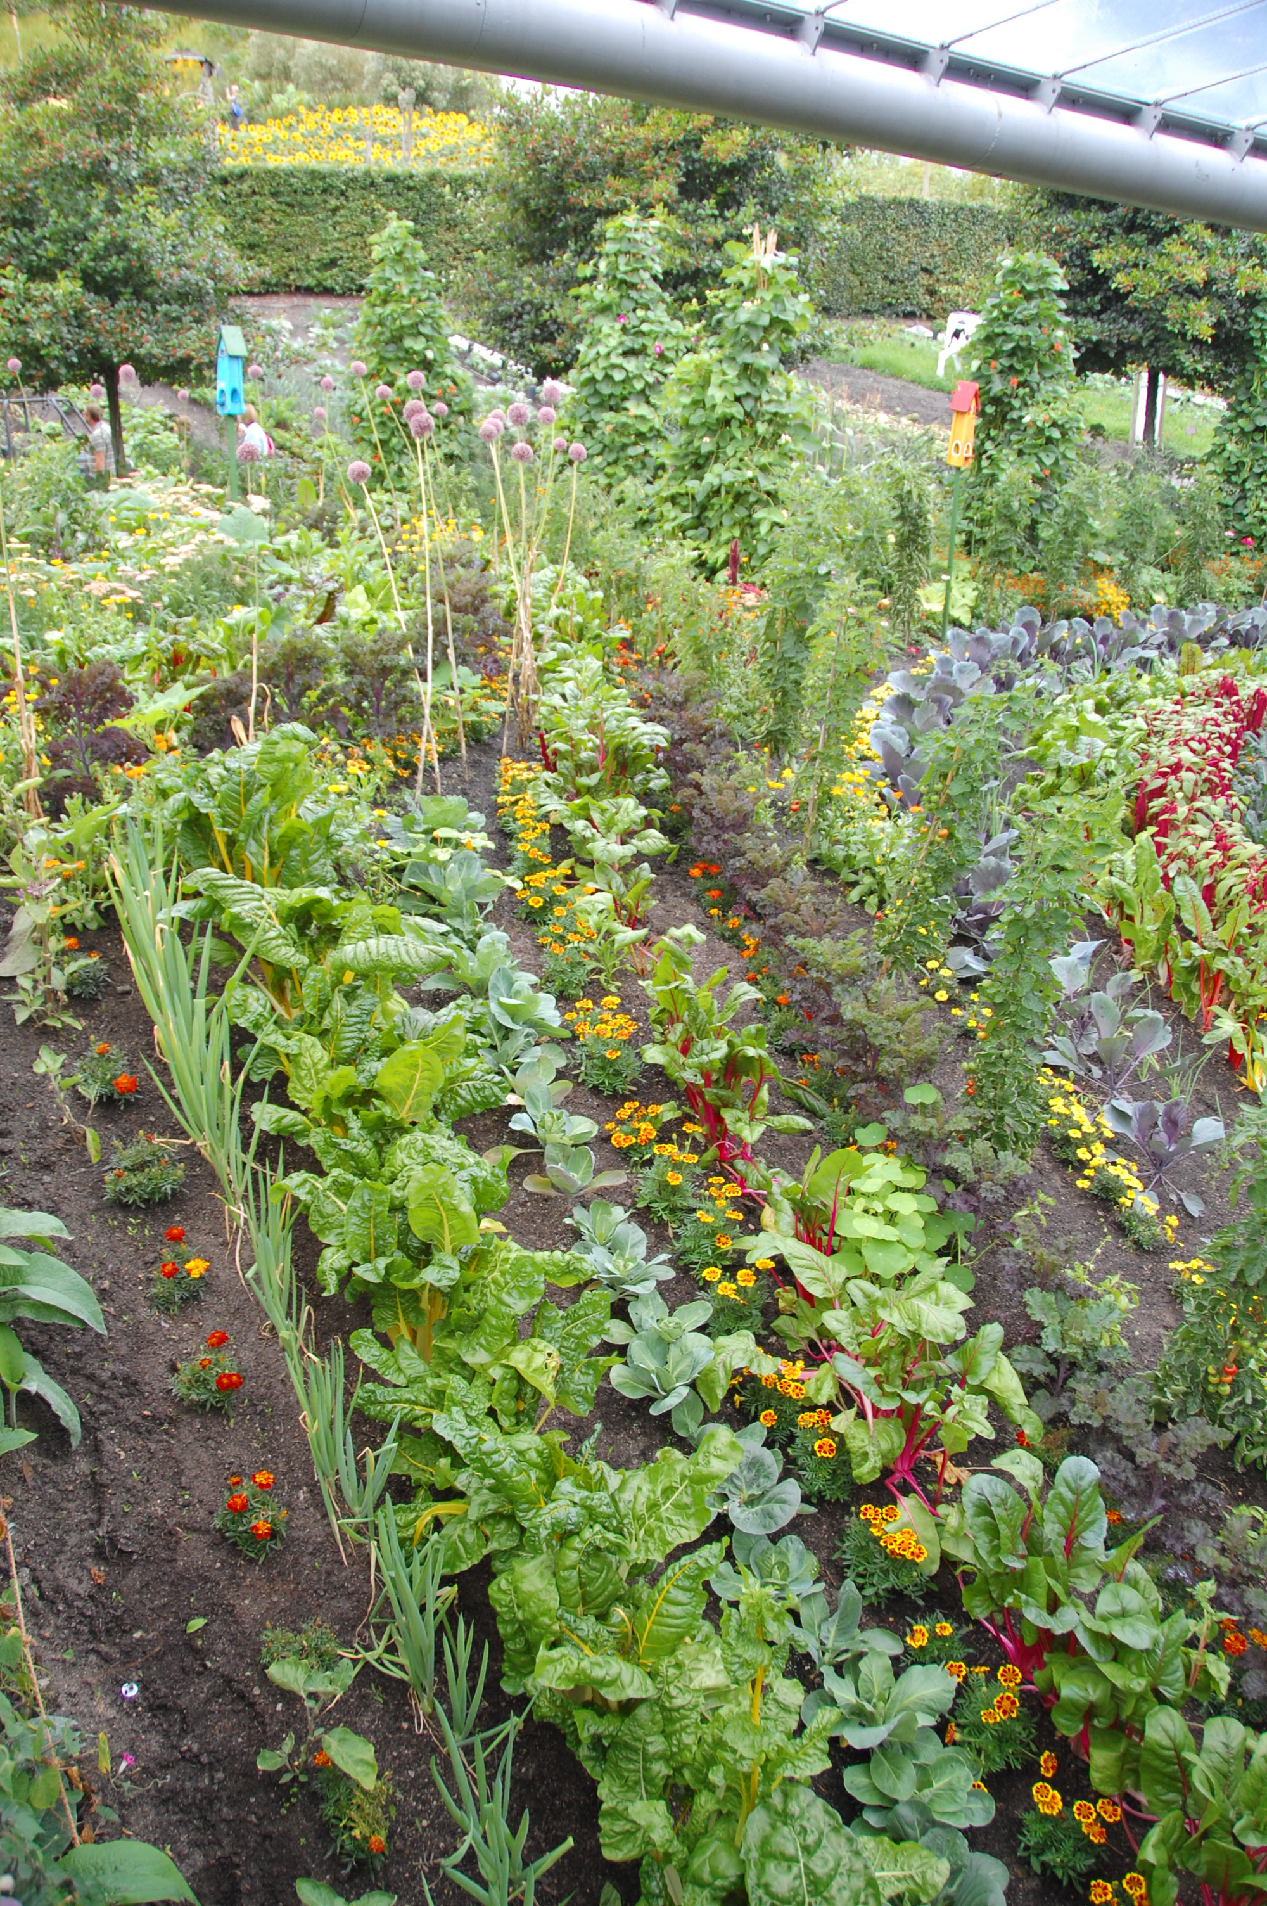
Date | Action | Why?
Sunday  21st March | World Water Day tomorrow:  Start a conversation about World Water Day with prayers for climate policy makers to put water at the heart of their action plans.
Monday  22nd March | Another Meat Free Monday in Lent. Try a vegetarian alternative with prayers for animals in the ocean. | Save the oceans, feed the world.
Tuesday  23rd March | This is your go plastic-free challenge. Choose one item in your house and commit to using a plastic free alternative for the rest of Lent. | Living without plastic: plastic free home
Wednesday  24th March | Our oceans are in trouble. Check your cupboards; do you have any tins of Tuna from an unsustainable source? Will you commit to shopping only for sustainably caught seafood? Ask questions at the fish counter, read the information on canned items. | The Marine Conservation Society has ten top tips on how to buy seafood.
Thursday  25th March | Consider the homeless and displaced from the increasing effects of climate change. | Many of the first communities to suffer the effects of climate change are not those responsible for the worst emissions, flooding, pollution or degradation of our environment.
Friday  26th March | Fish and Sea food free day with prayers of penitence for the polluted oceans | This effects not only our food and the natural abundance of God’s Watery Earth but all those places we visit to swim and sail and paddle.
Saturday  27th March | Do some research today into ocean food chains. Consider how fishing for any one species affects other sea life. Re-watch David Attenborough’s Blue Planet II. | The oceans sustain livelihoods and provides food for millions of people.
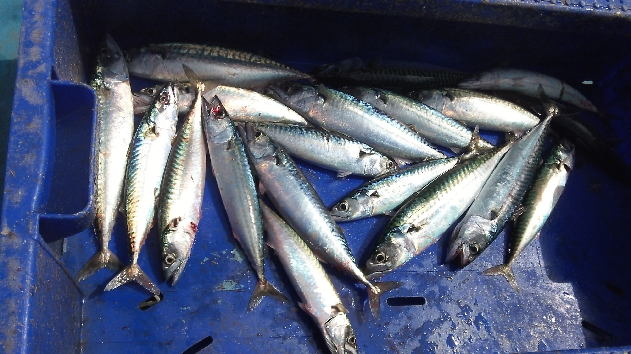
Date | Action | Why?
Sunday  28th March | Think of one positive thing you can do for children you know that would improve the natural world they will inherit from us. | What messages of hope can you bring for them about their environment?
Monday  29th March | Meat Free Monday. Reflect on your research into Compassion for World Farming, The Rainforest Alliance, Fair-Trade, Nature Friendly Farming, Low Food miles. | What food related actions will you continue to follow after Lent?
Tuesday  30th March | Turn your thoughts to wildlife today and the loss of biodiversity (the variability among living plants and animals). Choose one animal that you can learn more about. It might be a hedgehog, or it could be an African Elephant. | Why did you choose this animal? Look into how you could support your animal or its habitat (where it lives). You could donate to a charity, or wildlife hospital, commit to providing food and shelter in your garden or just put up a balcony bird feeder etc.
Wednesday  31st March | Reflect on your actions,  what did you give up for Lent?  Why did you choose it?  How easy was it to give up?
Thursday  1st April | Reflect on if you pay enough attention to the way your food is produced and supplied. What could you do to help find a sustainable future?
Friday  2nd April | Will you make a commitment to  act against Climate Change?
Saturday  3rd April | Buy nothing today! Take a day off being a consumer.  Remember the Diderot Effect.
Sunday  4th April | How will your behaviour reflect your care for God’s creation?

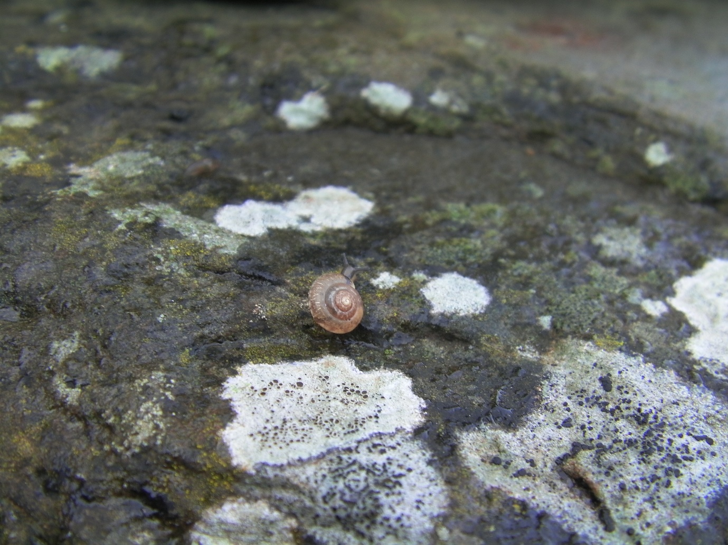

This document has been produced by the Portsmouth Diocese Environmental Advisory Group
The members of the Diocese Environmental Advisory Group are:
- Mrs Rachel Houlberg, Secretary to the Bishop of Portsmouth
- Dr Sara Collins, The Eco Urban Ranger
- Mrs Janet Hammerton – The Sustainability Centre, GU32 1HR
- Rev Alison Morley, Vicar of Seaview, St Helens, Brading and Yaverland Benefice
We would love to hear how you found the Lent Actions. It would be great if you could send any stories and photo’s to Rachel so that we can publish them on the Diocese website. Thank you for taking part.

