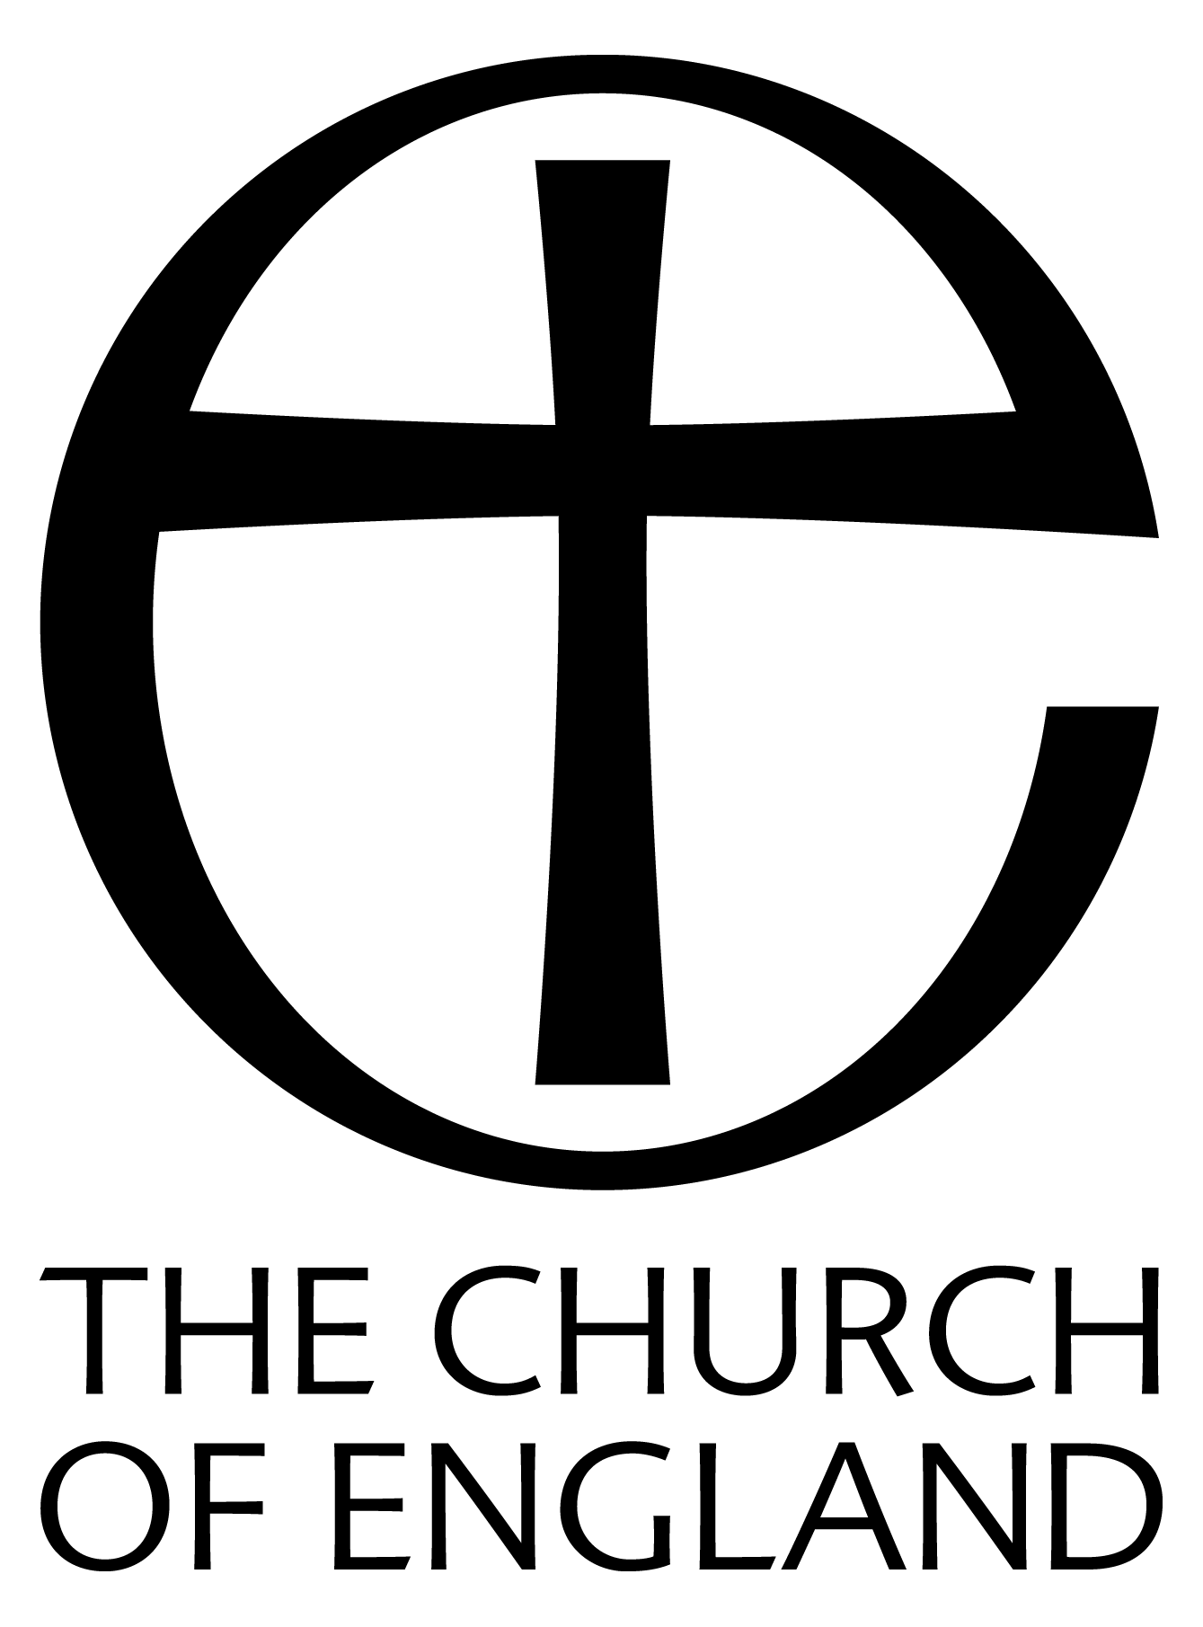

THE ELECTORAL ROLL

– what is it?

- what effect will GDPR, (General Data Protection Regulation) have on the Electoral Roll

- the Annual Revision

- New Roll Preparation - (every 6 years)

What is the Electoral Roll? - the Electoral Roll is a membership list of those who consider themselves committed members of their respective parish, and as such gives them the opportunity to have their say and also vote at the Annual Parochial Church Meeting, (APCM).

More formally - the Electoral Roll is used to determine eligibility for attendance and participation at the APCM and for election to the parochial church council (PCC). It is also used to determine eligibility for election to the deanery, diocesan and general synods. In addition it is used for the calculation of the number of representatives who may be elected to each of these synods.

GDPR and the Electoral Roll
Since the Church Representation Rules, which govern practice in relation to the Electoral Roll and Annual Parochial Church Meetings, are a Church of England Measure, they form part of the law of the land, and so the principal basis for the data processing is legal obligation not consent.

The objective of the Electoral Roll is to elect representatives to the PCC, and to vote at APCMs.

Publishing the Electoral Roll
The Church Representation Rules (CRR) require that:-

“(11) The roll shall where practicable contain a record of the address of every person whose name is entered on the roll . . ."
and
"(3) After the completion of the revision, a copy of the roll as revised shall, together with a list of the names removed from the roll since the last revision (or since the formation of the roll, if there has been no previous revision), be published by being exhibited continuously for not less than fourteen days before the annual parochial church meeting on or near the principal door of the parish church in such manner as the council shall appoint."

The forms and full GDPR guidance are published on both the Parish Resources website:-
www.parishresources.org.uk/pccs/apcms/

and the Portsmouth Diocesan website:-

www.portsmouth.anglican.org/PCC-secretary/

which also includes the 2019 Application for Enrolment on the Church Electoral Roll – Form C including Privacy Notice in an easy printable format.

Please note that when the Roll is prepared, the addresses and contact details of the members should be included ‘where practicable’, but the published Roll should only include names.

This guidance is reflected in the official guidance supplied by the Church of England.
ELECTORAL ROLL - REVISION

The electoral roll is revised annually. A notice, announcing the revision of the roll, (available at www.portsmouth.anglican.org/PCC-secretary/ as Form B or www.parishresources.org.uk/pccs/apcms/) should be displayed on or near the church door for at least 2 weeks before the commencement of the revision.

The only people who need to fill in an application form - available from the website above - are those who have recently moved into the parish, joined the church, or reached the age of 16.

Announcements should be made in church each Sunday during the 14 days the notice is displayed.

The revision should be completed not less than 15 days or more than 28 days before the Annual Meeting (which must take place before 30 April).

During this period, corrections may be made, but no names may be added or removed between the time that the revised roll is completed and the close of the Annual Meeting.

The Church Electoral Roll Certificate - available from the websites above - should be completed and signed immediately after your APCM

No later than 01 June 1 copy should be returned to:-

The Electoral Roll Officer
Diocese of Portsmouth
1st Floor
Peninsular House
Wharf Road
Portsmouth
PO2 8HB

The 2nd copy should be put up on or near the principal door of the Parish Church for a period of 14 days.

Copies should also be fixed to the doors of any daughter churches in your parish as the number certified should include any daughter churches.

Each Parish should have only one electoral roll, even if there is more than one place of worship within the Parish.

Ensure that the name of the Parish and Deanery are clearly indicated on the Church Electoral Roll Form.

The timetable below will help the preparation run smoothly.

Timetable : Electoral Roll - REVISION

ACTION /  EVENT | WHEN IT NEEDS TO HAPPEN | DATE IN YOUR PARISH
Put up notice regarding the revision | At least 14 days before the start of the revision
Complete the revision | A fixed date 15 to 28 days before the APCM
Display the revised roll with a list of those names removed | At least 14 days before the APCM
Annual Parochial Church Meeting (APCM) | By 30th April

NEW ELECTORAL ROLL - PREPARATION

New electoral rolls are prepared every 6 years, as from 2019 the following dates will be 2025; 2031; 2037; 2043; 2049; 2055; 2061; 2067; 2073; 2079 and so on.

A notice should be displayed on or near the main door of every Church of England church in the parish, (available at: www.portsmouth.anglican.org/PCC-secretary/ - Form A or www.parishresources.org.uk/pccs/apcms/). This needs to be done at least 2 months before the Annual Parochial Church Meeting (APCM) and has to stay up for at least 14 days.

Once the notice is up, the preparation of the new electoral roll begins.

During the 14 days while the notice is up, whoever is conducting services at the church needs to announce to the congregation that the new roll is being prepared.

The PCC needs to ensure that reasonable efforts are made to let everyone on the old electoral roll know that a new one is being prepared. These steps do not have to be taken for anyone who is no longer qualified to be on the roll, i.e. anyone who has become a clerk in Holy Orders or anyone living outside the parish who no longer worships regularly in the parish.

During the period of preparation of the roll, members on the previous roll need to apply to be included - inclusion is not automatic.

New people can also apply during this period. A person applies by filling out a Application for Enrolment on the Church Electoral Roll including Privacy Notice -available from the website above. The preparation of the roll needs to be completed by a fixed date between 15 and 28 days before the APCM.

As with the annual revision, once the roll is complete a copy needs to be put up on or near the main door of the parish church, for at least 14 days before the APCM.

During this time corrections may be made to the entries on the roll, for example how a name is spelt or amending the details of an address. No names can be added or removed during this period, this can only happen after the APCM.

The Church Electoral Roll Certificate - available from the website above - should be completed and signed immediately after your APCM.

No later than 01 June 1 copy should be returned to:-

The Electoral Roll Officer
Diocese of Portsmouth
1st Floor
Peninsular House
Wharf Road
Portsmouth
PO2 8HB

The 2nd copy should be put up on or near the principal door of the Parish Church for a period of 14 days.
Copies should also be fixed to the doors of any daughter churches in your parish as the number certified should include any daughter churches.

Each Parish should have only one electoral roll, even if there is more than one place of worship within the Parish.

Ensure that the name of the Parish and Deanery are clearly indicated on the Church Electoral Roll Form.

The timetable below will help the preparation run smoothly.

Timetable : New Electoral Roll Preparation

ACTION /  EVENT | WHEN IT NEEDS TO HAPPEN | DATE IN YOUR PARISH
Put up notice | At least 2 months before the APCM
Announcements during services | The 1st 2 Sundays once the notice is displayed
PCC informs those on the previous roll | Once the notice has been displayed
Completion of the roll | A fixed date 15 to 28 days before the APCM
Display the completed roll | At least 14 days before the APCM
Annual Parochial Church Meeting (APCM) | By 30th April

All the necessary forms are available to download from:-

www.parishresources.org.uk/pccs/apcms/ and

www.parishresources.org.uk/pccs/apcms/

If you require any further assistance please contact Jane Dobbs:-

Tel: 023 9289 9661 or email: jane.dobbs@portsmouth.anglican.org

