Our Ref: S.69 VJ/JD

02 November 2018

To: Laity Members of the Diocesan Synod

Dear

Vacancy in See Committee - Election of 2 laity members

Further to my letter of 03 October 2018 asking for nominations for the above, I have received 3 laity nominations from the Archdeaconry of the Meon.

As representation from the house of laity is limited to 2 per Archdeaconry there will need to be an election.

An election for the remaining places is to be held using the approved Church of England system of Single Transferable Vote.

It is important to read the instructions on the voting form before casting your vote.

Your voting form is printed below, and, where received, manifestos from the candidates are enclosed.

Please also remember to sign, print, and fill in your deanery in the space provided at the bottom of the voting paper to validate your vote. If you accidentally spoil your ballot paper or wish to correct an error, return your paper to Jane Dobbs and she will supply a replacement.

Completed voting forms must be returned to the Diocesan Secretary at the address below, by not later than 12.00 noon on Monday 26 November 2018. Any papers received after this time will not be counted.

Thank you.
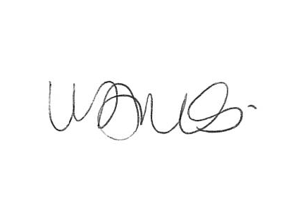
Diocesan Synod Secretary
Enc

1st Floor, Peninsular House Wharf Road Portsmouth PO2 8HB TEL: 023 9289 9655
Email: victoria.james@portsmouth.anglican.org Website: www.portsmouth.anglican.org
(A company limited by guarantee Registered in London No. 226466 Charity No. 249256)

VACANCY-IN-SEE COMMITTEE

ELECTION – HOUSE OF LAITY

Vote for 2 candidates only

Vote by placing:- ‘1’ against the candidate of your 1st choice;

and

‘2’ against your 2nd

Remember that :- you MUST number your preferences as above or your ballot paper will be declared invalid;

DO NOT votes using ‘X’s as this will make your vote invalid.

CANDIDATES | ARCHDEACONRY | MARK YOUR VOTE IN THIS COLUMN
NORMAN CHAPMAN | MEON
LUCY DOCHERTY | MEON
STUART FORSTER | MEON

Signature of Voter ____________________________

Name of Voter (Please print clearly)____________________________

Deanery of Voter ________________________________

Voting Forms to be returned to:- Mrs Victoria James
Diocesan Secretary
1st Floor
Peninsular House
Wharf Road
Portsmouth
PO2 8HB

VACANCY-IN-SEE COMMITTEE
Norman Chapman – Licensed Lay Minister (Reader) PTO
Lay-Chair Bishop’s Waltham Deanery Synod
Current member of Vacancy –in – see Committee
Member Bishop’s Council
Chair Diocesan Property Committee
Member Diocesan Mission & Pastoral Committee
Parish PCC Secretary/Chair.

I am retired from full time employment using my talents to work with the Christian Community in the Diocese.
I have from my last professional employment extensive experience in selecting persons for various forms of employment.

Norman Chapman 26th October 2018

Vacancy in See Manifesto - Lucy Docherty
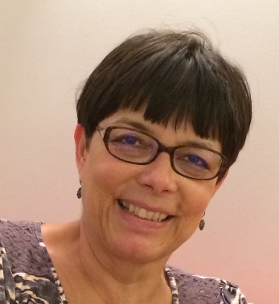
School governors are often told that the most important role they may be called on to undertake is to select a new headteacher, for their decision will set the direction of the school for the next few years. The same is true for all those involved in the selection of a diocesan bishop and I would like to offer my services to represent the people of the Archdeaconry of the Meon when the need next arises – hopefully, not for a considerable while – to choose a new Bishop. I believe most firmly that this process of selection must be more than a “job interview”. In the first place the people of the diocese (both within and outside the church) must be given an opportunity to express their views and concerns which will then form part of the Vacancy-in-See committee’s prayerful discernment about the priorities and challenges for the next diocesan bishop’s ministry. This will then lead to the identification of the skills and gifts he or she is likely to need in order to be the right shepherd for the people of our Portsmouth diocese.
I offer myself for this crucial role because I believe I have the right skills and experiences to accomplish the task. I represent my parish (Holy Trinity with St Columba in Fareham) on Deanery Synod; am an elected member of Diocesan Synod and Bishop’s Council; and, from 2007-2015 I was the lay chair of Diocesan Synod. I have also represented our diocese as a lay member of General Synod since 2007. Throughout all this time I have taken every opportunity to listen to people carefully when they have wanted to talk to me about issues within and outside the church and to reflect these views back to the right audiences at the right time. In my professional career, largely within the NHS, I have spent most of my time working in governance and strategic planning roles. My experience in these roles has given me a good grounding in the thinking needed to consider the strategic concerns of our diocese. But as well as working at a strategic level I have also worked closely with the public and patients to help them understand the future plans and structures of the local NHS and have tried to ensure that people feel we have listened to them. I have also had a lot of experience in both the NHS and the Church at national and diocesan level of appointing candidates to senior positions.
Should I be elected I will do my utmost to ensure that all views and voices in our diocese are heard in the Vacancy in See committee and are reflected in our thinking.
I ask that you consider giving me a high preference in your vote. Thank you.

Stuart Forster

I have been involved with my local church as well as deanery and diocesan roles (please see below) for many years and believe that this gives me a good background and the experiences required to serve if required on the Vacancy in See Committee.

In my local church, Crofton Parish Holy Rood with St Edmunds, in Stubbington I have served since 1996 as a member of the PCC and served 7 years as Parish Treasurer. At Deanery level I am a member of the Deanery Synod and am the Deanery Treasurer and a member of the Deanery Standing Committee. In addition I am the Chair of the Deanery Finance Committee and represent the Deanery on the Diocesan Finance Committee.

I am a member of Diocesan Synod and a member of Bishop’s Council. In addition I am the current Chair of the Diocesan Patronage Board. The Bishop appointed me a Lay Canon of Portsmouth Cathedral, in which role I attend Cathedral services at least once a month.

I believe it’s important to also be involved in activities outside church. After early retirement from paid employment I became a school governor at my local Primary School (Woodcot). Although not a church school I regard it very much as part of God’s calling for us to be involved in the wider world. As well as Governor Duties I volunteer for one to one reading with the children normally on a Friday afternoon. I have been asked to say prayers at Friday assemblies.

I am a member Hampshire Constabulary’s Independent Advisory Group and am currently Vice Chair of the Fareham and Gosport Group. This involves regular meetings with members of Hampshire Constabulary (at all levels) to give an Independent view about Policing. By asking challenging questions we help the Police interact with the Public in a better and understandable way, for example less use of Police jargon. We also monitor and review Stop and Search records, Domestic Abuse and Hate Crime records. We have made some suggestions about the local process itself as well as provided a level of re-assurance to senior management.

Although this is a committee I hope will not be required to meet for some considerable time, when required it’s important to have membership to reflect the diocese as a whole, attending Crofton Parish and the Cathedral I believe helps to give me a broad perspective of the Diocese.

