Our Ref: S.69 VJ/JD

02 November 2018

To: Clergy Members of the Diocesan Synod

Dear

Vacancy in See Committee - Election of 2 clergy members

Further to my letter of 03 October 2018 asking for nominations for the above, I have received 4 nominations, 2 from the Archdeaconry of the Meon and 2 from the Archdeaconry of Portsdown, so as there only needs to be 1 clergy representative from each Archdeaconry there will need to be an election.

An election will now need to be held.

This election would usually be held using the approved Church of England system of Single Transferable Vote, but as this election will be for 1 candidate out of 2 from each archdeaconry as above, a simple cross to mark you preference will suffice.

It is important to read the instructions on the voting form before casting your vote.

Your voting form is printed below, and, where received, manifestos from the candidates are enclosed.

Please also remember to sign, print, and fill in your deanery in the space provided at the bottom of the voting paper to validate your vote. If you accidentally spoil your ballot paper or wish to correct an error, return your paper to Jane Dobbs and she will supply a replacement.

Completed voting forms must be returned to the Diocesan Secretary at the address below, by not later than 12.00 noon on Monday 26 November 2018. Any papers received after this time will not be counted.

Thank you.
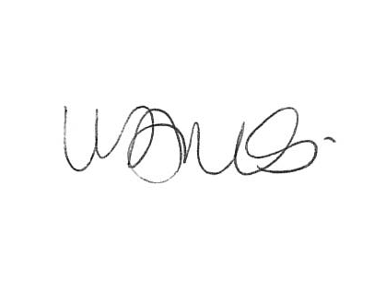
Diocesan Synod Secretary
Enc

1st Floor, Peninsular House Wharf Road Portsmouth PO2 8HB TEL: 023 9289 9655
Email: victoria.james@portsmouth.anglican.org Website: www.portsmouth.anglican.org
(A company limited by guarantee Registered in London No. 226466 Charity No. 249256)

VACANCY-IN-SEE COMMITTEE

ELECTION – HOUSE OF CLERGY

Vote for no more than 2 candidates remembering that you MUST pick at least 1 candidate from each archdeaconry

Vote by placing:- ‘X’ against the name of your chosen candidate

CANDIDATES | ARCHDEACONRY | MARK ‘X’ IN THIS COLUMN
GAVIN FOSTER | MEON
WILLIAM HUGHES | MEON
CANDIDATES | ARCHDEACONRY | MARK ‘X’ IN THIS COLUMN
PAUL ARMSTEAD | PORTSDOWN
MICHAEL DUFF | PORTSDOWN

Signature of Voter ____________________________

Name of Voter (Please print clearly)____________________________

Deanery of Voter ________________________________

Voting Forms to be returned to:- Mrs Victoria James
Diocesan Secretary
1st Floor
Peninsular House
Wharf Road
Portsmouth
PO2 8HB

Election for the Vacancy-in-See Committee

The Revd Canon Paul Armstead
Priest in Charge of St James, Milton, (Portsmouth Deanery)

I would be delighted if you would consider casting your vote to enable me to be a member of the Vacancy-in-See Committee, should it need to be constituted.
A member of this Diocese since 2012 and ordained in 2008, I have brought to my ordained life the previous experience of finance and governance as a chartered accountant with my own practice. I have been a member of the Bishop’s Council since 2015.
As well as being the priest in charge at St James, Milton, I am a member of the Deanery Standing Committee, Succentor at the Cathedral, the Bishop’s Deliverance Officer, and, for the national church, a trustee of one of the residential theological colleges. This year I was installed as an Honorary Canon of St George’s Cathedral, Ghana. I believe that my ‘interests’ are such that bring a wider as well as parish priest’s perspective to the needs of the Diocese for the future.
As the chair of the planning group for this autumn’s Diocesan Conference, I have been reminded of the breadth of gifts and expressions that our Diocese possesses and how we can celebrate these and hold them together.
As a part of that journey, this parish is taking a full part as we prepare to launch a brand new initiative called ‘Choir Church’ which takes a pioneering approach through the medium of music to build a brand new worshipping community within the city. A very exciting development.
In standing for election to the Vacancy in See Committee, I seek to reflect the experience of a parish priest who’s ministry is centred in the sacramental life of the church and to be a voice for those who are in parish ministry in all its variety.
Thank you for taking time to read this and considering how to cast your vote.

Paul

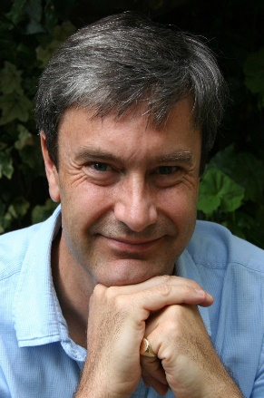
Revd Canon Mike Duff – Vicar, St Jude’s, Southsea

A little about myself:- I’m married to Rachel and we have two grown-up children. I’ve worshipped in urban, inner-city, suburban, city-centre & village settings, and in catholic, traditional & evangelical congregations. Before ordination, I worked in database software and ran a Christian Arts Centre. Following my curacy in Southsea, we moved to Indonesia with CMS where I was responsible for national theological training & liaison with the diocesan leadership in Singapore, and was on the international synod.
Back in Southsea, I lead a lively congregation with a strong children & youth ministry including a foundation school and a PCC-owned Nursery. We are in mission partnership with our neighbouring parish, St Simon’s, and as requested by the deanery have planted a new congregation at St Margaret’s, Southsea. The ministry of women at every level is long established at St Jude’s.
In the Diocese, I’ve been Associate Area Dean for Portsmouth Deanery for 7 years, serving on the Standing Committee, Diocesan Synod & Bishop’s Council. I’ve co-led a youth project to our link diocese of Ho and contribute significantly to our exciting Deanery Plan for growth & renewal blending youth/older persons chaplaincy projects, parish partnerships, deanery clusters & congregation planting. Beyond the Anglican family, I’ve been Area Advisor for Alpha and developed relationships with churches in Portsmouth and across the Diocese, through networks like Churches Together & New Wine.
As a member of the Vacancy in See committee I look forward to representing the breadth of parish life & mission, drawing on 19 years deepening relationships across the Diocese and participation in its strategic leadership.
- I passionately believe in the local church as the place of God’s compassion, healing & liberation. I’m interested in creative expressions of outreach & discipleship, affirm wholehearted worship of in whatever style, have experience of the world-wide church & understand the principles of cross-cultural mission as applied to fresh-expression.
- I want to see the growing unity of Christ’s church within and beyond the Church of England based in shared ministry, honest & honouring relationships, and mutual hospitality in Christ’s name.
- I love our diocese and the vibrant city of Portsmouth, and long to see the church here grow in strength, confidence and impact.
I hope you might consider voting for me as your first preference.

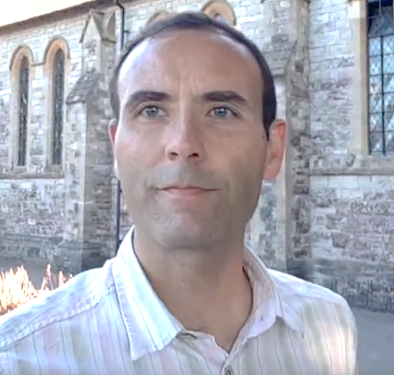
The Reverend
GAVIN FOSTER

Candidate for the
Vacancy in See Committee

I believe in good leadership. God has always given his people the gift of leaders. Good leadership enables God’s people to flourish, the good news to be proclaimed and lives and communities to be transformed. Appointing a new bishop to lead a Diocese is one of the most important decisions the church can make.

If a vacancy arises, I believe we will need someone who is:
- a sold-out friend and follower of Jesus
- filled with the Holy Spirit, living each day in response to the promptings of the Spirit
- committed to sharing the good news and to making disciples of Jesus
- growing in holiness and continuing to learn
- a student of scripture and a guardian of the faith we have inherited
- a leader and an encourager
- creative and innovative

As a former Bishops Chaplain and (even earlier) a former barrister with an interest in Canon law, I believe I have the skills and experience to navigate the procedures and committees of the Vacancy in See process at Diocesan and national level, and to ensure that we prayerfully discern the bishop God is already preparing for us.

Please vote for me for the Vacancy in See Committee.

31 October 2018

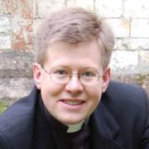
Rev’d Canon Will Hughes
I am the Vicar of Petersfield and Rector of Buriton, in the north of the diocese.
I’ve been a parish priest in the diocese of Portsmouth for 12 years. I know and love this diocese- its parishes, people and geography, but equally importantly its unique character, its approach to life and faith, and its unity and openness, all of which we saw embodied at the diocesan conference in September.
I’ve been deeply involved in the diocese for some time, on Bishop’s Council, Diocesan Synod, DBE, Vocations boards, as Area Dean and as a Canon of the Cathedral. I remember what the diocese felt like in its last vacancy, after Bishop Kenneth left, and have admired the growth and culture created by Bishop Chris’ leadership. I’ve worked with neighbouring dioceses, and seen the different styles of episcopate and their impact on the dioceses. This have given me a strong awareness of the way the appointment process shapes the future of a diocese, and how important it is that those who choose our next Bishop have a strong awareness of the diocese- its needs, strengths and possibilities.
Should it be needed, the Vacancy in See committee must be able to give the Crown Nominations Committee the information it needs to make the right appointment for Portsmouth. I’d be honoured to help make sure this happens. Please vote for me.

