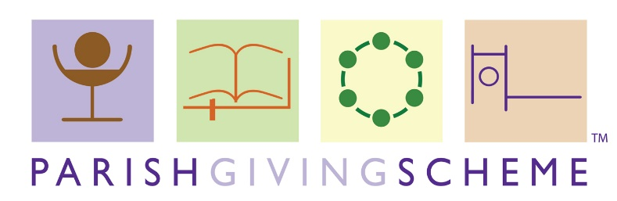
RESOURCES REQUEST
Church Name
Delivery Address Resources *
Contact Name
Contact Number

Resource | Quantity Required
Donor Gift Form
Donor Information Booklet
A Better Way to Help Your Local Church Leaflet
Tokens
Parish Labels (for gift forms)

Please allow a week for your resources to be prepared.
To avoid postage costs it is preferable if materials can be collected from the Diocesan Office by a parish member if this is achievable. If there is a member of staff from the Diocesan Office in your local area, then we will do what we can to deliver the resources by hand.

