A class reflection based on ‘Voices in the Park’
by Anthony Browne
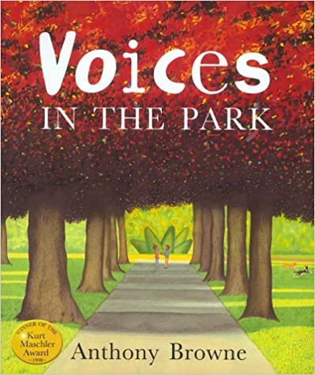
Teacher notes
There are lots of themes you could explore in this classic book, such as not judging by appearances, community, hope or friendship. There is an excellent version of the story on Anthony Brown’s website, filmed with the Adriamus Ensemble; it’s too long to use in collective worship time, but could be useful if you wanted to spend more time looking at the different characters. The link on the PowerPoint takes you to a shorter version from the Hamilton Trust.

Introduction
Unpeel an onion and show the class its different layers. Shrek says that ‘Ogres are like onions’ what do the class think he means by this? You could either show them this clip now, or use it in a follow up discussion. PowerPoint Slide 1

Alternatively, show PowerPoint Slide 2. Have the children heard the phrase ‘Don’t judge a book by it’s cover’? What do they think it means? Can they think of any examples from books or films about people who’ve jumped to conclusions about someone else? Do they think you can tell what someone is like from first impressions? When might this be unhelpful?

Voices in the Park
PowerPoint Slide 3. Ask the children to look out for characters who make hasty judgements about others, based on the way they look or how they talk.
For example, Charles’ mother refers to Albert as a scruffy mongrel and says there are some ‘frightful types’ in the park. Charles is disappointed that Smudge is a girl and she thinks he is a wimp to start with.
Do any of the characters change their mind about the others? (Charles and Smudge) What makes them change their opinion?
Why do the children think that Charles’ mother continues to judge Smudge and her family? What would need to happen for her to change her mind?

Bible Reading
PowerPoint Slide 4.
Read these words, based on the Message version of Matthew 7 (or ask a child to do so.)
A simple guide for behaviour
Don’t pick on people, jump on their failures, criticise their faults – unless, of course, you want the same treatment. That critical spirit has a way of boomeranging. It’s easy to see a smudge on your neighbour’s face and not notice the ugly sneer on your own. Do you have the nerve to say, ‘Let me wash your face for you,’ when your own face is full of contempt? Wipe the ugly sneer off your own face, and then you might be fit to offer a washcloth to your neighbour.’

Final Reflection
PowerPoint Slide 5.
Smudge’s father says that ‘You’ve got to have a bit of hope, haven’t you?’
Where is there hope in the story? (The children and dogs enjoy playing together, Charles hopes to see Smudge again and gives her a flower. She cheers her Dad up and makes him a cup of tea….)
Do the children think there’s any hope for the adults in the story? What might happen to make them change?

Prayer
Pray these words, or ask a child to. Ask them to say Amen at the end, if they agree with the prayer.
Thank you, God, that there is always hope.
Please help us to be like Charles and Smudge and not judge other people by appearances.
Help us to get to know people, before we judge them.
We pray that people like Charles’ mother would be able to change, so that they are more open to people who are different from them.
Amen

