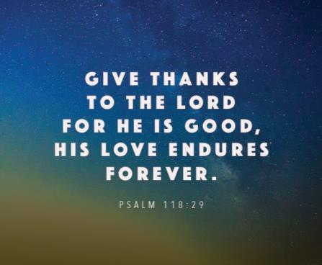

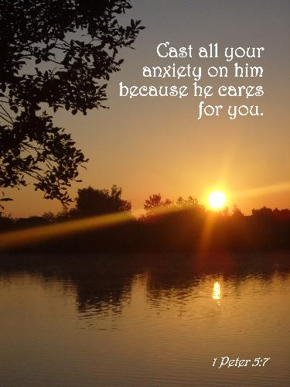

[](https://www.google.co.uk/url?sa=i&url=https%3A%2F%2Fwww.iemoji.com%2Fview%2Femoji%2F56%2Fsmileys-people%2Fthumbs-up&psig=AOvVaw0ZP8C5GuwI_HtN5oJUp_Bq&ust=1597392436387000&source=images&cd=vfe&ved=0CAIQjRxqFwoTCMjNkdjcl-sCFQAAAAAdAAAAABAD)

**Thumbs up prayers**

**Teacher Guidance**

**Context:** This prayer activity involves children using their hands to remind them how they can pray.

**You will need:** paper, pencils, scissors

Give each child a piece of paper and ask them to draw around and cut out the shape of their own hand. On the four fingers they can write:

* something to praise God for
* something to thank God for
* something for which they would like to ask God’s help
* something they would like to say sorry about

As this is a prayerful activity, ask the children to do this quietly; as they write, their thoughts can be prayers themselves. If comfortable to do so, it would be helpful for the leader of the activity to share ideas for their own prayer as an example for those children who might find it difficult to get started.

Children can fold down the fingers on their paper hand to keep their prayers private. This leaves the hand in the ‘thumbs up’ shape as a reminder that God has heard our prayers. They can also do this physically with their own hand while saying their prayer.

The leader could conclude by praying for everyone, leaving pauses for children to bring their own prayers to God silently. **Further reflection:**

Just like God cares for us, we can care for others too; we can also thank those who care for us.

* What can you do today to demonstrate you care for other people?
* Who could you thank today for caring for you?