The Tin Forest
(Appreciating God’s creation)

Reflection 3
This is the third in a series of three reflections based on the book The Tin Forest. The series encourages children to reflect upon the wonders of creation and forms part of the resources to support the Diocesan Education Team’s Ten:Ten#Flourishing project for this academic year.

These reflections are designed for a Year 3 or Year 4 class but can be adapted for younger or older children.
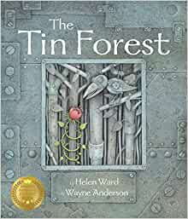

The Tin Forest by Helen Ward and Wayne Anderson
A tale of transformation. An old man lives in a grey and forsaken place ‘that looks out on other people’s rubbish and bad weather’. He dreams of a wild and colourful place and uses the resources around him in such a creative way that change begins to happen. A natural forest becomes entwined with one of metal.

The book retails on Amazon for £7.25.

Overall aims of these reflections.
- To engage children with a story with which they will empathise.
- To explore the themes of Creation and stewardship; and through discussion, enable children to make connections with their own lives.
- To give thanks for the beauty of God’s world.
- To develop creative responses to the text through drama, storytelling and artwork.

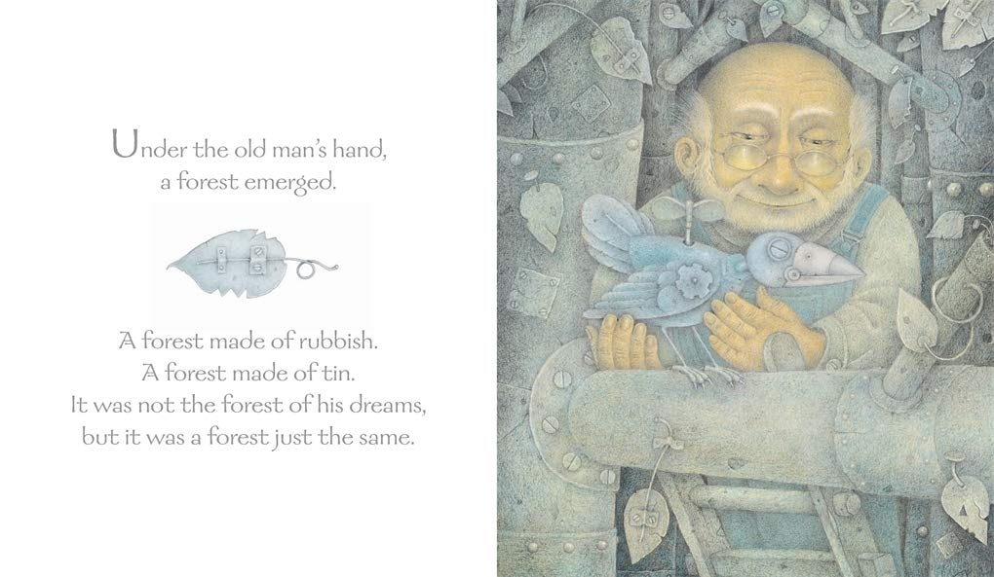

Read the book all the way through so that the children learn about how the man created a new landscape.

A ‘graph of emotions’ can be used to show the emotional journey of man, by comparing his emotional state over the time continuum of the story.
▪ Re-read the whole text from the beginning and the last page of the story to the children.
▪ Consider the emotional journey the old man has undergone since the start of the story.
▪ Think about the emotional range of the character you want to graph and ask the children to select words to demarcate the y axis of your graph. Spend some time thinking about the most suitable words to use – is it sad? Or could you describe the emotions experienced better by using words such as miserable, despairing or desolate?
▪ Use a thermometer image to build up a scale of suitable words, perhaps in small groups, and share these as a whole class, selecting appropriate vocabulary for your graph.
▪ Use the main events of the story as the x axis and then graph the emotional state of the character at each of these main events to form your graph.
▪ Display these graphs and orally retell the story of the character’s emotional journey.

Alternatively (depending on the age and ability of the children) -

Give the children time and appropriate and available resources and allow them to create a soundscape of the forest come to life.
▪ You may want to support this initially with exploring the sounds that they can hear in a forest or woodland environment. You could do this by taking the children outside. If this is not possible, clips are available on line. As an example:
http://soundbible.com/1263-Nature-Ambiance.html

- Return to the language chosen by the author to create the sense of sound and movement in the forest and encourage the children to use this to support their soundscapes. Ask the children to suggest sounds that could be heard in the Garden of Eden.
- Once the children have rehearsed their soundscapes, give them time to perform these.
Ask the children to think about why the old man is the only human in the story, where is everyone else? Why is he alone? Who in the Bible was alone in the world? Is he lonely at the end of the book? Why? Why not? What legacy will he leave?
Tell the children that the first words in the Bible (in the Book of Genesis) are “In the beginning, God created the heavens and the earth”. Genesis 1:1
The last verse in the Bible reads “The grace of the Lord Jesus be with you all. Amen”. Revelation 22:21
Explore with the children why the Bible may start and end with these words. What is it trying to tell us about the world and how we should live in it? Christian grace is about God’s unconditional love for us even though we do not always do the right thing. He wanted us to show grace towards other people and the beautiful world he created.
Say to the children: How often do we thank the Lord for the beautiful creation of which we are a part, or pray for the grace to become more caring towards His creation? Follow with the prayer below:

Closing Prayer
God of the universe,
We thank You for the beauty of Creation, for clean water and fresh air, for food and shelter, animals and plants. Forgive us for the times we have taken the earth's resources for granted and wasted what You have given us. Transform our hearts and minds so that we would learn to care and share, to touch the earth with gentleness and with love, respecting all living things.
Amen
Links to other texts and resources to explore the reflection themes
Books which explore similar themes:
• The Great Kapok Tree: A Tale of the Amazon Rain Forest by Lynne Cherry (Harcourt Brace)
• The Promise by Nicola Davies and Laura Carlin (Walker)
• Window by Jeannie Baker (Walker)
• Where the Forest Meets the Sea by Jeannie Baker (Walker)
• The Tiny Seed by Eric Carle (Puffin)
• For further texts please see the CLPE Environment booklist: https://www.clpe.org.uk/environment-booklist
For information about the authors of the book:
• http://helenward-illustrator.co.uk/
• http://www.wayneandersonart.com/Wayne_Anderson_Art/home.html
For a full list of Helen Ward’s books http://www.templarco.co.uk/picture_books/helen_ward/helen_ward.html

Information on recycling and environmental movements:

http://kids.niehs.nih.gov/topics/reduce/
http://www.bbc.co.uk/education/clips/zqm76sg
http://www.reducereuserecycle.co.uk/greendirectory/kids_green_sites.php
http://www.eco-schools.org.uk/freeresources/bbcprimarylearning

Geography
The children could conduct a local area study, including the impact of our environment on an individual or group and vice versa

DT
The children can design and make shadow puppets and theatres
The children can design and make their own ‘tin forests’

Information on puppet shows and theatre:
http://www.bbc.co.uk/education/clips/z23hfg8
http://www.bbc.co.uk/programmes/p0114p6j
http://www.bbc.co.uk/education/clips/zkqw2hv
https://littleangeltheatre.com/creativelearning/schools-and-teachers/links-resources/

An example of the Tin Forest brought to life as a puppet show: https://www.youtube.com/watch?v=yMC4qWFyt9A

Art
The children could learn about artists, such as Henri Rousseau or Paul Gauguin. Supporting resources can be found on the following websites:

http://www.bbc.co.uk/education/clips/z34wmp3
http://www.tate.org.uk/art/artists/henri-rousseau-le-douanier-1877
http://www.tate.org.uk/download/file/fid/4651
http://www.metmuseum.org/toah/hd/gaug/hd_gaug.htm
http://www.tate.org.uk/art/artists/paul-gauguin-1144

