The Tin Forest
(Appreciating God’s creation)

Reflection 1
This is the first in a series of three reflections based on the book The Tin Forest. The series encourages children to reflect upon the wonders of creation and forms part of the resources to support the Diocesan Education Team’s Ten:Ten#Flourishing project for this academic year.

These reflections are designed for a Year 3 or Year 4 class but can be adapted for younger or older children.
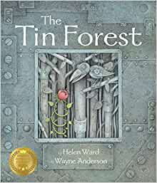

The Tin Forest by Helen Ward and Wayne Anderson
A tale of transformation. An old man lives in a grey and forsaken place ‘that looks out on other people’s rubbish and bad weather’. He dreams of a wild and colourful place and uses the resources around him in such a creative way that change begins to happen. A natural forest becomes entwined with one of metal.

The book retails on Amazon for £7.25.

Overall aims of these reflections.
- To engage children with a story with which they will empathise.
- To explore the themes of Creation and stewardship; and through discussion, enable children to make connections with their own lives.
- To give thanks for the beauty of God’s world.
- To develop creative responses to the text through drama, storytelling and artwork.

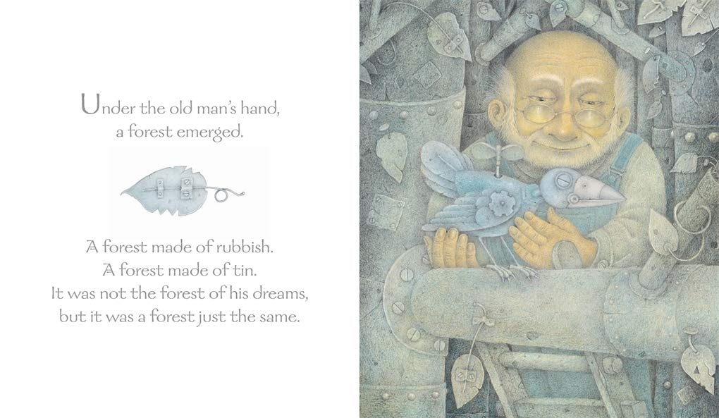
For the sequence to work effectively you will need to ‘keep back’ the title and the text from the children initially. The story unfolds slowly over three reflections and it is best for children not to know the ending until reflection 3.

You will need:
Paper
Art materials

Record all the children’s feelings and reflections from this session and retain for next time.

- Read aloud the first two pages until ‘bad weather’.
- Re-read the text again but this time ask the children to close their eyes and invite them to try to visualise the scene in their mind’s eye.
- Elicit from the children which words or phrases help them to imagine the scene for example, ‘wide, windswept place’ and ‘close to forgotten.’
- Ask the children draw the scene they pictured. Read the section again several times while the children draw their pictures.
- Give the children time to share their work with one another and to compare and contrast their images. Discuss what kind of place this is, what might it be called?

Show the children the real illustration, asking them to compare it to their own interpretation. Encourage them to explore the way the scene is drawn, drawing out ideas about the colours, the light, the placing of the house etc. Ask the children to look closely at the image, drawing out what else they notice.
- Look at the next image of the old man reading, but do not reveal the text or the following page. Ask the children to look closely at the image drawing out what they notice. Also ask them to consider the light and shade in the image.
- Some children may notice the toucan in the picture in the background, the armchair shaped like a cat and the images on the book cover that the old man is reading. Ask the children to consider what the significance of this could be.
- Read aloud the accompanying text ‘in the house lived an old man’ until ‘still the same’.
- Ask the children to respond to the images of the old man and what he is doing. What do his facial expressions suggest about his feelings? What book was he reading? Ask the children why you may be thinking the book the man is reading is a Bible. How does that relate to these images? Talk about light coming not the man’s world once he opens the book. What effect is this having on him?
- What part of the Bible could he be reading about? Elicit from the children that it is the story of creation when God put all the colour and beauty into the Earth and what difference that means to people.

Tell the children that next time they will look at the creation story and see how what the man does reflects what we hear about in the Bible.

Closing Prayer
Dear God, we thank for the chance to think about and enjoy the story of creation. As we go through our day today help us to look carefully at the world around us and appreciate all the beauty that surrounds us in our lives.
Amen

Links to other texts and resources to explore the reflection themes

Books which explore similar themes:
• The Great Kapok Tree: A Tale of the Amazon Rain Forest by Lynne Cherry (Harcourt Brace)
• The Promise by Nicola Davies and Laura Carlin (Walker)
• Window by Jeannie Baker (Walker)
• Where the Forest Meets the Sea by Jeannie Baker (Walker)
• The Tiny Seed by Eric Carle (Puffin)
• For further texts please see the CLPE Environment booklist: https://www.clpe.org.uk/environment-booklist
For information about the authors of the book:
• http://helenward-illustrator.co.uk/
• http://www.wayneandersonart.com/Wayne_Anderson_Art/home.html
For a full list of Helen Ward’s books http://www.templarco.co.uk/picture_books/helen_ward/helen_ward.html

Information on recycling and environmental movements:
http://kids.niehs.nih.gov/topics/reduce/
http://www.bbc.co.uk/education/clips/zqm76sg
http://www.reducereuserecycle.co.uk/greendirectory/kids_green_sites.php
http://www.eco-schools.org.uk/freeresources/bbcprimarylearning

Geography
The children could conduct a local area study, including the impact of our environment on an individual or group and vice versa

DT
The children can design and make shadow puppets and theatres
The children can design and make their own ‘tin forests’

Information on puppet shows and theatre:
http://www.bbc.co.uk/education/clips/z23hfg8
http://www.bbc.co.uk/programmes/p0114p6j
http://www.bbc.co.uk/education/clips/zkqw2hv
https://littleangeltheatre.com/creativelearning/schools-and-teachers/links-resources/

An example of the Tin Forest brought to life as a puppet show: https://www.youtube.com/watch?v=yMC4qWFyt9A

Art
The children could learn about artists, such as Henri Rousseau or Paul Gauguin. Supporting resources can be found on the following websites:
http://www.bbc.co.uk/education/clips/z34wmp3
http://www.tate.org.uk/art/artists/henri-rousseau-le-douanier-1877
http://www.tate.org.uk/download/file/fid/4651
http://www.metmuseum.org/toah/hd/gaug/hd_gaug.htm
http://www.tate.org.uk/art/artists/paul-gauguin-1144

