The Great Kapok Tree:
A Tale of the Amazon Rainforest by Lynne Cherry (Harcourt)

This is the 3rd and final reflection in the series based on the book The Great Kapok Tree. The series encourages children to reflect upon the wonders of creation and forms part of the resources to support the Diocesan Education Team’s Ten:Ten#Flourishing project for this academic year

The Great Kapok Tree is an American children's picture book about rainforest conservation. It was written and illustrated by Lynne Cherry and was originally published by Harcourt Brace Jovanovich in 1990. The book is dedicated to Chico Mendes, a Brazilian environmental activist.

The tree and others like it connect the wildlife in the forest. The theme is about how all trees serve an equally important role, no matter where they are located, and that everyone should think more carefully about cutting them down or abusing them.
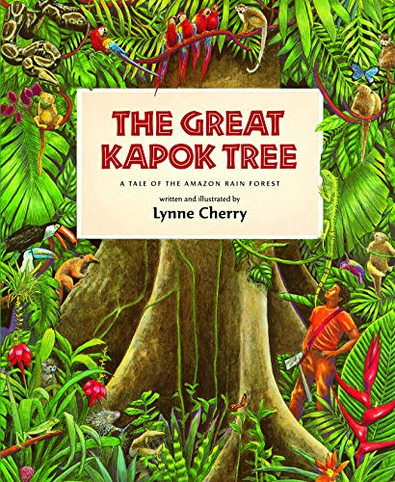
Subtitled ‘A Tale of the Amazon Rain Forest’ the book uses colourful illustrations and a patterned and poetic story, to children think about the importance of humans preserving the rainforests and their ecosystems for the sake of all who live on the planet. A man is ordered to cut down a great Kapok tree. He begins the task but when he gets tired, he falls asleep at its foot. Successive animals, birds, insects and finally a child of the Yanomamo tribe all whisper in his ear cogent reasons why he should not continue. When he wakes, will they have influenced him and what choice will he make? The book begins and ends with a map showing where in the world there are tropical rainforests and a diagram demonstrating the layers of a forest.

The book retails on Amazon for around £6 and there are several readings of it on YouTube.

These reflections are designed for a Year 4 class but can be adapted for younger or older children.

Overall aims of these reflections.
- To engage children with a story with which they will empathise.
- To explore the themes of Creation and stewardship; and through discussion, enable children to make connections with their own lives.
- To give thanks for the beauty of God’s world.
- To explore global issues through a narrative text

Reflection 3

Remind the children about previous reflections when they thought about the beauty and magnificence of rainforests and the amazing story of Creation.

Explain that today they will be asked to reflect of the actions of the two humans in the story, but first you are going to show them a video of what is happening in the rainforests of the world. Explain that this is not just a story, it is really happening in the world.

https://youtu.be/4J9Fi2mjBgk

Read the whole book, up until, ‘He turned and looked at the animals and the child’ on the penultimate page.
Taking into account everything they have learnt up until now, what do the children think the man should do next? What will the consequences be if he cuts the tree down? What will happen if he doesn’t? Who will be waiting for him when he leaves the forest? What do they now think we know about the ‘larger man’? Who might he be? What could the impact on him be?

Ensure that children can reflect on both sides of the situation. Ensure they are aware of the possible consequences of going back to the larger man without the tree. What ramifications might this have for the smaller man? Ask each child to think of one reason for him cutting the tree down, and one reason against.

Remind the children of the story of creation. Tell them that in the Bible we learn how God gave human beings a special responsibility within creation - to nurture it, guard it and use it wisely. This is called stewardship. Humans have to work within creation and to look after it: God put people into the Garden of Eden to take care of it.

Ask the children about the actions of the smaller man in terms of the Biblical message to protect God’s creation. Did he do the right thing? What would we have done? What could we do? How do we protect the people who need to make a living in the rainforest and, at the same time, not destroy its beauty?

Closing Prayer
God of the universe,
We thank You for the beauty of Creation, for clean water and fresh air, for food and shelter, animals and plants. Forgive us for the times we have taken the earth's resources for granted and wasted what You have given us. Transform our hearts and minds so that we would learn to care and share, to touch the earth with gentleness and with love, respecting all living things. Amen

Links to other texts and resources to explore the reflection themes
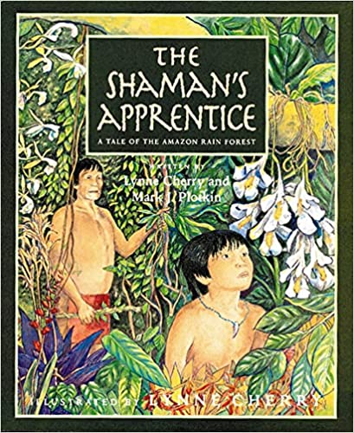
This is a second book written by the same author. In a Tirio village deep in the heart of the Amazon rain forest, the shaman Nahtahlah has a place of honor in his tribe. Young Kamanya wants to learn the healing secrets of the forest plants--he hopes that he, too, will become the tribe's shaman, so that he can cure his people. When the villagers fall sick with an illness that Nahtahlah cannot cure, many lose faith in the shaman's wisdom--until a foreign woman helps them understand its value while giving Kamanya an opportunity to realize his dream. Lynne Cherry returns to the rain forest with ethnobotanist Mark J.Plotkin to tell an important story about the healing plants of the earth-and why we must protect them.

Books which explore similar themes:
• The Promise by Nicola Davies and Laura Carlin (Walker)
• Window by Jeannie Baker (Walker)
• Where the Forest Meets the Sea by Jeannie Baker (Walker)
• The Tiny Seed by Eric Carle (Puffin)

Information on recycling and environmental movements:
http://kids.niehs.nih.gov/topics/reduce/
http://www.bbc.co.uk/education/clips/zqm76sg
http://www.reducereuserecycle.co.uk/greendirectory/kids_green_sites.php
http://www.eco-schools.org.uk/freeresources/bbcprimarylearning

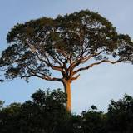
Is The Great Kapok Tree a real tree?

Absolutely. The trunk can expand to nine or 10 feet in diameter. In the nooks and grooves of this huge plant live a diverse number of species including frogs, birds and bromeliads. The kapok tree is deciduous, shedding all of its leaves during the dry season.

One of the biggest and oldest trees in Costa Rica, this Ceiba pentranda, or kapok tree, has a height of almost 60m (190 ft.) and is approximately 500 years old.
