The Great Kapok Tree:
A Tale of the Amazon Rainforest by Lynne Cherry (Harcourt)

This is the 2nd reflection in the series based on the book The Great Kapok Tree. The series encourages children to reflect upon the wonders of creation and forms part of the resources to support the Diocesan Education Team’s Ten:Ten#Flourishing project for this academic year

The Great Kapok Tree is an American children's picture book about rainforest conservation. It was written and illustrated by Lynne Cherry and was originally published by Harcourt Brace Jovanovich in 1990. The book is dedicated to Chico Mendes, a Brazilian environmental activist.
The tree and others like it connect the wildlife in the forest. The theme is about how all trees serve an equally important role, no matter where they are located, and that everyone should think more carefully about cutting them down or abusing them.

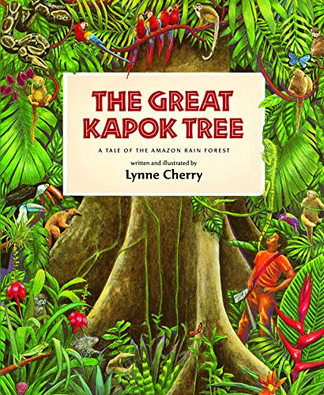
Subtitled ‘A Tale of the Amazon Rain Forest’ this picture book uses colourful illustrations and a patterned and poetic story, to children think about the importance of humans preserving the rainforests and their ecosystems for the sake of all who live on the planet. A man is ordered to cut down a great Kapok tree. He begins the task but when he gets tired, he falls asleep at its foot. Successive animals, birds, insects and finally a child of the Yanomamo tribe all whisper in his ear cogent reasons why he should not continue. When he wakes, will they have influenced him and what choice will he make? The book begins and ends with a map showing where in the world there are tropical rainforests and a diagram demonstrating the layers of a forest.

The book retails on Amazon for around £6 and there are several readings of it on YouTube.

These reflections are designed for a Year 4 class but can be adapted for younger or older children.

Overall aims of these reflections.
- To engage children with a story with which they will empathise.
- To explore the themes of Creation and stewardship; and through discussion, enable children to make connections with their own lives.
- To give thanks for the beauty of God’s world.
- To explore global issues through a narrative text

Reflection 2

Remind the children about Reflection 1 when they thought about the beauty and magnificence of rainforests and the amazing story of Creation.

Explain that today and in a later reflection, you are going to use a book about the rainforest to think more about how we treat God’s world.
Introduce The Great Kapok Tree and read the first page of the book to the children. It would be useful for the children to see a large image of this, under a visualiser or as a scanned image on the IWB so that they can look at the interplay between the text and illustrations.

Ask the children:
What do you like and dislike about what you see?
Does it remind you of anything in real life or stories?
How does this picture add to or change what you thought about Creation before?

Talk with the children about who they think the smaller man and the larger man referred to in the text are. What do you think they are doing in the forest? What happens in the forest as they appear? Discuss the text: ‘Moments before, the forest had been alive with the sounds of squawking birds and howling monkeys. Now all was quiet as the creatures watched the two men and wondered why they had come.’
What impact does this part of the text have on you as a reader?

Read the second page of the text. Were the children’s predictions correct? Why do you think the smaller man is cutting down the tree? What impact might this have on the forest?

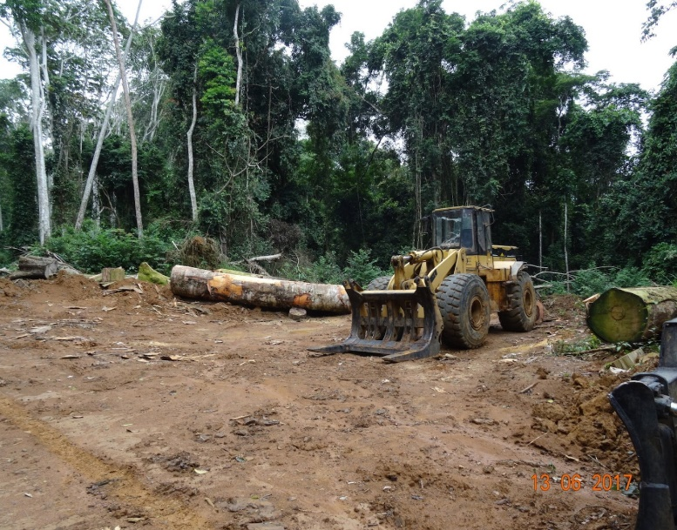
Re-read the text so far and on to the page where the bee buzzed ‘You see, all living things depend on one another.’
This Photo by Unknown Author is licensed under CC BY-ND

Ask the children to think about if this is true? Is that what God wanted when he created the Earth?
Elicit from the children that God wanted people to live in harmony with nature and take care of His world.

Ask the children why would the man cutting down the tree impact on the animals?

Ask the children to close their eyes, pick an animal and think of a reason why this animal would want to stop the man. Ask them to think about how this animal might look as they approach the man, think of what they might say to the man to persuade him not to cut down the tree and how they would phrase this so that he will really listen.

Ask the children to close their eyes and imagine how God may feel about the animals and then the man.

What might he say?

You may chose to share the answers to the last question, you may like to just get the children to think about that in their heads.
Tell the children that next time you will think more about what God may be thinking of His creation now.

Closing Prayer

Thank you, Lord, that you created such a beautiful place for us to live.
We pray, Lord, that we may live out
the trust you put in us to look after your world for you.
Help us to love and care for those around us
both near and far.
Amen.

