The Great Kapok Tree:
A Tale of the Amazon Rainforest by Lynne Cherry (Harcourt)

This is the first in a series of three reflections based on the book The Great Kapok Tree. The series encourages children to reflect upon the wonders of creation and forms part of the resources to support the Diocesan Education Team’s Ten:Ten#Flourishing project for this academic year

The Great Kapok Tree is an American children's picture book about rainforest conservation. It was written and illustrated by Lynne Cherry and was originally published by Harcourt Brace Jovanovich in 1990. The book is dedicated to Chico Mendes, a Brazilian environmental activist.
The tree and others like it connect the wildlife in the forest. The theme is about how all trees serve an equally important role, no matter where they are located, and that everyone should think more carefully about cutting them down or abusing them.

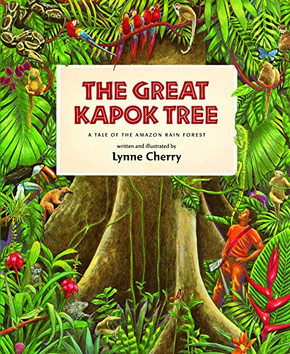
Subtitled ‘A Tale of the Amazon Rain Forest’ this picture book uses colourful illustrations and a patterned and poetic story, to children think about the importance of humans preserving the rainforests and their ecosystems for the sake of all who live on the planet. A man is ordered to cut down a great Kapok tree. He begins the task but when he gets tired, he falls asleep at its foot. Successive animals, birds, insects and finally a child of the Yanomamo tribe, all whisper in his ear cogent reasons why he should not continue. When he wakes, will they have influenced him and what choice will he make? The book begins and ends with a map showing where in the world there are tropical rainforests and a diagram demonstrating the layers of a forest.

The book retails on Amazon for around £6 and there are several readings of it on YouTube.

These reflections are designed for a Year 4 class but can be adapted for younger or older children.

Overall aims of these reflections.
- To engage children with a story with which they will empathise.
- To explore the themes of Creation and stewardship; and through discussion, enable children to make connections with their own lives.
- To give thanks for the beauty of God’s world.
- To explore global issues through a narrative text

Reflection 1

Explain to the children that they are going to watch a video about one of the most fantastic places on Earth. Ask them to listen and look carefully. Tell them that as they watch the film, you want them to think about how old and magnificent the place is.

Play the clip using the link below. Note: the total running time is 26 minutes – Just watch the first three or four minutes for this reflection.
https://youtu.be/InT2qpJRpfs?list=PLtF0v3uQ2I8YV3JCpCQ76b2x02O0xFcRn

Discuss some of the words and phrases in the video, e.g.
Huge trees stand like monuments, amidst the symphony of life
Outlasting the dinosaurs
Shrouded in a translucent veil , the rivers and streams are the veins and arteries of the rainforest

Ask the children: What do these particular phrases tell us about the rainforest? E.g. If it outlasted the dinosaurs, it must be strong, powerful, ancient.

Ask the children to close their eyes and imagine standing in this incredible forest. Ask them to imagine looking up, down and to each side and think about what they can see, hear and smell. You may like to play the rainforest soundtrack below.
http://soundbible.com/1818-Rainforest-Ambience.html

Tell the children that the Bible begins with the story of Creation – A story about the beginning of the world. Genesis means Creation. Ask the children to revisit the Bible story that tells us that God made the magnificent world that they have just seen on screen. Read the extract below from Genesis to the children.
In the beginning God created the sky and the earth. The earth was empty and had no form. Darkness covered the ocean, and God’s Spirit was moving over the water.
Then God said, “Let there be light!” And there was light. God saw that the light was good. So he divided the light from the darkness. God named the light “day” and the darkness “night.” Evening passed, and morning came. This was the first day.
Then God said, “Let there be something to divide the water in two!” So God made the air to divide the water in two. Some of the water was above the air, and some of the water was below it. God named the air “sky.” Evening passed, and morning came. This was the second day.
Then God said, “Let the water under the sky be gathered together so the dry land will appear.” And it happened. God named the dry land “earth.” He named the water that was gathered together “seas.” God saw that this was good.
Then God said, “Let the earth produce plants. Some plants will make grain for seeds. Others will make fruit with seeds in it. Every seed will produce more of its own kind of plant.” And it happened. The earth produced plants. Some plants had grain for seeds. The trees made fruit with seeds in it. Each seed grew its own kind of plant. God saw that all this was good.

Tell the children that you are going to show them some more images of God’s creation and you want them to watch in silence. Ask them to reflect on the power, beauty and care God took to create the world. Play the link below.

https://youtu.be/32TxpiGTOio

Tell the children that between today and the next reflection you want them to think about what they have seen and thought about today. Next time they will look at how God’s creation is being threatened.

Closing Prayer
Dear God, we thank for the chance to think about and enjoy the story of creation. As we go through our day today help us to look carefully at the world around us and appreciate all the beauty that surrounds us in our lives.
Amen

