A class reflection based on ‘The Day the Crayons Quit’ by Drew Daywalt
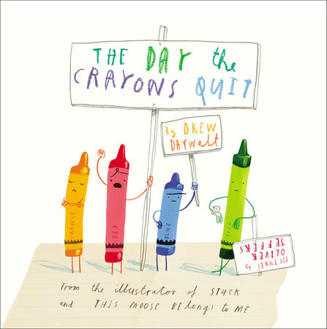
Teacher notes
This is an enjoyable and entertaining book for children of all ages. From a Christian perspective, this can be expanded into the theme of the church (ie: its people, not buildings) being described as The Body of Christ. All of us are special and contribute uniquely to our families, friendships and school community as well as those who are part of church communities. It would be helpful to have the book in class so that the children can look at it but there is a good version of the story being read here: https://www.youtube.com/watch?feature=share&v=489micE6eHU&app=desktop.
There are other themes that you could draw from elements of the story, for example, challenging stereotypes using the experience of pink crayon.

Introduction
PowerPoint Slide 1 Show a pack of crayons – ask how many children have used crayons at some point in their childhood so far. What colours do they like to use? Use the link in slide one to view YouTube video of the story being told.
PowerPoint Slide 2 Discuss the questions from this slide. You could choose to ask the children if they have ever felt similar to any of the crayons.

PowerPoint Slide 3 Introduce the idea of The Body of Christ – read 1 Corinthians 12 v 12-27.
¹²Just as a body, though one, has many parts, but all its many parts form one body, so it is with Christ. ¹³ For we were all baptized by one Spirit so as to form one body—whether Jews or Gentiles, slave or free—and we were all given the one Spirit to drink. ¹⁴ Even so the body is not made up of one part but of many.
¹⁵Now if the foot should say, “Because I am not a hand, I do not belong to the body,” it would not for that reason stop being part of the body. ¹⁶ And if the ear should say, “Because I am not an eye, I do not belong to the body,” it would not for that reason stop being part of the body. ¹⁷ If the whole body were an eye, where would the sense of hearing be? If the whole body were an ear, where would the sense of smell be? ¹⁸ But in fact God has placed the parts in the body, every one of them, just as he wanted them to be. ¹⁹ If they were all one part, where would the body be? ²⁰ As it is, there are many parts, but one body…………..²⁷ Now you are the body of Christ, and each one of you is a part of it.
Use this idea to think about everyone being an important part of the Body of the School. What do each of us contribute to the school community? It could range from having a role, such as library monitor, to being someone with a smiley, positive personality. How does our behaviour support the Christian ethos and epitomise the values of our school?

PowerPoint Slide 4 Consider how school could be if everyone worked well together, just like the colours in the picture at the end of the story. Use the prayer to end the time of reflection:
Dear God,
Thank you for our school. We pray it would be a safe place of learning, fun and friendship. Please watch over all our teachers, children and families.
Help us to learn new things, to explore the world together and to play and be happy.
Help us to have love for each other, to have forgiveness at our heart, and to build kindness into every day. Amen.

