A class reflection based on ‘Sulwe’ by Lupita Nyong'o
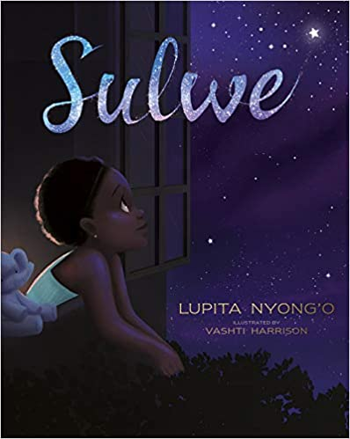

Teacher notes
This is a powerful book for children, which centres around the themes of self-worth and valuing differences but also touches on more complex and sensitive themes of implicit bias. There is much to be explored here regarding why we have come to value some physical characteristics more than others but teachers will obviously need to be mindful of the feelings of children in their classes.

It would be very good to have the book in class so that the children can look at it but there is an excellent version of the story being read by the author here (there is a brief introduction which you may want to skip): https://www.youtube.com/watch?v=vujbTOuzg2Q

Teachers may wish to use ‘Sulwe’s Song’ as listening music at the beginning and/or end of the worship: https://www.youtube.com/watch?v=Go55eGL-1nQ

Relection
PowerPoint Slide 1 We are going to reflect on a story called Sulwe, which was written by Lupita Nyong'o (she is an actor who has starred in Black Panther and Star Wars). The YouTube link above is embedded in the image on the right of this slide but you may want to have it open and ready to play before you start.)
PowerPoint Slide 2 Why did Sulwe pray this prayer? Why did she feel as though she wanted to look different? Is it right that she should have felt like that?
PowerPoint Slide 3 Sometimes God doesn’t answer prayers in the way that we are expecting. How might God have answered Sulwe’s prayer?
PowerPoint Slide 4. We are all different in all kinds of ways but people don’t seem to be able to resist comparing themselves to others and making up reasons why they are better than other people. This can make some people begin to feel bad about themselves - like happened to Sulwe. The truth is, like Sulwe’s mum told her, ‘Real beauty is in your mind and your heart. It begins with how you see yourself, not with how others see you.’
PowerPoint Slide 5 The Bible tells a story (John 4) about how one day Jesus was out teaching the countryside. He came to a place where a Samaritan woman was getting water from her well. Now Jewish people in those times used to think that they were better than Samaritan people and they used to call them all sorts of nasty names. The Samaritan woman thought that Jesus was going to be mean to her because he was Jewish but instead Jesus asked if it would be okay for him to have a drink of water from the well. The Samaritan woman was surprised at this because she thought that Jesus would look down on her so much that he wouldn’t even want to drink from her well. Jesus told her that everyone is precious to God - He loves everyone equally and in His kingdom all people will drink the same water.

Prayer and reflection
PowerPoint Slide 6
I’d like you to just close your eyes and think about any of the times in your daily life that you are tempted to believe that you are better than other people or times when you feel sad inside because you are tempted to believe that you are not as good as other people.
Remember what Jesus told the woman at the well: everyone is precious to God and He loves everyone equally.
I’m going to finish with a prayer now and if you would like to, you can make it your prayer by saying amen at the end.

Dear God
Help me to remember that my life is a precious gift from you
And that you care about me because of who I am
not because of what I look like.
Give me the courage not to compare myself to others
But to help others to be the best they can be
By having a kind heart and helping hands.
Amen

PowerPoint Slide 7 Teachers may wish to use ‘Sulwe’s Song’ as listening music at the end of the worship: https://www.youtube.com/watch?v=Go55eGL-1nQ

