Standing Together as Global Neighbours
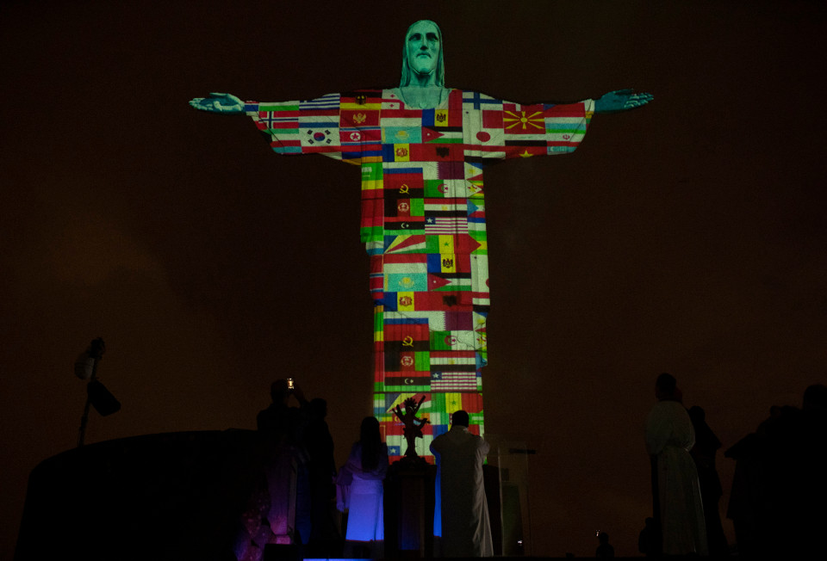

Look at this huge statue of Jesus, lit up with the flags of the world.

Can you see how small the people under it are? That gives you an idea of how enormous it is! The famous ‘Christ the Redeemer’ statue stands on a hill overlooking the city of Rio in Brazil. This is what it usually looks like:

Thinking time

Why do you think the statue was lit up in this way a few weeks ago?

What do you think the people that organised it were trying to say to the countries around the world?

Why do you think they picked a statue of Jesus for their message?

The world comes together

Are you bored at home? Feeling a bit fed up? Are you dying to see your friends? Are you scared that someone you know might catch the nasty coronavirus?
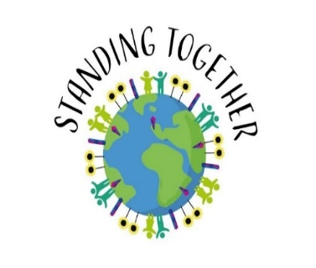
Over the last few months you may have heard lots of your friends and family saying similar things about the way that they are feeling. People from each nation across the world feel similarly and we know how other people are feeling because we feel the same. Coronavirus has already changed the day-to-day lives of millions of people. Some news has been sad, but the virus has also meant some positive things have happened.
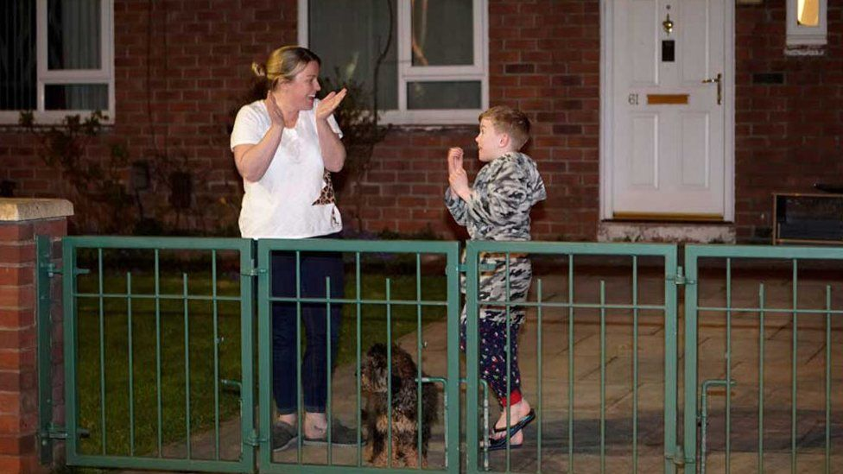
The internet is crowded with stories of neighbours helping each other and whole streets looking out for elderly residents. Maybe you join the thousands of people in the weekly “clap for our carers” moment, in which people up and down the country applaud NHS staff at 8pm each Thursday.

Time for you to help

Now is a good time to think about caring for your neighbours and to show them that care and love unites everyone across the world. What can you do to bring a smile, meet a need, offer hope to someone in your street this week?

Make a list of things you could do (maybe draw a picture for someone and pop in through their letterbox or make sure that you smile at everyone that you see on a walk). Try to do one thing each day this week.
This is a good time to think about your local area. Are there businesses, cafes or a vets that may need a prayer? What about your school and the teachers and other staff working there? Is there a doctors’ surgery and a doctor that needs your prayers today?

Read this verse from the Bible:

First, I tell you to pray for all people. Ask God for the things people need, and be thankful to him.

Look at a world map or globe (maybe online) and choose a country to pray for. If you want to, you can do some finding out about each country before you do your prayers. Remember to pray for the leaders of those countries, who are making very difficult decisions every day. Stick your prayers on the map if you have one.

Coronavirus has affected countries across the world, but remember, love unites us all. It’s time to stand together. Here is a prayer that you may like to say for your neighbours nearby and far away in other countries.
Dear God,
We know that Jesus is the light of the world. Please be with the people who are are ill because of the coronavirus in all the countries of the world. Please look after our neighbours in our road, town, country and across the globe. Help us to remember that your love reaches to the ends of the Earth.
Amen.

