A class reflection based on ‘Silly Billy’ by Anthony Browne
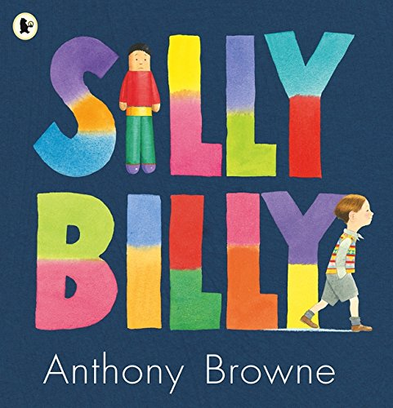

Teacher notes
This is a very appealing book for children, which centres around the theme of coping with worries. From a Christian perspective, this can be expanded into the theme of thankfulness and the blessing of small things. It would be very good to have the book in class so that the children can look at it but there is a good version of the story being read here: https://www.youtube.com/watch?v=vHiW5ndFNQQ.
It would be good to have a set of worry dolls to show the children. These can be bought quite cheaply (https://www.amazon.co.uk/s?k=worry+dolls&ref=nb_sb_noss_1) but slide one of the PowerPoint has and image of some worry dolls if you don’t have any.

Introduction
PowerPoint Slide 1 Show the children your set of worry dolls and/or look at the picture. Explain and discuss what they are used for. Tell the children that we are going to hear a story about some worry dolls.
PowerPoint Slide 2 Watch the video of the story. There is a hyperlink in the slide if you want to open it that way, though it may be more advisable to have it open ready.
PowerPoint Slide 3 Ask the children whether they can remember any of the things that Billy worried about. Were they sensible things to be worried about or silly things to be worried about? Perhaps tell a story about when you have been worried about something that wasn’t really important. Draw out the difference between serious worries that you need to tell someone about and worries about things that don’t really matter, even though they seem important at the time.
PowerPoint Slide 4. What was it that helped Billy with his worries? Was it the first set of worry dolls that his gran gave him or was it something else?
Lead the children to the conclusion that what helped Billy was that he was able to move on from dwelling on his own worries by thinking about the worries of others and doing something to help them.

Bible Reading
PowerPoint Slide 5 In the Bible Jesus says this to his friends:
Try not to worry about every little thing in your life, like what kind of clothes you will wear. Are the clothes you wear really that important? Consider the lilies that grow in the fields and the birds that fly in the air, they don’t ever worry about anything but God makes them more beautiful than any human clothes. God thinks you are more beautiful than the lilies and birds and he wants you to follow his values so that his Kingdom can come on earth as it is in heaven. If you do this then you don’t need to worry about anything else. (Matthew 6:25-33, paraphrased)

You may want to discuss this reading our you may feel it is appropriate just to allow the children to reflect on it.

Prayer and reflection
PowerPoint Slide 6
I’d like you to just close you eyes and think about any of the things in your daily life that worry you. Some of these might be important things that you need to tell someone about and some of these might be things that aren’t really important.
Remember what Jesus told his friends: God thinks you are more beautiful than the lilies and birds and he wants you to follow his values so that his Kingdom can come on earth as it is in heaven. If you do this then you don’t need to worry about anything else.
I’m going to finish with a prayer now and if you would like to, you can make it your prayer by saying amen at the end.

Dear God
Help me to remember that you have a plan for my life.
Teach me to know the difference between what is important
And what is not worth worrying about.
Give me courage when I am worried
So that I can move forward day by day
And help to make the world like you want it to be.
Amen

Note: PowerPoint Slide 7 is for the follow-up worry doll prayer activity if you should choose to use it.

