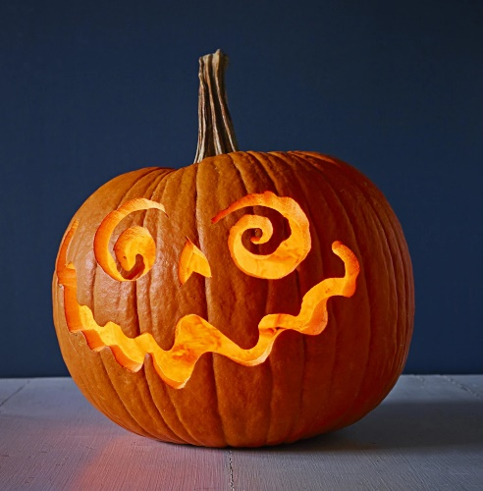
Pumpkin Prayers –
For use in the week leading
up to Halloween

Teacher Guidance

Context: This prayer activity is specifically intended to be used around Halloween and could be used with any age group (though possibly not the younger children). It is intended to convey an understanding of prayer as ‘letting the light in’.

You will need: You will need to have pre-cut your pumpkin’s face and washed the seeds.

Explain to the children: I wonder whether any of you are planning to make a pumpkin for Halloween?

Some Christians don’t like Halloween because they think it means celebrating the dark and scary things in the world but ‘halloween’ is originally a Christian festival – the word literally means ‘holy evening’. It is a time for thinking about holy people who let light into the world by following God’s values.

When we light the candle inside the pumpkin, we are showing that everyone has the light of God’s blessing inside them and we need to practice letting it out so that it can bring hope to others. This is what prayer helps us to do.

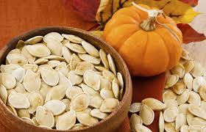
Each child is given one of the seeds from the pumpkin: I’m going to invite you to hold you pumpkin seed as we think and pray.

- We think about any times when we might have
made someone else unhappy.
- We reflect on what we might have done or said
differently.
- We know that every day brings opportunities to
shine light in the world.
- We pray that the light will grow in us so that we can overcome darkness for others.

Children could be invited to take their seed away and plant it.

