Prayer activity book for this difficult time

Praying for your friends
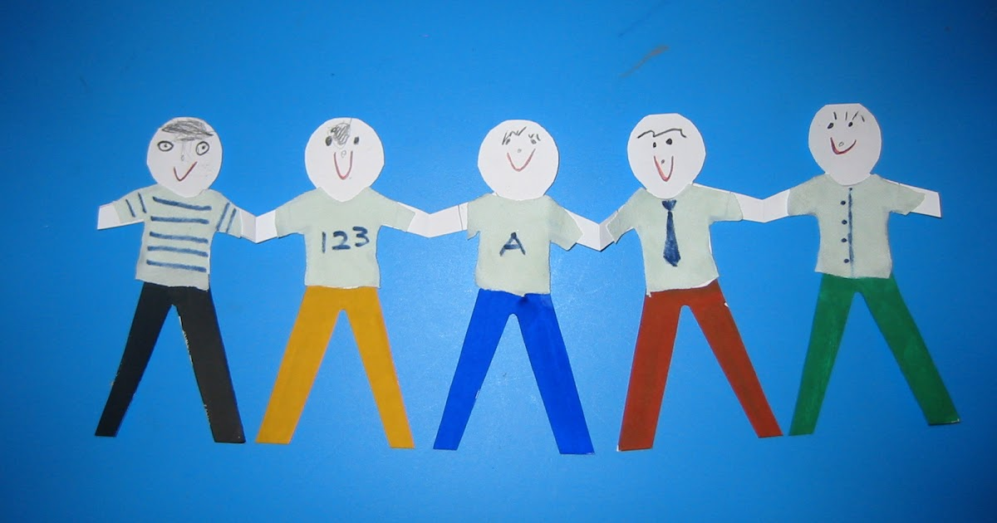
Activity
Create connected paper rings or paper friends.
Write on each a value that they show.

Prayer
God, Thank You for my friends. Thank You for giving us people to talk to and laugh with, even though we are not together at the moment. I pray for my friends today, that they have a good day wherever they are. Help me to be kind like Jesus, a good friend to others. Amen.

Praying for your community

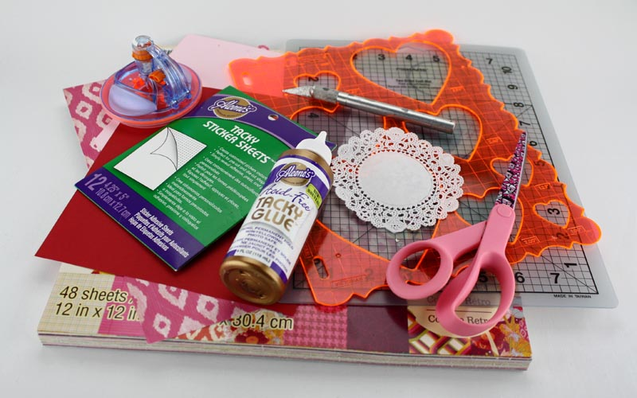
Activity
Make a heart out of materials you can find, either
inside or outside. Place inside the heart items
which could represent people and communities
that you would like to pray for.

Prayer
Lord, we thank you for always loving us. We pray
for all in our community, and pray that we can
extend your love to others this week.
Amen.

Prayer of thanks

Activity

Draw or create a model of a sunflower. Say the prayer below over your artwork before displaying it in one of the windows in your house.

Prayer
God, thank You for this day! Despite all the difficult things that are happening in your world, thank You for the birds and the animals, the flowers and the trees, the lakes and the streams, and the sun that rises and sets over them each day. Thank You for the life we live, and for making each person different. What an amazing God You are! Amen.
Praying for your School

Activity
Sit quietly and think of the teachers in your school, your headteacher and teaching assistant, cooks and cleaners that help you when you are at school. Close your eyes and think of one of your best days at school and how good it felt.

Prayer
Dear God, please bless my school. Thank You for all the teachers that work so hard to help us learn, especially now when they are planning things for many of us to do at home. Thank You for providing chances for us to learn more about the world. Please keep my school safe. Protect all of the grown-ups and children in school and those of us learning at home. Amen.

Praying for medical teams

Activity
Doctors and nurses spend a lot of time caring for patients who have to stay in bed. They always try to keep positive, smiling at their patients to make them feel a little bit better. Try cutting up some small pieces of paper and writing a note to each person in your family to cheer them up, then hide it under their pillow.
This Photo by Unknown Author is licensed under CC BY

Prayer
Dear God, please care for all our doctors and nurses as they work to help people who are ill.
Make yourself known to them.
Help me to hope for them from a distance
Help me to love them from a distance
Amen

EVERY DAY

Every day
New news batters
And bruises
Posts post truths
Causes clueless Confusions
All nonsense
No sense found
Up feels down
And here we stand

A SOCIALLY DISTANT NIGHT LIKE THIS

I see you in the street
Almost a world away
While our eyes may meet
Our hands will not
For you have your isolation
And I have mine
Barely a road width apart
Orbiting different homes
Flung out by different forces
The neighbourhood torn apart
Our job is to tether it together
And raise a glass from afar

© Tim Watson.

The content is licensed under a creative commons attribution – non-commercial – sharealike 2.0 license. In practice this means the author grants permission for these rants and poems to be used and remixed creatively and with imagination for non-commercial purposes. Please attribute the work to the author.
For any other use please contact the author via www.twitter.com/BeatLiturgist or revtimwatson@Hotmail.com

