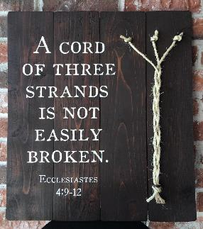

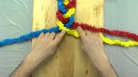

**Prayer plaits**

**Teacher Guidance**

**Context:** This prayer activity helps children to understand the importance to Christians of their relationship with God and with others.

**You will need:** Three equal lengths of wool (eg: 25cm) of different colours

Ask the children to look at the threads before them and explain that one colour represents themselves; one colour represents God and one colour represents other people. Ask the children to knot them together at one end.

Introduce this as a prayerful activity. The children can then plait the wool as they reflect on their relationship with God and others (perhaps have some atmospheric music playing in the background). Make sure that they know to leave enough thread at the end to tie another knot. Once this is completed, it could be suggested to the children that they say a prayer commending themselves and those they thought about, to God’s love.

The plaits could then be displayed or turned into wrist bands, as a reminder of this important three way relationship, for the children to take home.

**Further reflection:**

There is a reason that the construction of rope is based on three strands – it provides strength.

Christians believe that this message in the Bible is saying that when their relationships with people include God, through the presence of his Holy Spirit, there is an added strength to them.

What do you think gives strength to your relationships?

What values are important to you?