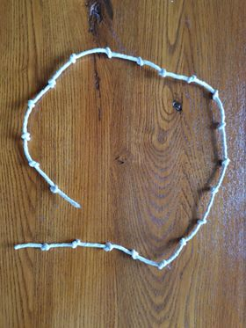
Prayer Strings

Teacher Guidance

Context: These take a little bit of effort to make but older
children should be able to make them for themselves.
Once you have made them, they can be used in a variety
of ways

You will need: The idea is to end up with a string with 20 evenly spaced knots in it. You could use coloured sting or just ordinary string (wool doesn’t work so well as the knots become too small). Start with a piece of string roughly 130 cm long, hold the end between your index finger and thumb, take a turn around your index finger and tie an overhand knot. Hold the knot, take a turn around your index finger and tie another overhand knot. Keep doing the same thing until you have 20 knots then cut off any excess string.

Explain to the children: We are going to use these strings to help us focus our prayers. We close our eyes and hold the string starting at the first knot, try to think of:

Four people members of your family and friends to pray for.
Four people in our school who you don’t know very well to pray for.
Four things that worry you about the world to pray for.
Four things that are going to happen in the future to pray for.
Pray about four things that you would like to do better at.

You could use your imagination to change and vary this.

Another use for the prayer string would be to teach the children the Lord’s Prayer – saying the phrases ‘on the knots’ as follows:
as we forgive those
who trespass against us.
And lead us not into temptation;
but deliver us from evil.
For thine is the kingdom,
the power
and the glory,
for ever
and ever.
Amen.

Our father,
who art in heaven,
hollowed be thy name;
thy kingdom come;
thy will be done;
on earth
as it is in heaven.
Give us this day
our daily bread.
And forgive us our trespasses,

