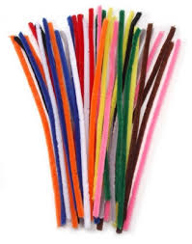
Pipe Cleaner Prayers

Teacher Guidance

Context: This is a simple prayer activity in which the pipe cleaner is a great aid to helping the children to focus.

You will need: You will need a pipe cleaner for each child.

Explain to the children: we are going to use our pipe cleaners to help us to pray in the kind of simple way that God wants us to. I am going to guide us through it step by step.

First, shape your pipe cleaner into an initial or a shape that stands for one of your family or friends.
Hold the shape and tell God how your friend might need His help. Think about how God can help others through you.
Screw the pipe cleaner up. Think about people in the world who live in confusion and don't understand what is happening to them - people who are caught up in wars; people who have to leave their homes; people who don’t even have any food. Hold the screwed-up pipe cleaner and ask God to help them.
Make your pipe cleaner into a heart shape. Think about people who are lonely and have no friends, family or support around them. Ask God to send them people who will be their friends.
Loop the pipe cleaner around your wrist. Think about when God has been with you this week. Has he answered any of your prayers? If you have any prayers, ask God now. Thank God for always being with us and caring for us.

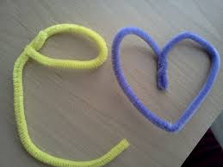
You may wish to allow the children to wear the pipe cleaner around your wrist for the day as a reminder.

