Creating pebble prayers
Teacher Guidance
You will need: Small stones or pebbles (8-10 per child). A small mat/piece of paper for each child (optional)
This prayer activity involves selecting pebbles for each member of a family and placing them together as one. How many pebbles children select depends on the make up of the family that they are praying for. The activity is designed to be reflective and peaceful. You may like to play some reflective music throughout.
On the next page are pictures to accompany the activity, you may like to display them on the whiteboard screen as you lead the activity. Alternatively, print them out to display in the class reflection corner to encourage the children to think and ray for other families.
Explain to children that God wants all of us to enjoy being part of a loving and caring family. Families come in all shapes and sizes, and sometimes families are not happy or safe places.

Read the following to the class, allowing time for the children to think and reflect.
Think of a child and family that you know. (pause)
Pick up a stone, feel it warm up as you hold it for a while and then place it on the mat, saying or thinking to yourself:‘This is a child’ (pause)
Pick up another stone and say or think: ‘This is the child’s mother (or carer).’ (pause)
Pick up another stone and say or think:‘This is the child’s father.’ (pause)
Pick up more pebbles and say or think: ‘This is the child’s family.’ (pause)
Pick up two more and say or think: ‘These are the child’s friends.’ (pause)
Look at your pile of stones, and quietly think of all the people involved in the family. (pause)
You may like to ask God to keep them warm and safe in their family, knowing that they are cared for and loved by God. (pause)

The stones can then be moved by the children to store together or safely taken home.
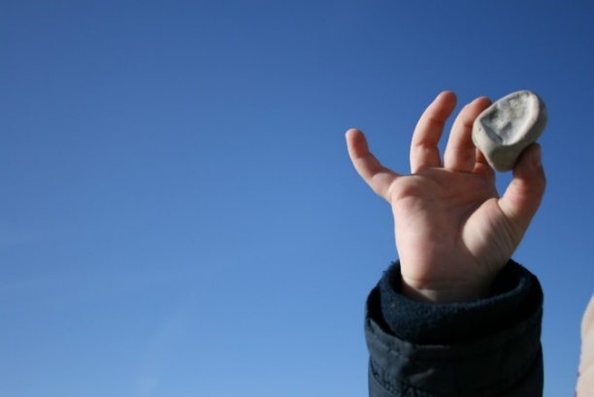

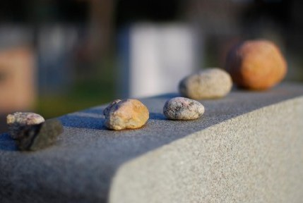

‘…and the whole family was filled with joy.’ Acts 16:34
