The Peaceful Path Project
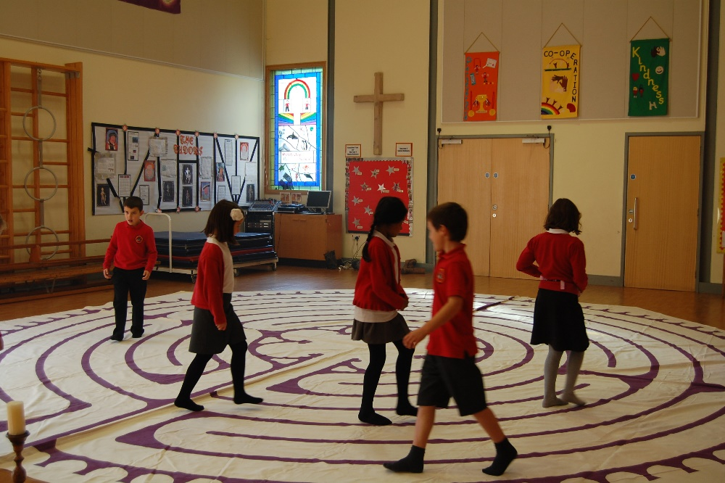
The seeds for this project were planted by a child’s question. She had been watching me walking an outdoor labyrinth at a retreat centre, and asked me what I was doing. I explained as simply as I could, and her immediate response was, ‘Can I do it?’ I told her she could, and the next minute she was walking the labyrinth with enormous care and concentration. The following day she was back again, this time with 2 young friends, and for the rest of the week these three children hardly left the labyrinth alone. I realised they were deeply drawn to the path, and that this was something I needed to ponder.
I started to work on some ideas for a project to introduce children to the labyrinth. A few weeks later the opportunity to do a feasibility study arose when I was asked to organise a labyrinth day for ninety 7 and 8 year olds at Archbishop Wake CE Primary School. The enthusiastic feedback from both staff and pupils alike led to the setting up of the Peaceful Path Project.
The Peaceful Path Project - Why?
Spirituality. Walking a labyrinth creates a sense of inner stillness and peace, allowing space for reflection and prayer. The fact that this is achieved through walking makes it particularly appealing to children, who due to their natural energy often find it hard to be still and to achieve a sense of quiet reflection. Walking the labyrinth is a form of embodied prayer that allows children to be both physically active and contemplative.
The labyrinth is a spiritual tool found in all major world religions, and as such offers a unique opportunity for children of different faiths and belief systems to walk a common path together, thus contributing to a sense of community. The labyrinth helps to focus our attention on what unites us rather than on what divides us, and is therefore particularly appropriate in schools where there is a diversity of beliefs.
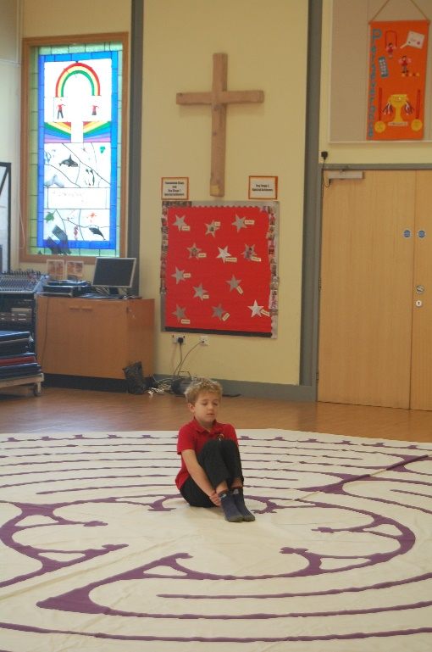
Wellbeing and Resilience. Childhood today can be a difficult time, with many children experiencing periods of anxiety and stress-related illness. Walking a labyrinth enables children to release stress and anxiety. The practice of labyrinth walking is therefore gaining increasing respect within schools, colleges and universities as a significant tool for promoting student wellbeing and personal growth.
‘It’s such a great experience to walk through a labyrinth following your feet and in the middle to get rid of your worries and come back out with none at all!’ Alys age 10

The Peaceful Path Project - How?
The Peaceful Path Project offers day workshops in primary schools, offering children the opportunity to
- learn about labyrinths and their uses, both historically and today
- create their own finger labyrinth for personal use
- experience walking a labyrinth in small groups
- express and reflect on their experience creatively through art.
I have a 24 foot medieval-style portable labyrinth which can be laid in the school hall. Carefully chosen music, candles and incense may be used to help create a sense of sacred space.
The Peaceful Path Project – Who?
I have over 20 years’ experience of working with children both in schools and community groups, including leading school workshops and INSET training for DEED (Development Education in Dorset) and running Salisbury Cathedral’s Sunday Club. I am a qualified labyrinth facilitator, and have given presentations on the labyrinth in Salisbury Cathedral and Sarum College, as well as holding labyrinth walks in a variety of settings including the cathedral, retreat centres, schools and public parks.
Price. £150 per day or £80 per half day plus travel
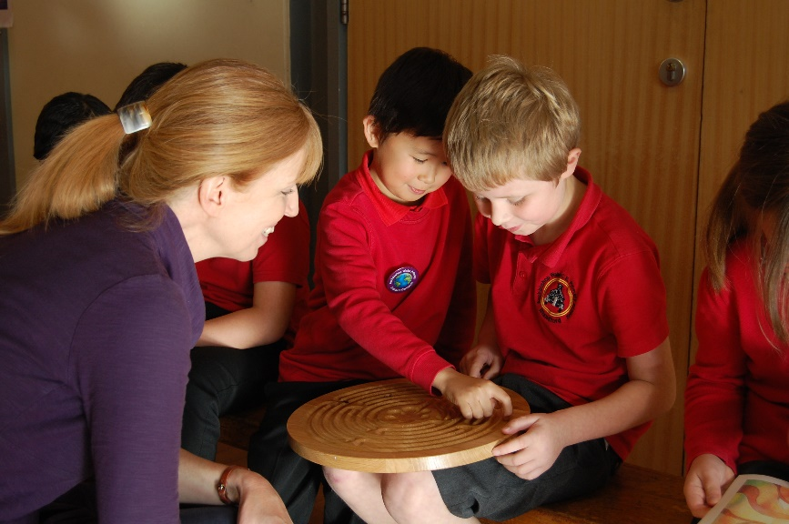
If you would like to book a workshop or have further questions, I would be delighted
to hear from you.
Nickie Fidgin
wessexlabyrinthwalks@gmail.com
07985 560518

