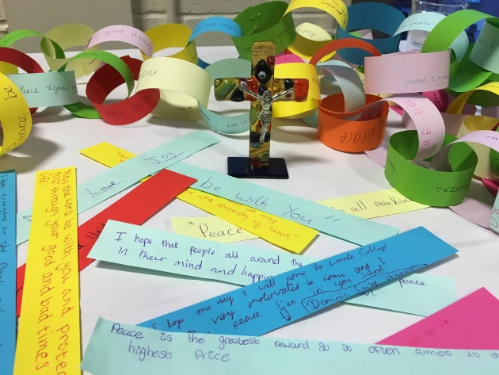
Paper Chain Prayers

Teacher Guidance

Context: This activity can convey the idea of unity in
‘joining our prayers together’ to the children.

You will need: Each child should be given three strips
of plain paper. A4 paper cut into four lengthways is roughly the right size. Children will also need colouring pens. The activity will work better if you have prepared you own strips to give the children inspiration.

Explain to the children: We are each going to create our own prayer ‘strips’ and when they are complete, we will join them together into a prayer chain. Children are asked to write on their prayer strips and decorate them with colouring pens. One strip for each of the following categories:

- A person who you would like to pray for. This could be someone close to you or someone you don’t know very well or even know at all.

- A place in the world that needs our prayers (you may need to discuss this with the children).

- Something that needs to change so that the world can be a better place for everyone.

Joining the strips: You may want to allow the children to stick their own strips into circles using glue sticks or it may work more effectively if you join them with a stapler as the children complete them.

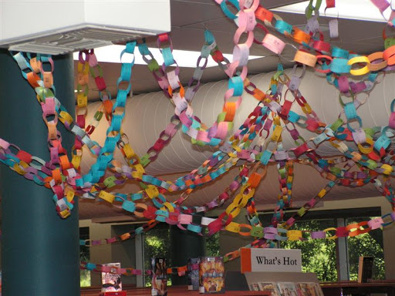
You may wish to end the activity with the following prayer:

Loving God,
We join together in unity to offer our prayers
For people, places and problems.
May we have strength and courage
To make a difference in the world.
Amen

