Bishop’s Council Update
There have been four Bishop’s Council meetings since Synod last met during which time some significant matters were discussed. This report will therefore discuss some items according to subject, detailing the discussion across those meetings, rather than simply a chronological summary of items discussed in each meeting.

Budget 2020
This has been a subject of discussion at each meeting considering both process and the substance of the budget. This, of course, is a main agenda item for Synod to discuss and consider in November and detailed in Paper 3. Related to this is a discussion which took place at Bishop’s Council in July in relation to Clergy Pensions.
For some years the size of the deficit on clergy pension scheme has been the subject of much discussion locally and nationally. Earlier in the year, Diocesan Secretaries and Finance Directors were told of the proposed approach of the Pension Board given that the deficit has reduced from £236m to £57m (now revised to £50m) between December 2015 and December 2018. Given the significant impact this has one the budget of every Diocese, it was felt prudent that Dioceses spoke out as a united voice to bring weight to the arguments put forward.
In July, Bishop’s Council approved our Diocese being included in this joint response. A copy of the letter which was approved and has now been sent is annexed to this report.
At the Inter Diocesan Finance Forum in October there was a presentation from the Chair of the Pensions Board which indicated that while our feedback was appreciated, the focus remains on reducing the deficit as quickly as possible, meaning it is unlikely Diocesan contributions will be reduced for another few years and therefore will remain a significant factor in the planning for the next triennial budget.
The following slide was used at the Forum to summarise the position:
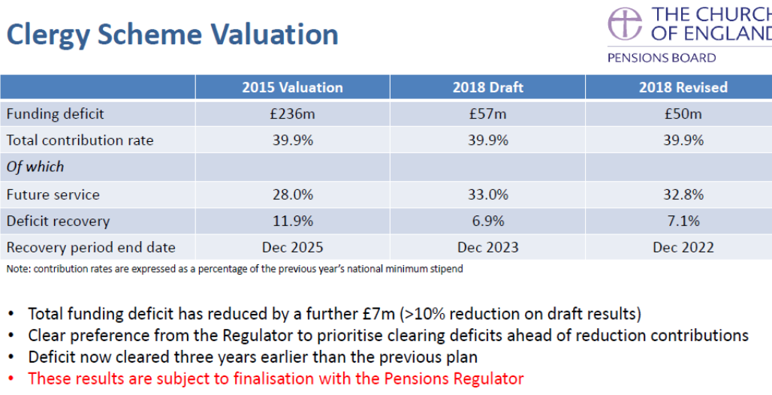

Resourcing Growth Project
Much of what would be recommended to Bishop Christopher in terms of the Schemes for Gosport, Newport, West Leigh and Leigh Park were discussed at meetings earlier in the year but one aspect had to be held until we received the report on St John’s, Forton church from the Church Buildings Council. This report was received in time for the June meeting of Bishop’s Council which enabled Bishop’s Council to consider the final element of the resourcing Growth Project. Council therefore discussed in detail the closure of Forton church for it to become a Mission Hub. This would mean that Forton would unite with Gosport Holy Trinity and Gosport Christ Church as a single benefice and exclude the church of St John, Forton from parochial responsibilities. Bishop’s Council approved this (19 votes in favour, 1 against and no abstentions).
Bishop Christopher notified the Council, by email, of the outcome of the hearing at the Church Commissioners on 17th July namely that the Commissioners’ Mission, Pastoral and Church Property Committee:-
- Noted that proposals to merge parishes in Rowner, Elson and Bridgemary, and to create a new team ministry to serve that part of Gosport would proceed as no representations were made against the scheme;
- were minded to accept proposals to merge the parishes of Forton, Christ Church and Holy Trinity, Gosport, and to create a mission hub at St John’s Church, Forton, but wanted the Bishop to do more work to develop job profiles for the new posts provided for by the scheme and form and assessment of the suitability and willingness of the existing clergy to be appointed;
- rejected proposals to merge the parishes of Leigh Park, Warren Park and West Leigh.
- accepted proposals to merge the parishes of Carisbrooke (St Mary); St Nicholas in the Castle, Carisbrooke; Newport (Minster); and Newport St John, subject to the removal of the benefice of Barton, from any new team ministry. Its clergy would also have responsibility for the separate parish of Gatcombe that would be held in plurality with the proposed united benefice.
In October, Bishop’s Council were updated that the Scheme for Bridgemary, Elson and Rowner, was made on 1st October 2019 and an announcement made to the congregations on 6th October 2019.
In relation to Forton, Gosport Christ Church, and Gosport Holy Trinity it remains the case that there is not any further information on this Scheme at present as the further process requested by the Commissioners is being undertaken.
As the Scheme for Leigh Park, Warren Park and West Leigh had been rejected, Bishop Christopher indicated that this Scheme would not be resubmitted to the Commissioners.
Bishop’s Council spent some time discussing the Scheme for Newport and the condition imposed by the Commissioners that Barton be removed from the Scheme, which Bishop Christopher was minded to accept. The Bishop’s Council unanimously agreed that the Bishop should accept the Commissioners’ Mission and Pastoral Committee’s amendment and progress with the scheme.

Council for Social Responsibility (CSR)
Following the review of CSR which Synod heard about in June, Bishop’s Council has been progressing with work relating to the main outcome of the review, namely that a new CSR Trustee Board is to be created, separate from Bishop’s Council. There has since been a huge amount of work conducted by Nick Ralph in conjunction with a charity lawyer and as such:-
- New Articles of Association have been approved;
- The Articles were adopted by Special Resolution on 12th September 2019;
- Prior to the adoption of the new Articles of Association, it was noted that all members of Bishop’s Council (with the exception of Lucy Docherty, Peter Leonard, Paul Chamberlain and Victoria James) intended to resign. These written resignations were received and accepted with effect from 11th September 2019;
- In addition to Lucy Docherty, Peter Leonard, Paul Chamberlain and Victoria James, the following have been appointed as directors with effect from 12th September 2019:-
- Robert Solomon
- Edward Philips
- Nicola Youern
- Andrew Robinson
- Jonathan Smith

Other Decision Made By Bishop’s Council
Bishop’s Council has made the following main decisions:-

Policies
There is an ongoing process of review of existing policies but also preparing new policies to meet the needs of the PDBF as it seeks to serve the wider Diocese. Over the last four meetings Bishop’s Council has therefore:-
- Approved a Complaints Policy
- Updated the Whistleblowing Policy
- Approved a Conflicts Policy
- Updated the Loans Policy – after consideration of a request for a parish loan, which was approved, it became clear that the loans policy needed review. This took place first at Diocesan Finance Committee and then at Bishop’s Council. Bishop’s Council agreed with the recommendation of the Diocesan Finance Committee that an interest rate of 5% above base rate was too high. Instead, it was agreed that a rate of 3% above base rate was appropriate. This would be reviewed in 2023 in line with the 3 year budget cycle, though can be looked at sooner if the need arises. This decision reflects the desire of Bishop’s Council (and indeed those employed within the central team) to reduce the burden on parishes wherever possible.

Committee Membership

Bishop’s Council & Vacancy in See Committee Vacancy
Rev Mike Duff left St Jude’s in September and moved out of the Diocese. This necessitated his resignation from Bishop’s Council and the Vacancy in See Committee. As it was more than six months since the elections to both Bishop’s Council and the Vacancy in See Committee, the Standing Orders provide that the vacancies can be filled in accordance with any direction of Bishop’s Council. As a consequence:-
- Bishop’s Council has therefore directed that Rev Paul Armstead join the Vacancy in See Committee and he has accepted.
- Bishop’s Council therefore directed that Rev Richard England of Crofton parish becomes a member of Bishop’s Council and he has accepted. This is direction was made because there was, at the time, no clergy representative from Fareham on Bishop’s Council. It was important to ensure that we have clergy representation on Bishop’s Council from all deaneries in our Diocese. .

Diocesan Advisory Committee Representative
Tom Kennar was appointed as the Diocesan Synod representative on DAC.

Lay Conference
Bishop’s Council approved the motion that there be a lay conference in September 2020 which is being arranged by the deanery lay chairs under the leadership of Debbie Sutton, the Chair of the House of Laity.
Victoria James
Diocesan Secretary

