The Boat Story
A Bible story with craft activities

Listen to the story below and find out what Jesus did when his friends felt scared about something. or watch a film of it using this link
https://youtu.be/ZzPwRXytr7U

Afterwards you may like to try some of the fun activities.,

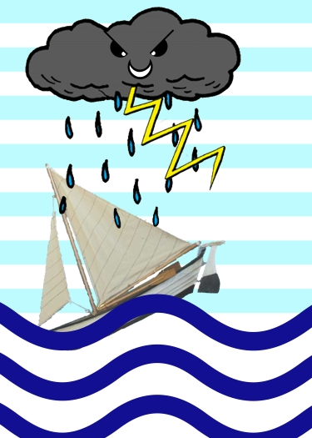
Jesus had been very busy helping lots of people.
One evening, after a long and tiring day, Jesus invited his friends to go with him to cross a lake in a boat.
They climbed into a fishing boat. After a while, rocked by the gentle waves, Jesus fell asleep.
Suddenly, the wind started to blow and a big storm began. Lightening and thunder filled the sky. Soon the waves were splashing into the boat!
The boat bounced around the sea, terrifying the men inside. The men knew the sea could be dangerous and they did everything they could, but they had never been in a storm like this!

The men tried to wake Jesus up. They were certain the boat was about to sink.
Jesus helped them at just the right time. When Jesus woke up, he spoke to the waves, saying, “Quiet! Be still!”

And, do you know, the storm was gone and the sea was calm! There were no more waves. There was no more wind. The sea was smooth and quiet. The men were safe. What an amazing man Jesus was!

Time to get crafty!
Make a boat
Lay a milk or juice box on its side and cut along the edges of the top side of the carton with scissors to remove the panel and create the open top of the boat. This is the boat's basic shape. A grown up will need to do this bit.
Wrap the boat, inside and out, with masking tape, tin foil or white paper to make it paintable.

Cut a triangle sail from white paper and use selotape to attach it to the end of a stick like a sail. Decorate the sail with crayons or felt tips.
Wrap a small box in white paper or silver foil and glue it flat inside the bottom of the boat (this will be your cabin.) Allow the glue to dry for 30 minutes.
Push the stick into the small box to make your sail, but not through the bottom of the boat!
Paint or colour the your boat. Let the paint dry before using the boat on water! Now sail you boat in your bath or sink. Make a storm like the one in the Bible story. Can you make figures for your boat and act the story out.

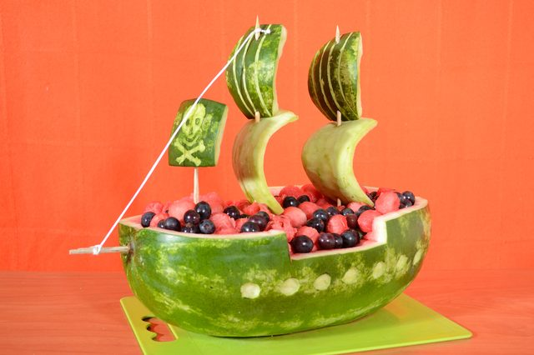
Snack
Look at this greatboat made using different foods.
Have a go at building a food boat of your own. Potatoes, apple and cheese slices are useful. You could add crisps or pretzel sticks to make masts and sails.
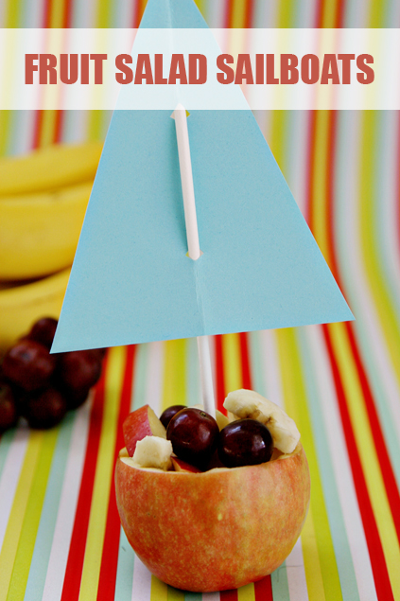
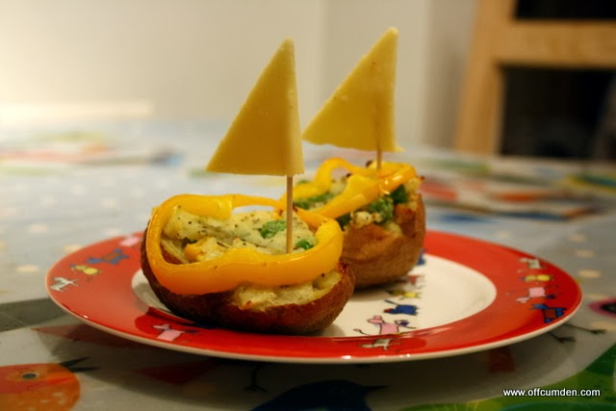

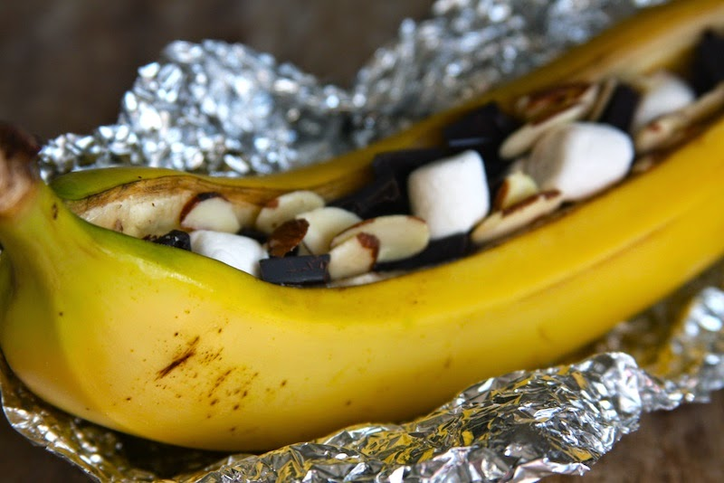

Make a storm in a bottle
In a clean bottle, clear jar or drinking glass, add coloured water to fill to about a third. To colour the water, If you have some, you can use blue food colouring, paint or whatever you have at home (an M&M or Smartie soaked in water adds colour.) Then add baby oil or cooking oil to another third. The top third is to leave room to avoid spills. Add glitter or pepper for fun.

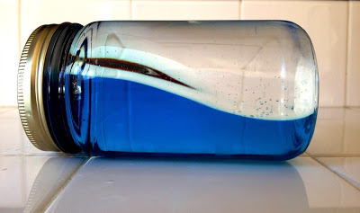
Now you can make your own waves or storm by tilting the bottle from side to side. Notice that it takes a little while for your storm to calm. The Bible says that when Jesus said, "Quiet! Be still," the wind died down and the sea was completely calm. See if you can tell the story using your bottle.

