Sheep Game

Put a dot of Vaseline or face cream on each child's nose and let them see how many cotton balls they can get stuck on their face and nose in an allotted time.
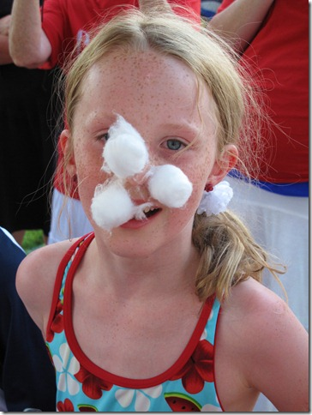
Make sure to take a picture of all the "sheep"! If time allows, the children can then see if they can run back and forth to get cotton balls from their noses to stick on an outlined picture of a sheep on the other side of the room.

You could smear the same cream on an outline of a sheep for children to stick their cotton balls from their noses on the board -- no hands allowed!

