Make A Family Cross

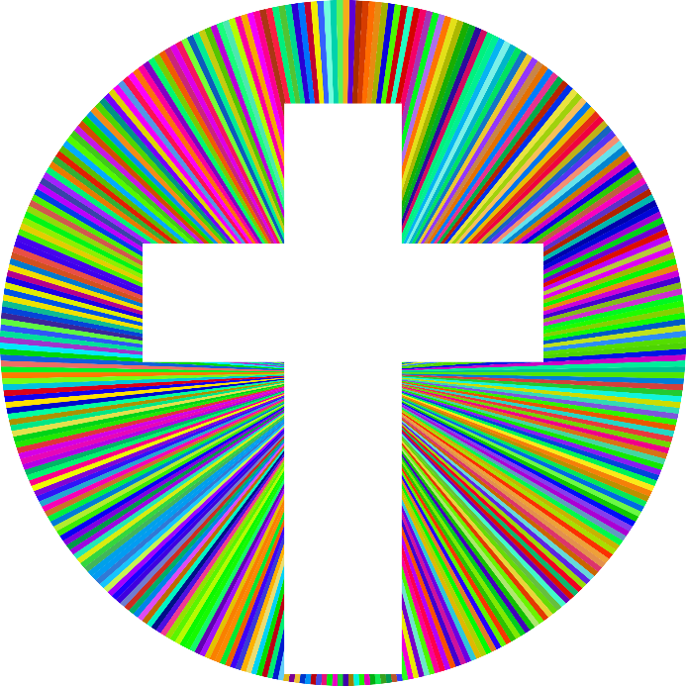
Think about crosses that you have seen at home or in nursery. For example:

• A kiss on a birthday card
• A crossroads sign on the road

Go on a cross hunt around your house and try and find cross shapes

To see more crosses, have a look at the different ones on the website below which shows crosses around the world.

https://www.cofeguildford.org.uk/resources/the-resource-centre/world-crosses

Make your own family cross

Can you make your own family cross? What would you put on it? What about pictures of every one in your family, your house or your pet?

You could use some of the ideas below:
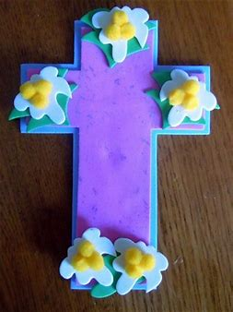
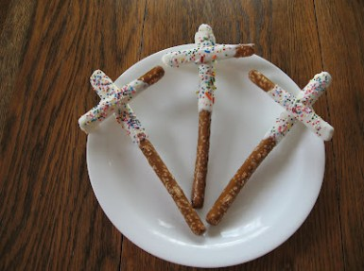

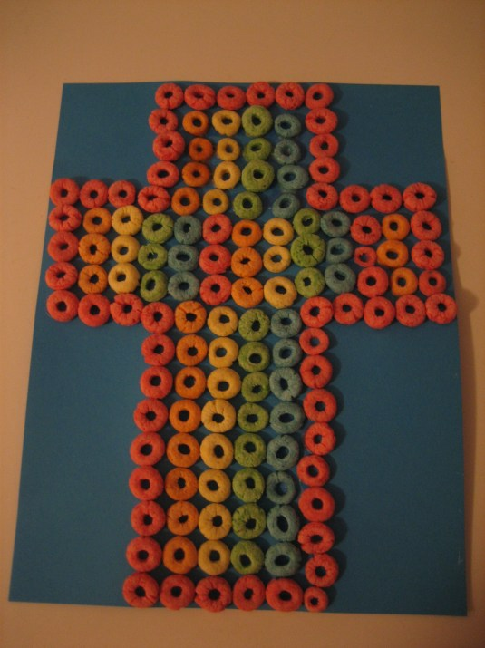
This one is made using breakfast cereal!

