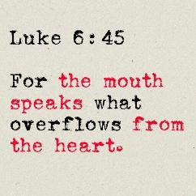

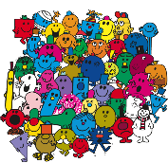

**Mr Men and Little Miss prayers**

**Teacher Guidance**

**Context:** This prayer activity would be most appropriate with Foundation Stage or Key Stage One but depending on the nature of the children you could try it with Key Stage Two as well! This activity helps younger children to develop an understanding of the things we can pray about.

**You will need:** Pictures of Mr Men and Little Miss characters either on big sheets or on an interactive whiteboard.

Keeping things visual is really important for young children. The Mr Men and Little Miss characters offer some inspiration for enabling this. Show the children a character. Ask them to talk about what they know about this character and what it means to be greedy or happy etc. In order to create a prayerful atmosphere, ask the children to close their eyes, hands together or open and lead a prayer around it (some of the children could also do this if they are able and confident to do so). Examples could be:

* Mr Happy—say thank you to God for something that makes you happy.
* Little Miss Naughty—say sorry to God for something you have done wrong.
* Mr Bump—ask God to be with someone who is poorly.
* Little Miss Sunshine—say thank you to God for the sunshine.
* Mr Greedy—say sorry to God for the times when you haven’t shared.

There are many more you can use, although don’t overload the children with too many characters and prayers, keeping their attention for two or three is likely to be more than enough.

**Further reflection:** We all have lots of different characteristics but which character do you think describes one of your best ones and which character describes something you to need to work at to improve?

For lots of people, thinking about the things we say is something to work on. Sometimes our inner thoughts lead us to say something unkind. We can ask God to help us to remember to think before we speak. In this way we can use our words to help and support people rather than to hurt them.