Modern Slavery in Rural areas

As we head towards Rogation Sunday on 9th May, Bishop Alastair Redfern, Founder of the Clewer Initiative reminds us,
‘Rogation invites people to ask for blessing – for a particular place; for all its inhabitants; for every endeavour to promote the common good. It is totally inclusive – joining everyone in seeking sustenance and a commitment to play their part in its provision.
What could be a more appropriate occasion for recognising that modern slaves are hidden in many rural settings, as well as in urban areas, their “work” unrecognised, and their well-being ignored. As churches celebrate the opportunity to ask for blessing in each parish, may we recognise the realities of those denied a proper place in the community, and include in our prayers, and through our endeavours over the coming months, a commitment that they may be properly seen, set free, and enabled to make their own desires known, that they may be a precious part of the fuller unfolding of God’s goodness.’
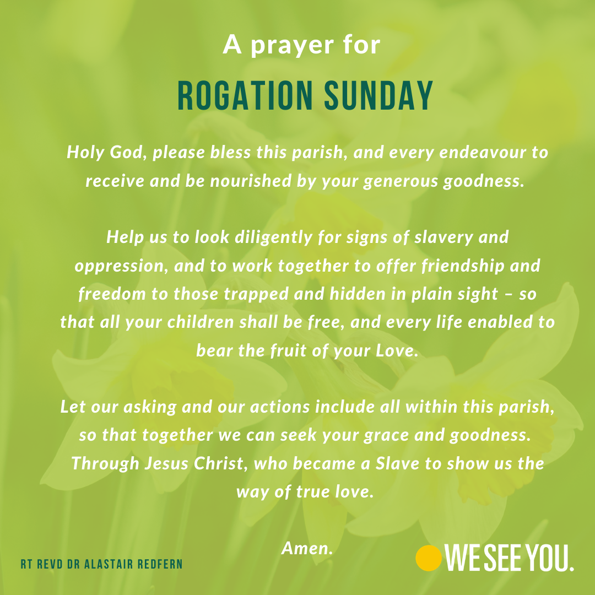
Through the zoom room opportunities that have become a recent pattern, we can join several events that Worcester Cathedral is hosting to raise awareness around modern slavery within rural settings.
Modern Slavery Awareness | Worcester Cathedral

Tuesday 4th May (via Zoom, time tbc)
“A Christian consumer’s response to Modern Slavery”
Talk and discussion led by Simon John. Simon is a supporter of Anti-Slavery International and global secretary of RAGAS, the Rotarian Action Group Against Slavery.

Sunday 9th May (online, 10.30 am)
Bishop Alastair Redfern, the lead bishop working with the Clewer Initiative, will preach at the sung eucharist in the cathedral.

Monday 10th May (online and Zoom, time tbc)
Gangmasters and Labour Abuse Authority Talk
Lys Ford is the senior partnership development manager for the Gangmasters and Labour Abuse Authority and will talk on the methodology of modern slavery (recruitment, control, and the difficulties that victims have in being identified), what signs to look for in business and in rural communities, how to manage and be aware of the potential risk to agricultural businesses, and what we can do collectively as a community. The talk will be followed by an online conversation.

Five myths about modern slavery in rural areas

Myth 1: Modern slavery is an urban thing.
Wrong! Modern slavery is present in all communities. In cities, when streets are full of people and activity, it can be hidden amongst the hustle and bustle. In rural areas, it is often hidden in remote locations, off the beaten track.
Myth 2: The only form of modern slavery in rural areas is forced labour
Wrong! Every form of modern slavery is possible in rural areas. Forced labour is common but so is sexual exploitation, domestic servitude, and county lines. In fact, over the last few years, there has been a growing trend for criminal gangs to rent remote holiday cottages and turn them into “pop up brothels”, keeping women against their will and selling their services online.
Myth 3: Forced labour is only present on farms and in factories
Wrong! Labour exploitation is the second most common form of modern slavery in the UK and can occur in every sector and industry. It is particularly prevalent in the agriculture, horticulture, food processing and packaging, shellfish gathering, warehousing and logistics, beauty, hotels, catering, cleaning, construction, manufacturing, and car wash sectors.
Myth 4: If slaves are found in a business, it is the fault of the employer
Wrong! It can be extremely hard to spot signs of modern slavery and criminal exploiters go to great lengths to hide the evidence. They are extremely savvy and sometimes provide forged documents to get past reputable employers who are doing the appropriate checks. What’s more, workers who are employed in lawful employment can still be subjected to exploitation outside of their working environment, in their home lives. That is why it is so important that employers know the signs to look out for.
Myth 5: There is nothing that can be done to prevent modern slavery in rural areas
Wrong! We all have a part to play in knowing what to look out for. Spotting signs of modern slavery and reporting suspicions to the Police could result in victims being rescued and criminal networks thwarted. Also, if employers know how to follow best practice recruitment policies and find licensed labour providers, they will be able to avoid traffickers and illegal labour providers.

If you are interested in the impact of Covid and Brexit on horticultural businesses,

click the link below to listen to James Barnes, the chair of the Horticultural Trades Association.

Covid and Brexit have caused havoc for horticultural businesses — The Clewer Initiative
The Rev’d Edwina Fennemore
Liaison Lead Against Modern Slavery, Diocese of Portsmouth & Winchester

