Ordinands in training for the Diaconate/Priesthood

Ordinand Training at:
Emily Ashworth Cuddesdon
Nikki Bryant Portsmouth Pathway
Liane Chalmers Cuddesdon
Lizzie Davidson Trinity Bristol
Sam Douglas Wycliffe Hall
Levi Freed Trinity Bristol
Polly Honeychurch Portsmouth Pathway
Charlotte Hudd Portsmouth Pathway
Jo Lorimer Portsmouth Pathway
Jack McDonald St Mellitus
Stuart McKerracher Mirfield
Paul Pope Portsmouth Pathway
Chris Toms Trinity Bristol

The Rev Canon Peter Hall
Diocesan Director of Vocations and Ordinands

Please Pray for

MICHAELMAS EMBER LIST 2023

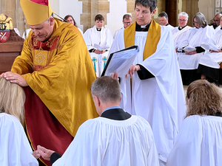

Almighty God, giver of all good gifts, by your Holy Spirit you have appointed various orders of ministry in the Church: look with mercy on your servants now called to be deacons and priests; maintain them in truth and renew them in holiness, that by word and good example they may faithfully serve you to the glory of your name and the benefit of your Church; through the merits of our Saviour Jesus Christ, who is alive and reigns with you, in the unity of the Holy Spirit, one God, now and for ever. Amen.
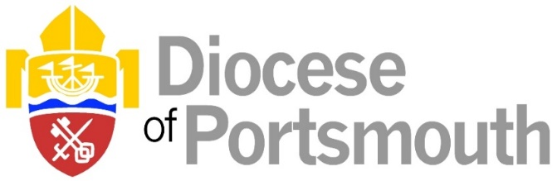

ORDINATION OF DEACONS

At the Cathedral Saturday 30 September at 11.00am

KAREN CROWHURST St Blasius, Shanklin TI: The Rev Tony Richards

CLARE KING Holy Trinity, Bembridge
TI: The Venerable Steve Daughtery

COLEEN JACKSON Blendworth with Chalton with
Idsworth
TI: The Rev Vickie Morgan

NICOLA PINNOCK St Catherine, Ventnor
TI: The Rev Leisa Potter

BEVALY RACKETT St Mary the Virgin, Brading
TI: The Venerable Steve Daughtery

RICHARD SHURMER St Cuthbert, Copnor, with
St Aidan, Anchorage Park
TI: The Rev Godfrey Hilliard

LAURENCE STONE Harbour Church
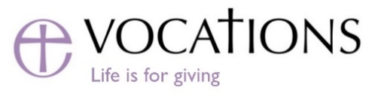
TI: The Rev Andrew Hargreaves

*TI – Training Incumbent

