The Christian Value of Love

EYFS – Reflection 2
God loves us unconditionally

This reflection focuses on teaching children that

God loves you no matter what. He loves you when you are at your best and He loves you when you are at your worst. He is there to talk to during times that you are happy and when you feel low. His love is unconditional!
Here are three simple activities that you may wish to use in one session or as separate shorter reflections.
Sit the children in a circle and remind them that in the last reflection you learnt about how God loves us all. Remind them of the hearts that they decorated and ask them to feel their heartbeats again.
Activity 1
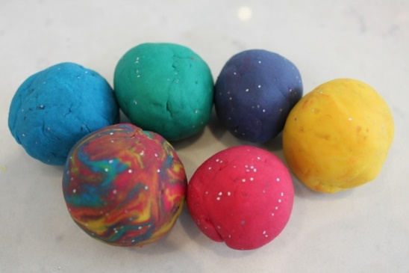
You will need
A piece of playdoh for each child
Ask the children when they think God loves them – Is it in the morning, at night, when they are having tea or is it all the time? Establish that it is all the time.
- Talk about a variety of bad choices we sometimes make (shout, don’t listen to mummy, etc.). Does God love us when we behave like that?
- Explain that God’s love is unconditional. That means no matter what, he loves you. He might not like what you choose to do, but he will never stop loving you.
- Set out playdoh and encourage children to make various shapes and then a ball.
- Explore how there is no beginning or end to the ball; it is the same with God’s love. He does not start loving you and then stops loving you.

Activity 2
You will need
Paper straws, big enough to fit a pipe cleaner through
Some pipe cleaners

Ask the children: How many people are in your family? How many children are there in our class today? How many sheep do they think farmers have?
Explain that there can be 100 sheep or more in a flock. A shepherd uses a long piece of wood to pull sheep back to him when they run off to protect his sheep.
Tell the children that there is a great story in our special book (the Bible) about sheep. Use the link below to watch the story of The Lost Sheep

https://www.youtube.com/watch?v=094upaf4BME

Talk to the children how the shepherd looked after his sheep, even when it was naughty and wandered off. Explain that God looks after us like that. He loves us all the time, even through the night, even when we sometimes do the wrong thing.

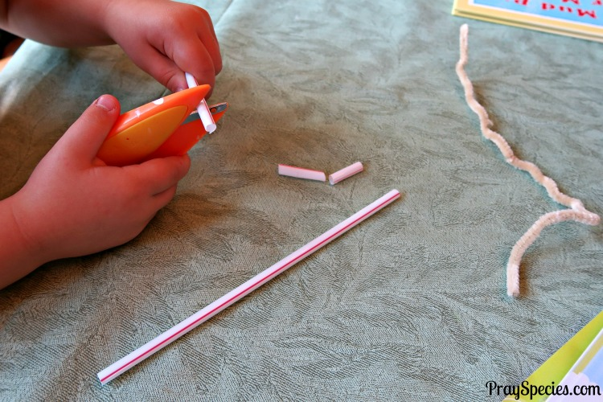
Look at the straws. Tell the children that you are going to cut them to make little white beads and these will be like our little sheep.

Invite children to explore and bend the pipe cleaner.

Invite children to cut their straws into pieces to make beads.

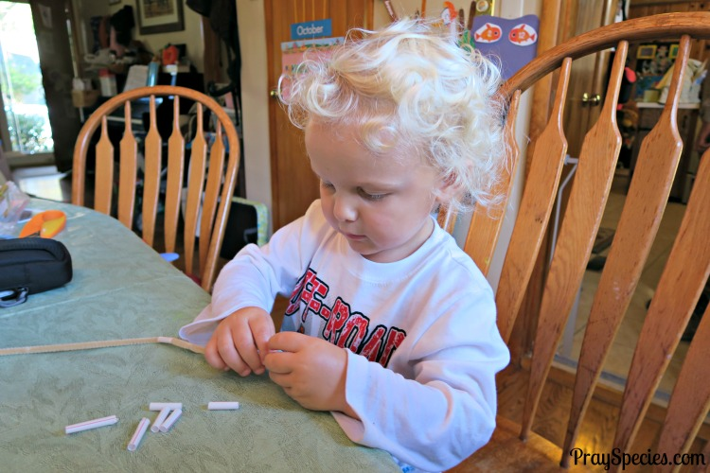
Thread a few beads onto a pipe cleaner.Connect the ends of the pipe cleaner to make a bracelet to keep all of the sheep safe.
Encourage the children to make their own bracelets of sheep.

Explain that God has room for everyone in his flock and keeps them safe because he loves all of them.
Invite children to wear their bracelets and pray together.
Lord, you are the good shepherd. Even when we make bad choices and do the wrong thing, you will still love us. Please help us to make the right choices and love one another like you love us. Amen.

Activity 3
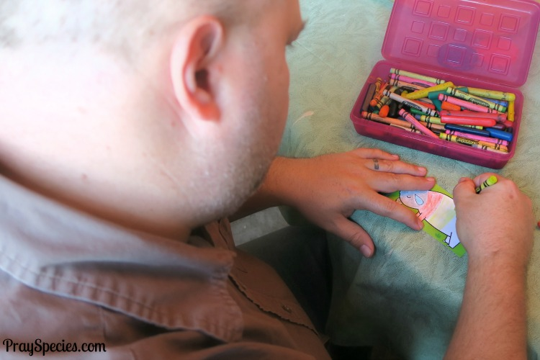

Try This Together: Decorate and Know Your Sheep
Cut apart sheep cards on the template and give one to each child.
Each person decorates their sheep and stacks the sheep in a pile in the middle of the children sitting in a circle.
Spread out the cards and invite each child to find the sheep he or she decorated.
Discuss how easy it was to find your own sheep. In the same way, God loves us so much that he looks after you all the time, no matter what. Now hide the sheep around the room and look for your own sheep again.

Closing prayer

Ask the children to put their hand on their heart while you pray.

Dear God
Thank you for putting your love into our hearts and loving us even when we sometimes do the wrong thing. Help us to make good choices and to love each other, our friends and our family like you love us.
Amen.

