Dear Children, teachers, families and friends,

You are invited to take part in a special week of global prayer.

Join thousands of people across the world in praying for all those globally who are facing change, uncertainty or illness due to the Coronavirus.
Below you will see a collection of prayers that thousands of children across the world are saying. They have been especially written by people currently looking after some of the world’s most vulnerable children. You are invited to say one of these prayers each day this week. As you pray, hold onto the fact that adults and children around the world will be also be praying for you at the same time.

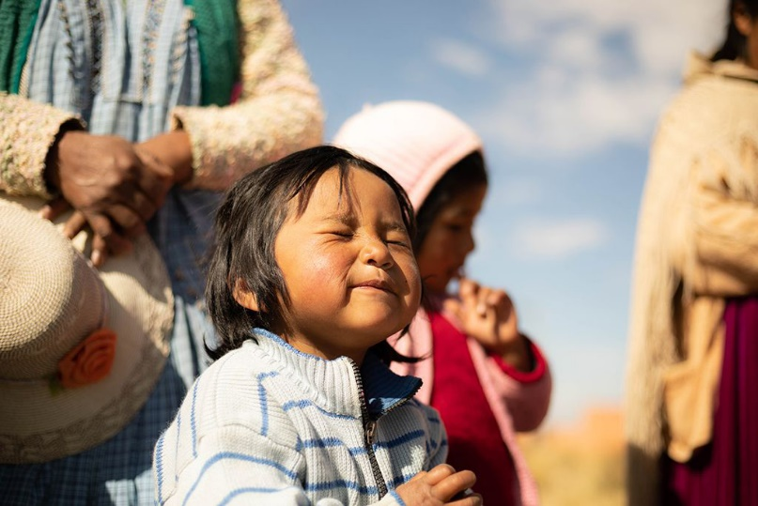
1. For the most vulnerable around the world, including people living in poverty
Father God, we pray that you would protect people in our world who are most vulnerable to the Coronavirus. We pray for the elderly, those people who are already poorly and those without access to good medical care. We pray they would know your peace, comfort and protection.
We pray particularly for countries in our world who have less medical staff and supplies to respond to the Coronavirus. Lord God, give governments wisdom as they try to help people across the world. Amen.
So do not fear, for I am with you; do not be dismayed, for I am your God. I will strengthen you and help you; I will uphold you with my righteous right hand. Isaiah 41:10

2. The Church
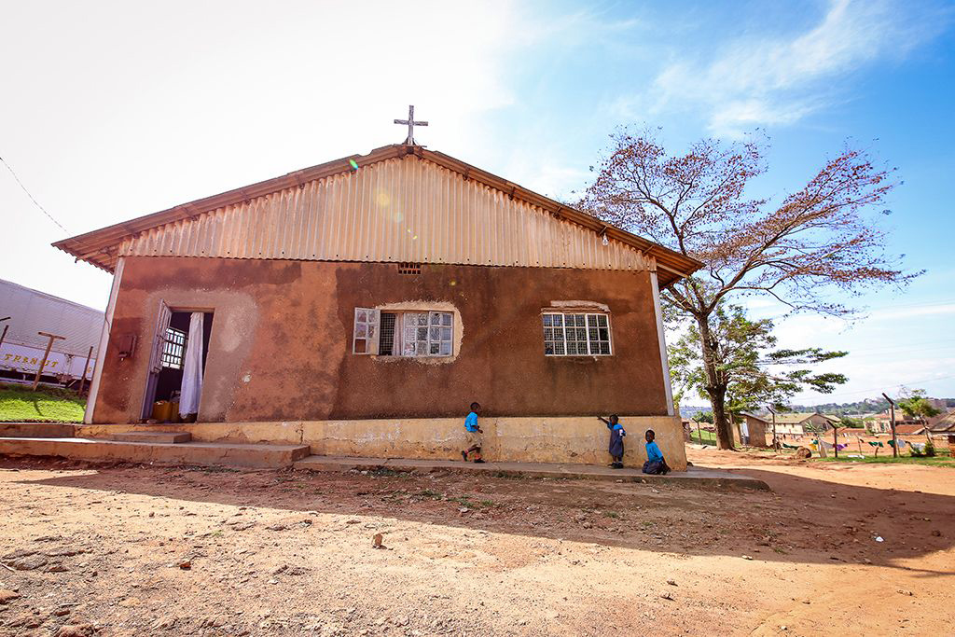
Father God we pray for churches to be a light and support to their communities during this time. We pray that people would know that they can look to their local church for help. We pray you would help members of the clergy who are still looking after people even though their churches are closed.
Loving God, we pray you would help us to love our neighbour. Help us to point others towards your love with acts of love and kindness. Amen

You are the light of the world. A town built on a hill cannot be hidden. Matthew 5:4

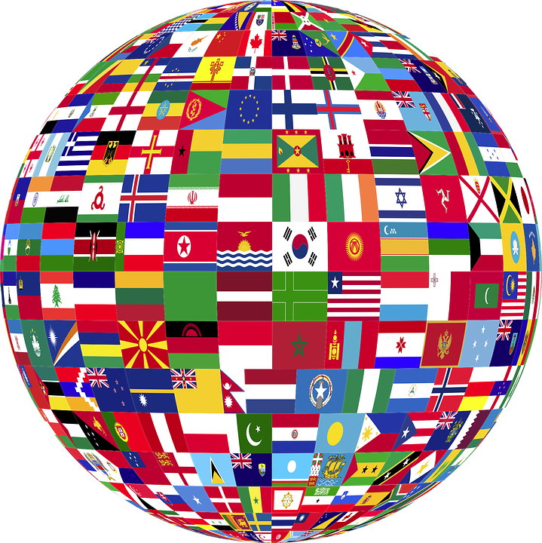
3. Governments and policy makers
Father God, we pray for wisdom for our government and health advisers. Lord God, please guide their decisions and help them to communicate plans clearly. We pray they make decisions which will quickly and effectively stop the spread of the Coronavirus. Give world leaders energy during a time where they will be working long hours. In Jesus’ name, amen.

For the Lord gives wisdom; from his mouth come knowledge and understanding. Proverbs 2:6

4. Health workers and medical researchers
Father God, we pray for health workers around the world. We give thanks for the incredible NHS staff here in the UK. Lord would you sustain and keep them during these times. Give nurses, doctors and other health professionals wisdom as they make medical decisions and give them energy and resilience as they work long hours.
Father God, we pray for your blessing over medical researchers who are searching for a vaccine for Coronavirus. Please speed their work and make it effective in protecting lives. Amen.

My command is this: Love each other as I have loved you. John 15:12

5. A Special Five Finger Prayer to end the week
Find the world map at the end of this document and pray over the nations of the world or draw your own map and pray over the challenges of a certain country that you point to. Spend some time learning about the specific needs in that place using online resources.
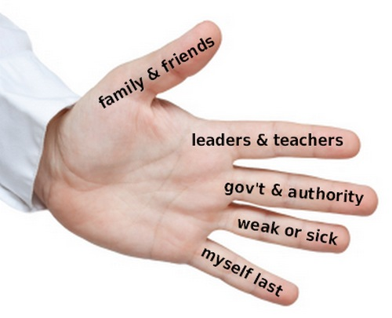
Thumb:
Pray for those closest to you - your family, neighbours, friends or community.
Pointer finger:
Pray for those that point your life in the right direction –this may be teachers, mentors or someone from the church.
Index finger(the tallest finger):
Pray for those who are leaders in governments across the globe.
Ring finger: Pray for those that are sick, those who need help and are unable to care for themselves.
Little finger: Pray for yourself and all children and families across the world.

