The Christian Value of Hope

EYFS – Reflection 1

You will need a small group of children, a sheet or banket big enough to fit the children on, lots of paper or card fish and a large bit of net.

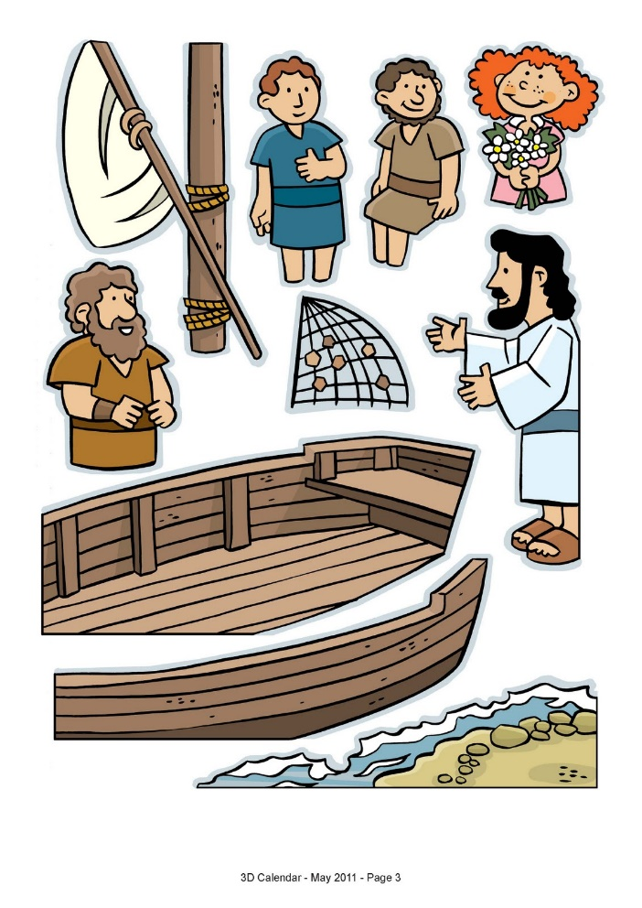
Tell the children that to tell our story from the Bible today, they will need to learn a song. Ask the children to sit on the sheet and pretend to row a boat. Lead the children in sitting down and rowing in time – Row, row, row and frieze!

Teach the children the song by pointing to yourself to indicate ‘my turn’ and point to the children to indicate ‘your turn’.
Sing the words to the tune:
Row, row, row the boat (rowing in time.)
Back in Galilee
Throw the net then pull it in
What can we see?

Practise singing this with the children before telling them that now they are ready to hear the story.

One of Jesus’ friends was called Peter and he was a fisherman (show the children a paper fish.)
Come on, let’s go fishing with Peter. I hope that we catch lots of fish. (Row the boat again) Ask the children to sing the song as they row out to the middle of the lake.

Here is a good place to fish. Let’s all help throwing the net over the side of the boat and hope that we get lots of fish today. Sing the song again.

Right, let’s have a look what we have caught (pull up the net and look disappointed to have caught nothing.

Oh dear, there are no fish in here. Let’s try again. I hope that we have more luck this time.

Repeat singing the song and casting the net in several more times.

Tell the children that Peter was getting more and more upset. He was in the boat for ages and had not caught one fish. Tell the children that you are losing hope of catching any fish today.

(Discuss with the children how the people in the boat feel now.)

Tell the children that suddenly Peter saw someone standing far away on the beach. The stranger shouted across to the people in the boat. ‘Hey, have you caught anything?’. Peter told the man that they had not caught one fish all day and were giving up hope of having any fish for tea.

But then the man on the beach did something amazing. He told the people in the boat to throw the net into the water on the other side of the boat. ‘Trust me,’ said the man, ‘I can see that you are hoping for fish. I promise that you will catch fish if you do what I say.’ The fishermen trusted the man and threw in their net one more time (throw the net over the other side. (Try and distract the children while you secretly put some paper fish into the net.)

Get the children to pull in the net again and join in their surprise of seeing all the fish.

Peter was so surprised and so happy to have caught all the fish. He looked at the man to thank him and realised that it was his friend Jesus! Peter was so surprised that he rowed the boat back to the beach as fast as he could (row the boat fast to shore.)

Peter and all the people in the boat thanked Jesus for helping them catch fish and they all cooked and ate the fish on the beach.

‘All you needed to do was to trust me to help you,’ said Jesus.

Closing prayer

Dear God
Thank you for always being there to help us like the people in the boat. Thank you for helping your friends. Help us to help our friends today. Amen

