Compassion – a guided reflection to follow up the story of the Selfish Crocodile (for KS2).

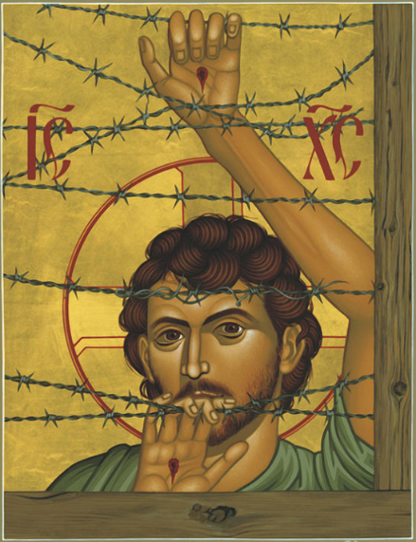
Teacher Notes

Older children will have enjoyed watching the film
of Sally Taylor reading the Selfish Crocodile, even though
it may be a picture book for younger children.
Start by discussing some of the themes in the story:
What values did the mouse show?
(Hopefully eliciting, courage, compassion, kindness, love)
Did the crocodile deserve such courageous and compassionate
behaviour from the mouse?
What changed because of the mouse’s courage and
compassion?

Explain to the children: Now that we’ve thought about that story (the Selfish Crocodile), which was probably written with younger children in mind, we are going to reflect on Jesus teaching about courage and compassion. Display the picture above, which is provided with this reflection as a pdf. Here is a picture of Jesus – there is something unusual about it but I’m not going to ask you what it is now, I would just like you to look at the picture while I read you some of Jesus teaching from the gospels.

The Reading

Jesus told the people this: “When the Kingdom of God comes, I will gather all of the people before me and I will separate them out just like a shepherd separates his sheep from his goats - sheep on his right and goats on his left.
Then I will say to those on the right, ‘Come, you who are blessed by my Father. For I was hungry and you gave me something to eat, I was thirsty and you gave me something to drink, I was a stranger and you invited me in, I needed clothes and you clothed me, I was sick and you looked after me, I was in prison and you came to visit me.’
Then the people on the right will answer, ‘Lord, when did we see you hungry and feed you, or thirsty and give you something to drink? When did we see you a stranger and invite you in, or needing clothes and clothe you? When did we see you sick or in prison and go to visit you?’
And I will reply, ‘Truly I tell you, whenever you did these things for any person in need, you did them for me.’

Then I will say to those on the left, ‘Depart from me, there is no place for you in God’s Kingdom. For I was hungry and you gave me nothing to eat, I was thirsty and you gave me nothing to drink, I was a stranger and you did not invite me in, I needed clothes and you did not clothe me, I was sick and in prison and you did not look after me.’
They also will answer, ‘Lord, when did we see you hungry or thirsty or a stranger or needing clothes or sick or in prison, and did not help you?’
And I will reply, ‘Truly I tell you, whatever you did not do for any person in need, you did not do for me.’

Discussion

I’d like us to think about the picture now. How would we know that it was a picture of Jesus? (wounds in hands and halo with cross; the picture is painted to look like a traditional icon – the letters IC XC stand for Jesus Christ in Greek).

What is unusual about it? (barbed wire fence). Do you notice the line of barbed wire that runs right across Jesus’ forehead – does this remind you of something that happened to Jesus? (crown of thorns)

Why do you think the artist has painted Jesus standing behind a barbed wire fence……where do you think he is? (The children may well say that Jesus is in prison – the intention of the painting is to identify Jesus with all those who are unjustly imprisoned, such as refugees.)

How do you think this relates to the teaching of Jesus that we just heard? (You might want to read it again.)

Reflection

I’d like you to close your eyes and imagine that you were there listening to Jesus when he said those words that we heard earlier.

I wonder how it would have made the people feel who were standing by?

I wonder whether they might have felt angry or guilty…?

I wonder how you would have felt?

Sometimes it’s easy to let ourselves think that people deserve to be poor or lonely or to have bad things happen to them because it means that we don’t have to do anything to help….

I wonder whether there have been times in our lives we have told ourselves that something was someone’s ‘own fault’ when really we should have been kind to them…?

I wonder what Jesus would say to us about this…..

Closing prayer

I am going to finish with a prayer now and if you would like to make it your own prayer, you can say Amen at the end.

Dear God,
Please remind me that whenever anyone is suffering
Or in need of kindness,
Jesus is present with them.
Give me the courage to show compassion to those in any kind of trouble,
Especially when I am tempted to blame them
And say that it is their own fault.
Amen

