**Gratitude – a guided reflection based on the story of The 10 Lepers.**

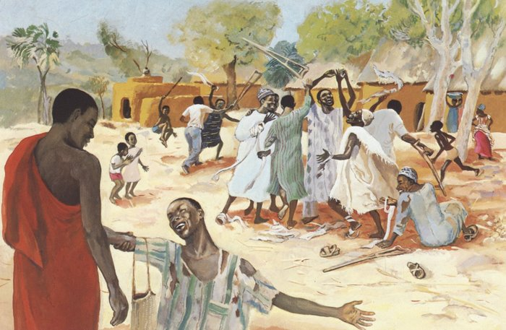

**Teacher Notes**

A PDF of the image opposite accompanies

this reflection, which may be projected for the

children to look at. This image comes from

[Vie de Jesus Mafa](http://www.jesusmafa.com/?lang=en)(Life of Jesus Mafa), which was an

arts initiative undertaken in the Mafa Christian

communities in Cameroon to help Mafa people

connect the Bible with their own identity.

**Explain to the children:** We are going to hear a story of something that happened to Jesus and reflect on what it might mean for us. The picture on our board is an artist’s impression of how he imagined the scene in the story, you may find it helpful to look at the picture carefully while I tell the story.

**The Story**

Jesus was travelling through small villages and towns on a journey to Jerusalem, the capital city. As he was going into a village, ten men who had leprosy met him. Now in Jesus’ time, people were frightened of lepers because the disease was very easy to catch. People who had it were made to live away from others on the edges of towns. So these 10 men with leprosy stood at a distance from Jesus and called out in a loud voice, “Jesus, Master, have pity on us!”

When Jesus saw them, he felt sorry and said, ‘Go and show yourselves to your leaders.’ They were puzzled by this but as they walked away, they realized that they had been healed and their skin had returned to normal. And so they ran off rejoicing.

But one of them came back, praising God in a loud voice. He threw himself at Jesus’ feet and thanked him. Now this man was a Samaritan and Samaritans are enemies of the Jewish people.

Jesus asked, “Were not all ten men healed? Where are the other nine? Has no one returned to give praise to God except this Samaritan?” Then he said to him, ‘Rise and go on your way; you have shown more thankfulness for what God has done than the other 9 men who claim to be God’s people.’



**Reflection**

I’d like you to close your eyes now and try hold that picture and the story in your mind.

Try to imagine that you are actually in the scene yourself, looking on at the 9 lepers rejoicing and the one who remembered to thank Jesus.

I wonder what it must have felt like to have a terrible illness and then to suddenly be healed….

I wonder how Jesus felt when no one remembered to show that they were grateful….

I wonder why the one man did remember to say thank you….

Are there times in your life when you need to remember to show thankfulness?

You might like to think about your daily life and the people in it.…….Things that happen on weekdays and things that happen at weekends……The place you live and the places you visit…… The things that make you feel peaceful and the things that make you feel excited……The things that make you feel safe and the things that make you feel happy.

Do you remember to show thankfulness?.....pause

How could you show thankfulness to people and to God?…..

**Closing prayer**



