Faith – a guided reflection based on a story about Peter.
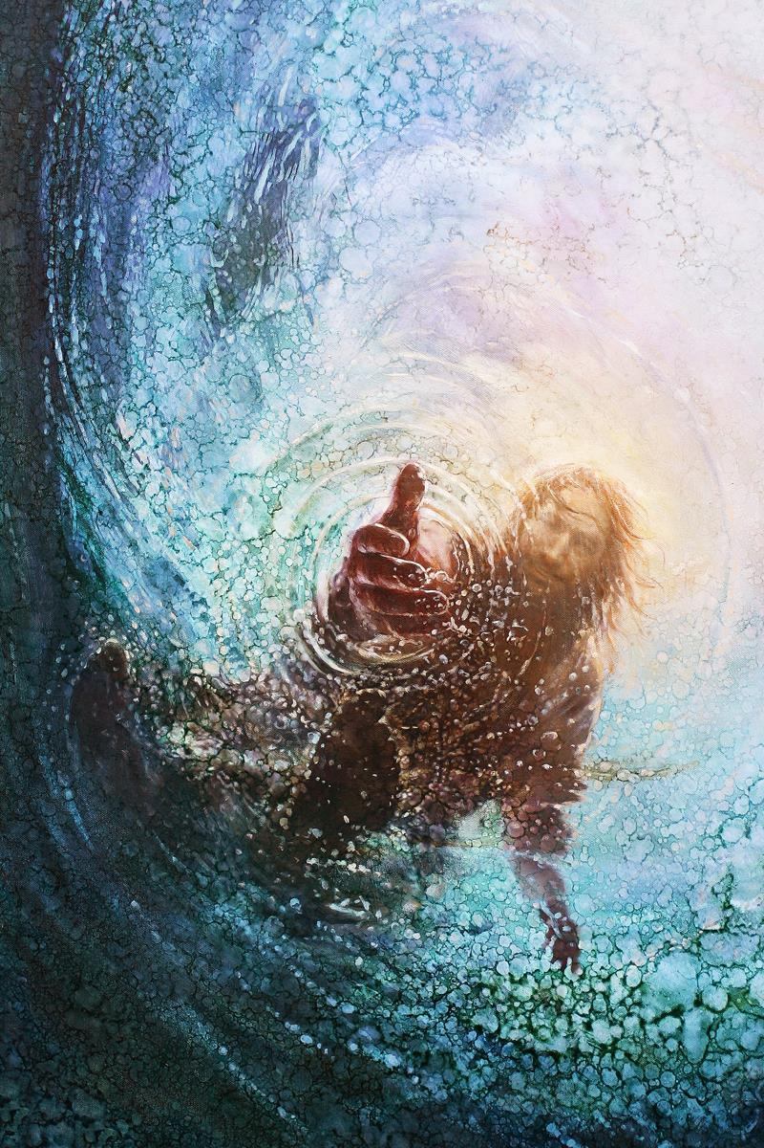
Teacher Notes

A PDF of the image opposite accompanies this reflection, which
may be projected for the children to look at. This painting by an
artist called Yongsung Kim, illustrating the story of Peter trying to
walk across the water to meet Jesus.

Explain to the children: We are going to hear a story of
something that happened to Jesus and reflect on what it might
mean for us. The picture on our board is an artist’s impression of
how he imagined the story.

It isn’t really like the usual kind of illustrations that you
see in Bible story books is? I wonder whether you can imagine
which story it might be about….you may find it helpful to look
at the picture carefully while I tell the story.

The Story

One time when Jesus was out in the countryside, he made a plan with the disciples to cross a huge lake so he could teach the people on the other side. Jesus told the disciples to get into a boat and go on ahead of him so that he could pray on his own for a while. Later that night, a strong wind blew up and the disciples were buffeted by waves out on the lake in their little boat. They were cold and frightened.

Shortly before dawn, Jesus realised that the disciples were in trouble so he went out to them, walking on the lake. When the disciples saw him walking on the lake, they were terrified. “It’s a ghost,” they said, and cried out in fear.

But Jesus immediately said to them: “Take courage! It is I. Don’t be afraid.”

As he often did, Peter got carried away with his enthusiasm and cried out, “Lord, if it’s you, tell me to come to you on the water.” “Come,” Jesus said.

Then Peter got down out of the boat, walked on the water and came toward Jesus. But when he lost faith and began to panic. He started to drown and cried out, “Lord, save me!”
Immediately Jesus reached out his hand and pulled Peter out of the water. “You of little faith,” he said, “why did you doubt?”

Jesus helped Peter into the boat and the disciples worshiped him, saying, “Truly you are the Son of God.”

Reflection

I’d like you to close your eyes now and try hold that picture and the story in your mind.

Try to imagine what it would be like to be clinging to the sides of a small wooden boat out on a great lake in the dark, being pitched around by the wind and the waves.

I wonder how it would have felt when a strange figure came walking across the water as the dawn broke.….

I wonder why Peter asked Jesus to let him walk across the water toward him….

I wonder why Peter suddenly lost faith.….

Sometimes it’s easy to commit ourselves to something but then we lose faith and give in.
Sometimes we doubt ourselves and doubt that we can be as good as we want to be.
Are there times in your life when you have doubted yourself?
Are there times when you have doubted that there are things that really matter; things you should stand up for?

Jesus reaches down to us when we are full of doubts, like he did to Peter in the water. If we let him, he pulls us up and gives us the strength to keep going.

Closing prayer

I am going to finish with a prayer now and if you would like to make it your own prayer, you can say Amen at the end.

Dear God,
Help us to look to you when we are full of doubt.
Be with us through Jesus
so that we can overcome our fears
and face our challenges
with hope in our hearts.
Amen

