A class reflection based on ‘Grumpy Monkey’
by Suzanne Lang
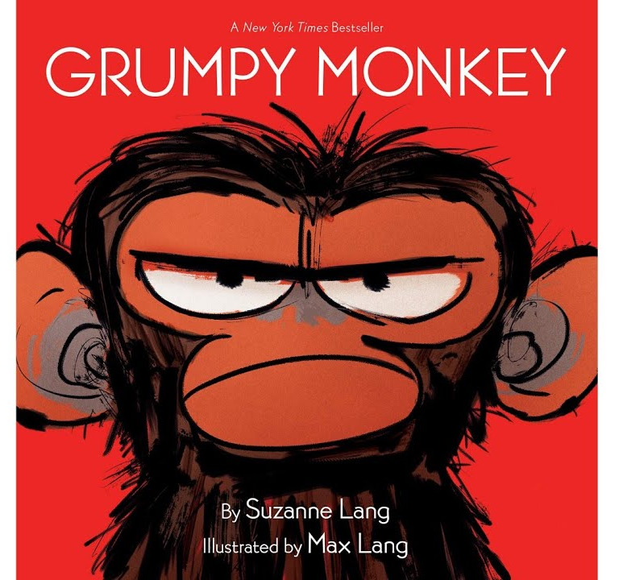
Teacher notes
Everyone feels grumpy sometimes! Jim Panzee is feeling grumpy and although his friends all try to cheer him up, he just wants to sit quietly for a while until it passes. This is a great book for helping children to explore their emotions and for reassuring them that grumpiness doesn’t last forever, they’ll probably feel better soon! Obviously we’re not talking about depression here, but learning to recognise and handle a healthy range of emotions.
Introduction
PowerPoint slide 1 What kind of things make you grumpy? Do we all feel grumpy about the same things, or do we react differently?
Have you ever woken up feeling grumpy for no particular reason? What happened? Did you cheer up in the end?
PowerPoint slide 2 Play the YouTube video of Grumpy Monkey
Ask them if they can copy Jim’s body language – what does it look like to be all hunched up? And to loosen up? Can they make their eyebrows all bunched up? And wiggle them? Ask them to show you their grumpiest expression, their most chilled, their happiest etc
Reflection Questions
PowerPoint slide 3 What did the other animals suggest to cheer Jim up? (Sing, swing, roll, stroll, lie in the grass, stomp your feet, hug someone, laugh, dance….) Do any of these things cheer you up when you’re feeling grumpy? Is there something else that works for you?
PowerPoint slide 4 When does Jim start feeling better? Do they agree that it’s when he finally admits that he’s feeling grumpy and decides to hang out with Norman? They both decide that they’ll probably feel better soon enough. How does Norman help? Is it important to be able to name our feelings? In what way?
PowerPoint slide 5 Should we try to look happy even when we’re not? (Jim tried to smile, but he still felt grumpy on the inside.)
Is it OK to be grumpy? Is it ever not OK? What if we take it out on our friends or our family? What if we’re grumpy all the time?
PowerPoint slide 6 What advice would you give Jim? (Maybe that it’s OK to feel grumpy sometimes and that it won’t last forever?)
What would you say to his friends? (Perhaps they should accept how he’s feeling and not to try too hard to cheer him up?)
What could you remember from this story next time you’re feeling grumpy?
PowerPoint slide 7 The Bible is very honest about emotions, for example ‘Psalms’ is a book of poems and songs about feeling sad, angry, afraid, trusting and joyful. King David wrote many of the psalms (the same David who was a shepherd boy and killed Goliath) and they reflect the highs and lows of his life, from hiding away in fear of his enemies, to being made king, from feeling angry with God to celebrating in the Temple. Psalm 30:5 reminds us that we may feel sad – or grumpy – sometimes, but it doesn’t last forever ‘Joy comes in the morning.’ What do the children think this means? Do they think it is helpful?
Final Prayer
PowerPoint slide 8 Invite the children to join in with this prayer – or one like it – or ask volunteers to say their own prayers based on the ideas you have talked about. If they agree with the words, they can say ‘Amen’ at the end.
Dear God, thank you for our emotions.
Thank you for all the times we feel happy, peaceful, calm or excited.
Please help us to recognise when we’re feeling sad or grumpy or anxious,
And to find ways to deal with it. Amen.

Why do they think there’s a rainbow in the picture? What does it tell us about sad times and happy times?

