A class reflection based on ‘Giraffes Can’t Dance’
by Giles Andrae
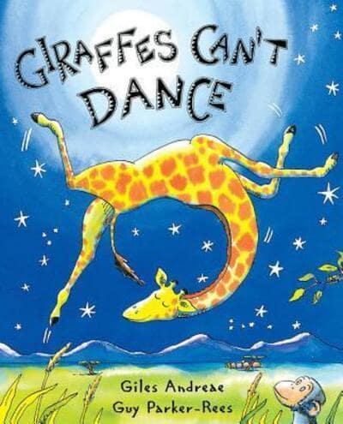
Teacher notes
This is a great story for teaching children that it’s all right to be different and to do our own thing! Gerald the Giraffe finally learns to dance and express himself when he develops the confidence to listen to a different song. The PowerPoint has a link to Giles Andrae reading his story, alternatively there’s a good version on You Tube here, which shows the illustrations more clearly.
If you want to extend the discussion with your class, there are some good children’s philosophy questions based on the book on the Prindle Institute website.

Introduction
Have you ever worried about going somewhere new and wondered whether you’d fit in? E.g. starting a gymnastics or football club? Everyone feels nervous when they try something new. Gerald really wants to go to the Jungle Dance, but he’s worried, because everyone knows that giraffes can’t dance. He’s afraid that the lions will laugh at him. Listen to the story and find out what he learns about himself.

Giraffes Can’t Dance
PowerPoint Slide 1. As they listen to the story, ask the children to notice what Gerald thinks about himself at the beginning of the story and how he has changed by the end of it.

Reflection questions
PowerPoint slides 2 & 3
What does Gerald learn about himself?
What do the children think it means, to ‘move to your own beat?’
In what ways can being different be a positive thing?
What do they think the cricket meant when he said, ‘Sometimes when you’re different, you just need a different song’?

Bible Verse and Prayer
Power Point slide 4
Christians believe that we are all unique and special, because God made us that way. The bible says that we are each like a masterpiece that God has created – and that he didn’t make any mistakes when he made us!
Read the bible verse slowly, then invite the children to pray with you if they want to. They can say ‘amen’ at the end if they like, which means ‘I agree.’

Dear God,
Thank you that you made us all different and that each one of us is a masterpiece.
Help us to be happy with who we are and to be confident to try new things.
Help us to be happy with who other people are, and not want everyone to be the same.
Amen.

Final Activity
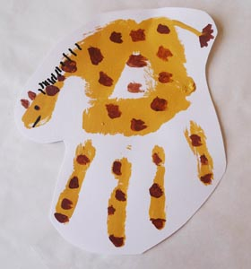
Depending on the age of your class, there are different ways to unpack what they have learned from Gerald’s story. If time permits, you could use one of these ideas.
What did we used to think we couldn’t do that we can do now?
What are the things that we can’t do yet? Whistle? Swim? Ride a bike? Do a handstand?
What mindset do we need to help us achieve these goals? We need to listen to the voices in our head that tell us we can do things – like Gerald did!

You might like to make handprint giraffes, and label them with some of the things that we can’t we do yet. Make this positive, with the emphasis on the idea that one day we’ll be able to do all sorts of things if we’re confident and keep trying!
Alternatively, with older classes: What does it mean to march to a different beat? You could play the Little Mix song (PowerPoint slide 5) (It’s worth cueing this up beforehand, so you can skip the ads!) and discuss what it means to do your own thing. Is this always a good thing? Are there times when it could get you into trouble? Does this matter? Are there situations when it’s good to stand out from the crowd? Are there times when it’s better to ‘go with the flow?’

