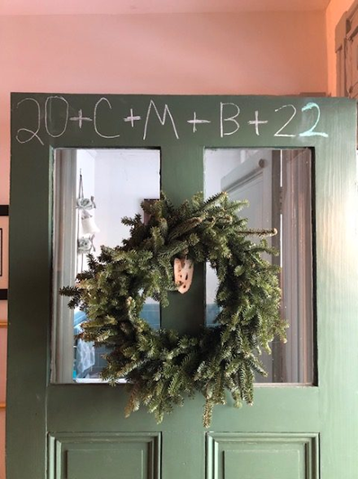
Epiphany 2024

In schools we usually take down the Christmas
decorations over the holiday to start the new year
afresh. However, this means we often miss
celebrating the Feast of the Epiphany on or near
January 6th

The feast of the Epiphany relates to the visit of the
Magi, bringing gifts to the infant Jesus.
This story can be found in Matthew 2:1-12 and is a separate account from the visit of the shepherds, which is found in Luke’s gospel - though we often conflate the two stories in nativity plays. So our usual Nativity Scenes and Christmas Cards with the angels, shepherds and magi all looking on together are inaccurate and out of sequence.

Also there’s no mention of ‘three’ magi (there were three gifts, that could have had several ‘givers’!) and magi is better translated as ‘wise men’ rather than ‘Kings’.

Recalling the first Epiphany helps us to understand that Jesus was a new kind of king for all people. The magi had come from distant countries where kings ruled through power and sorcery. They thought that they had been led to a new all-powerful king but what they found was a baby laying in a manger. In that moment of ‘epiphany’ they realised that what truly matters to God is not what they thought. Here is a ‘king’ who is even today to be found in the most humble of circumstances, who rules in the hearts of all people and is present where we least expect; whose power is the power of love. It is this realisation that is the ‘epiphany moment’.

Herod was king in Jerusalem for Jewish people at the time. He was a ‘puppet’ leader installed by the Romans and only cared about his own power and position – that’s why he wanted to have Jesus killed. Having learned who Jesus really was, the magi returned home by a different route to avoid reporting back to Herod. You could say that the ‘different route’ is also a metaphor for the new way of seeing things that the magi had discovered (ie. a metaphor for the ‘moment of epiphany’ that they had experienced).

There is a superstitious tradition that Christmas decorations need to be taken down by the 12th day of Christmas - but this isn’t a Christian tradition. In many churches, Christmas decorations, particularly nativity scenes actually remain throughout the season of Epiphany (which lasts for 40 days) and are removed at Candlemas. Candlemas is more properly called the Presentation of Christ in the Temple (Luke 2:22-40). It is called Candlemas because of the tradition of candles being blessed and given out on that day which was a precious gift years ago, and it is a good day on which to hold a school Christingle Service. In 2024 Candlemas is on Friday 2nd February, but any day that week works well.

How Epiphany might relate to learning in school:
Jesus came to show us a new way to live in appreciation of all of the things that we take for granted, that’s why we value learning so much – so we want to find the wonders of God’s creation in the world. Every small discovery that we make, whether it’s Einstein discovering relativity or just us learning a new skill or little piece of personal understanding, is a moment of epiphany because it represents God revealing the wonders of creation for all people to appreciate. God wants us to learn the lesson of the magi : that it is in stopping to think, reflect and care for the things we take for granted that we find true meaning.

An Epiphany tradition that you might like to try:
The Epiphany tradition of ‘chalking the doors’ is when Christians chalk the doors at home and at Church with : 20 † C † M † B † 24 on a day during Epiphany. The numbers refer to the calendar year; the crosses stand for Christ. The letters have a two-fold significance: C, M, and B are the initials for the traditional names of the Magi (Caspar, Melchior, and Balthasar), but they are also an abbreviation of the Latin blessing Christus Mansionem Benedicat, which means, ‘May Christ bless this house/dwelling’. The Christus Mansionem Benedicat prayer is used during the chalking:
Bless this (house)(dwelling) and all who inhabit it. Fill them with the light of Christ, that their concern for others may reflect your love.
We ask this through Christ our Lord. Amen.

You write the above message as big as you can above the door to the school / church / home (every entrance if you like) and say these words as you do each part:

The Wise Men, C Caspar, M Melchior,B and Balthasar followed the star to God’s Son who came among us 20 two thousand 24 and twenty-four years ago ++ May Christ bless our school/house ++ and remain with us throughout the new year, guiding us to find epiphany in our relationships and our learning. Amen.
The Christus Mansionem Benedicat prayer is also used : Bless this house / school and all who inhabit it. Fill them with the light of Christ, that their concern for others may reflect your love. We ask this through Christ our Lord. Amen
You can read more about the history of this tradition across the internet – a good start is here: https://en.wikipedia.org/wiki/Chalking_the_door

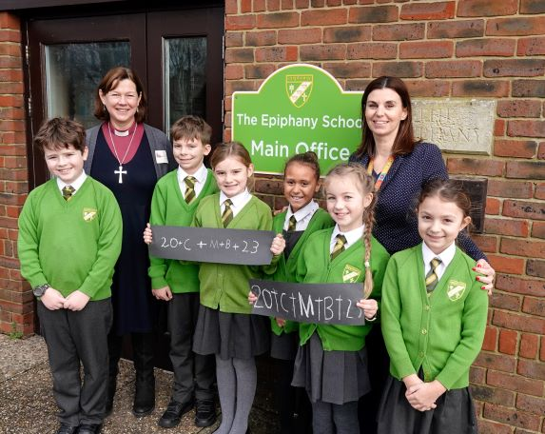
The Epiphany School in Bournemouth
makes this an annual tradition and
often have a special visitor to lead
their school Epiphany day.

The children are each given a ‘mini kit’
with a piece of chalk and the
instructions above so that they
can go and ‘chalk the doors’ at home.
It’s also a great way for children to
explain and offer a chalking to their
neighbours.

An Epiphany prayer written by two Year 5 children at Twyford St Mary’s CofE school:

Dear Lord,
Today we reflect on a New Year and Epiphany. We are reminded that a long journey starts with small steps and that sometimes a gift isn’t always an object; but love.
No matter rich or poor, far or near, where you come from or who you are - we are all loved. Amen

We are encouraging all of our CofE Schools in Winchester and Portsmouth Dioceses, as well as all of our parishes, to engage in this interesting and missional activity in the first week of next term (w/c Tuesday January 2nd 2024). Do let us know if you are taking part so we can publicise and share any photographs.

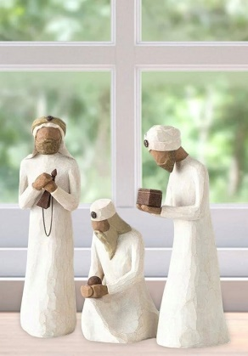

JW/RW 10/23

