Epiphany – Making a King Cake

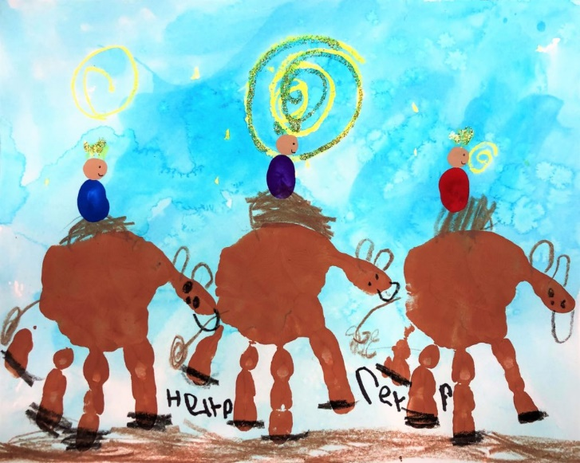
Background

In nurseries and schools we usually take down the Christmas decorations over the holiday to start the new year afresh. However, this means children miss out on celebrating the Feast of the Epiphany after Christmas.

The feast of the Epiphany relates to the visit of the Magi, translated as ‘wise men’ rather than ‘Kings’, bringing gifts to the infant Jesus. This story can be found in Matthew 2:1-12 and is a separate story from the visit of the shepherds, which is found in Luke’s gospel, although we tend to put the two events together in nativity plays.

The story of Epiphany helps children understand that Jesus was a new kind of king, not someone rich and power-hungry, but someone born in a stable to a poor family whose power is the power of love. It is this realisation that is the ‘epiphany moment’.

There is a superstitious tradition that Christmas decorations need to be taken down by the 12th day of Christmas but this isn’t actually a Christian tradition. In many churches, Christmas decorations actually stay up throughout the season of Epiphany, well into January.

A king cake, also known as a three kings cake, is a cake associated in many countries with Epiphany. In the UK the cake was traditionally baked with a bean hidden in one side and a pea hidden in the other. A man or boy finding the bean in his slice became King for the night, while a woman or girl finding the pea became the Queen.
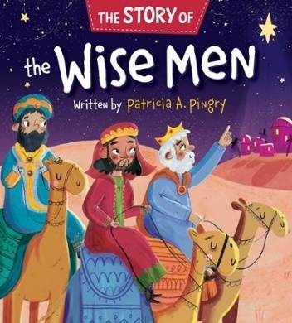
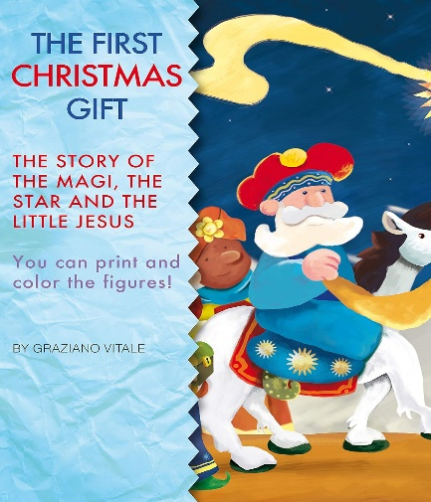
You may like to make a king cake with the children. This could be done anytime between Tuesday 2nd and Friday 5th January. Share the story of the magi before you start. Here are some recommended books for very young children.

Easy king cake recipe

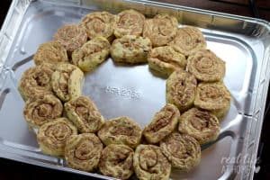
Ingredients
- 3 rolls premade cinnamon roll dough
- Icing
- Edible glitter/gems or sweets to decorate your crown shaped cake
- One edible star (either made of icing or chocolate, there are lots of readymade available)

Instructions

- Preheat oven according to cinnamon rolls instructions.
- Spray a baking sheet with cooking spray.
- Arrange 16 of the cinnamon rolls in an oval shape on the baking sheet.
- Squeeze your remaining eight cinnamon rolls so that they are smaller in the middle and long. (as the picture.) You will make a second ring with these rolls inside the first ring.
- Bake according to package directions, but don't over bake! You want your rolls to be done, but still soft. Remove from oven and allow to cool.
- This is the time to carefully slice into one of the rolls and hide the star.
- Make the icing by sifting the icing sugar and adding water until it is a ‘dropping consistency’. Pour over your King Cake. Spread it out a little bit to be sure you get frosting all over.
- Decorate with glitter/gems or sweets

An Epiphany tradition that you might like to try:

There is an Epiphany tradition called ‘chalking the doors’, where Christians chalk their doors with a pattern such as this, "20 † C † M † B † 24" on Epiphany. The numbers refer to the calendar year (2024) ; the crosses stand for Jesus; and the letters C, M, and B are the initials for the traditional names of the Magi (Caspar, Melchior, and Balthasar).

At nursery, you may like to get the children to draw a king, a crown or a cake and put it on the nursery door to welcome visitors at Epiphany.
