

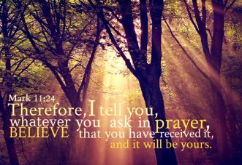



**Envelope prayers**

**Teacher Guidance**

**Context:** This prayer activity involves children writing and ‘sending’ simple prayers without the need to read them aloud or share them. The prayers could be themed or left open.

**You will need:** 10cm x 10cm squares of paper (one per child), pencil, large bowl/container, water

Pour water into the bowl/container to a depth of at least 2cm. Then invite children to make an envelope by folding the four corners of their piece of paper to the centre, just like the diagram below. This will create four envelope flaps. Ask the children open the four flaps and quietly reflect while writing a prayer in the middle of their envelope so that when they close it up again their prayer will be hidden inside (the act of writing the prayer is a prayer itself).

Once the prayers have been written, ask the children to carefully fold the envelope flaps to hide their prayers. Once this is done, invite the children one at a time to place their envelope with the flaps facing up onto the surface of the water in the bowl / container. The child can then watch while their envelope flaps gently open to reveal their prayer. This is a visual way of offering their prayers to God. It is helpful for each child to think about their prayer as they watch the water interact with the paper to open the flaps.

Clearly this would take a long time for all the children to place their prayers in the bowl and watch them being ‘sent’. Our suggestion would be that the sending of the prayer is an activity available to the children throughout the day to do individually. In this way, prayers could be more privately sent and then the child can dispose of the envelope afterwards if they wished.

**Further reflection:**

Think about what Jesus said in the quote from Mark’s gospel (see image on the left). He is reassuring us that God always listens to us.

Does this always mean that we will get what we pray for?

Why/why not?