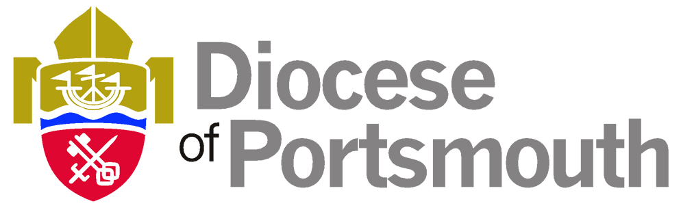
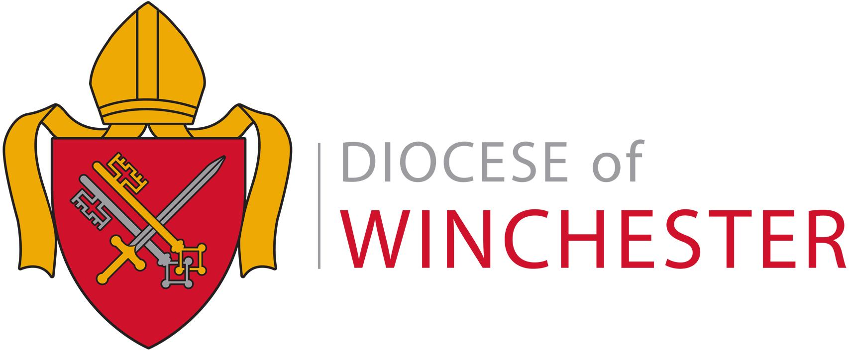

The
Dioceses of Portsmouth & Winchester
Diocesan Board of Education

There are 152 maintained schools supported by the Education Team of The Diocesan Board of Education for Portsmouth and Winchester.

The Education Team work with six local authorities, Bournemouth, Dorset, Hampshire, The Isle of Wight, Portsmouth and Southampton.

Every working day within these schools around 32,000 children and 2,000 adults encounter an education based on Christian values.

The Bishops of Portsmouth and Winchester encourage Church school Headteachers and governing bodies to consider carefully, with parish clergy and parochial church councils, matters relating to the spiritual, moral, social and cultural development, ethos, worship, religious education and the partnership between school and parish.

The Diocesan Board of Education and its staff support church schools in these matters as well as working alongside Local Authorities with general support, advice and training for church schools and their governing bodies. The education staff also support parishes and clergy in developing their work with schools.

New Headteachers are expected to attend an induction course provided by the Diocese during their first term. The Diocese also offers courses and events for school staff and governors on all aspects of church school development.

The diocesan representative involved in the appointment process at the school you are applying to will be:

Sue Bowen Richard Wharton
Diocesan Schools Adviser Diocesan Schools Adviser

Sue.bowen@portsmouth.anglican.org richard.wharton@portsmouth.anglican.org

If you are successful in the post you are applying for, the Diocesan Director of Education and his staff will be pleased to offer you whatever support they can during your time in the school.

