Leaves – a classroom reflection.

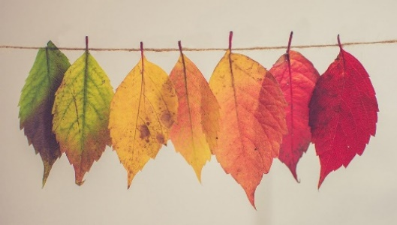
Teacher Notes

Ask each child to bring in a leaf that they like (you will need a to have a few spares ready) or if you can move around safely, go out into the school grounds and collect a leaf each.
Ask them to look at their leaves carefully; notice the colours, the pattern of the veins, the shape and the texture. What What makes their leaf unique?
Play some quiet, reflective music (First PowerPoint slide) while the children get to know their leaves thoroughly. (Moby can be good for this, or Hillsong instrumental worship music.)

Class discussion:
It’s estimated that there are up to half a million leaves on a mature oak tree and no two leaves are the same. (Second PowerPoint slide) Talk about what makes each child unique and what the special gifts and talents that they each have.
You could use this graphic to discuss which gifts and abilities matter most. It’s important to emphasise that being a good friend is at least as important as being chosen for the football team!
(Third PowerPoint slide)
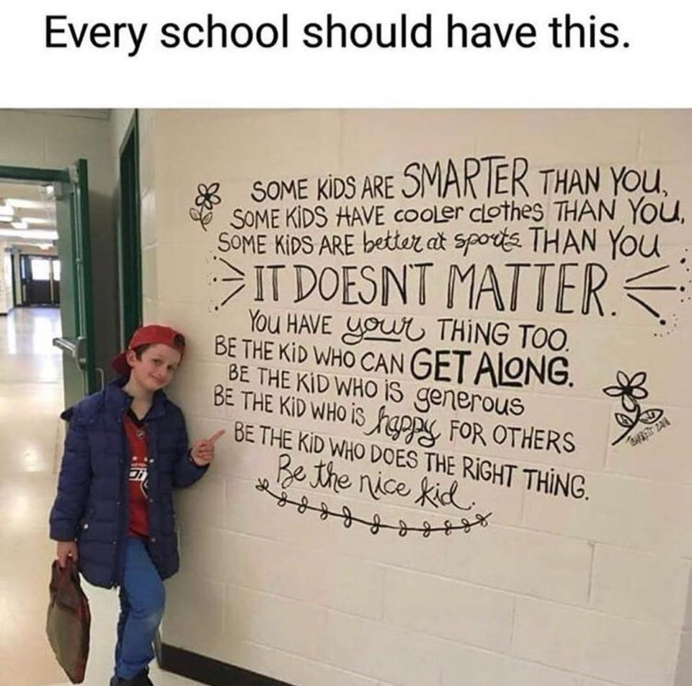

This might make an interesting estimation challenge; how many leaves do the children think there are on a twig? How many twigs on a branch? How many branches on a tree?

Closing Prayer
Collect the leaves together and pray for all the children that they represent, or ask for volunteers in the class to do this. For example:
‘Father God, we thank you for all the children represented by these leaves. Thank you for their individual personalities and talents and for all the qualities that make them unique. Please bless each one of them and help them to achieve their potential in life. Amen
If you can do this in a Covid-friendly way, then see if the children can recognise their own leaf again, once they’ve all been mixed up. (Fourth PowerPoint slide)
Jesus told his followers that God knew them all individually, even down to the number of hairs on their head. Perhaps he knows us as well as we know our individual leaves, even if there are millions of people in the world, or billions of leaves.
What do the children think?! What difference would this make?

(Matthew 10:30)

Reflection

